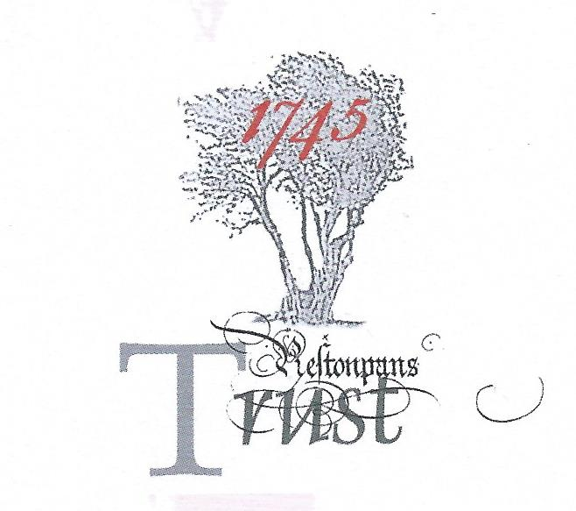

MEMORANDUM OF UNDERSTANDING
Between
Hargreaves Services [Blindwells] Limited and the Battle
of Prestonpans [1745] Heritage Trust Limited

Parties

Hargreaves Services [Blindwells] Limited, registered company number 08587087 (hereafter Hargreaves) and

Battle of Prestonpans [1745] Heritage Trust Limited, registered company number SC 302280, registered Scottish Charity number SC 037447 (hereafter the Trust).

Together the “parties”.

Introduction

The parties share an interest in honouring the historic significance of the area in East Lothian where a new town is to be established at the former opencast mining area of Blindwells, the development of which is being overseen by Hargreaves.

The town will be situated within the Scottish National Battlefield Inventory’s Designated Area of the Battle of Prestonpans, 1745. It will be built across the Riggonhead Defile, the route followed during the night by the Jacobite army of Prince Charles Edward Stuart, enabling it at dawn on September 21st 1745 to mount a successful surprise attack on Lt General Sir John Cope’s British Army, which resulted in a convincing victory. The Trust welcomes the decision by Hargreaves to reflect the history of the area by naming a park and a loch to be situated in the northern corner of the town as Prince’s Park and Prince’s Loch. The Trust will make representation to East Lothian Council that the new town be called Charlestoun as a clear acknowledgement that a major military victory, of not only British but European significance, occurred in the area, the cultural and other echoes of which can still be found in Scotland today.

Living History Centre

Established in 2006, the Trust’s charitable Objects include advocacy for the preservation of the site of the Battle of Prestonpans, the study of all aspects of the Jacobite “cause”, and the employing of a range of media to tell the story of the Battle and the Jacobites for the benefit of the general public. After considerable research and consultation with appropriate organisations and individuals, the Trust has come to the view that it should establish a Living History Centre, if possible commanding views of the battlefield, as the main focus for achieving its objectives.

In its preliminary specification for the Living History Centre, the Trust envisages it should provide sufficient space for – (i) the Primary Exhibition interpreting the Battle in the context of Jacobite history, (ii) the long-term display of the 104-metre Prestonpans Tapestry, (iii) temporary exhibitions including cohorts of panels from the Scottish Diaspora Tapestry, (iv) facilities for cultural activities/ theatre, educational visits, and (v) café and bookshop. Feasibility studies have indicated that a world class centre can be expected to attract 80/ 100,000 visitors each year, and so adequate parking spaces will be necessary.

As a complement to the work of the Heritage Centre, and as a celebration of his victory on the nearby battlefield, the Trust proposes the commissioning of an equestrian sculpture of the Prince accompanied by cheering Highlanders, to be located in the Prince’s Park. This would be the first such sculpture in Scotland, and the Trust is convinced it would attract visitors in its own right, and would quickly become a widely-recognised icon for Charlestoun.

Constructive initial discussions between Hargreaves and the Trust have identified the possibility of the Living History Centre being located in Charlestoun’s town centre. This Memorandum of Understanding is intended to provide a framework for exploring further, and ultimately achieving, that objective.

Practical Aspects

It is proposed that the Trust’s architect be briefed [as appropriate] on the design of the built environment at the north-western corner of the proposed Town Centre. This would facilitate the development and sharing of design concepts for the Living History Centre, and ensure it would be fully integrated with the over-arching vision for the Town centre.

When the outline design of the Living History Centre is agreed by the parties, it would be the intention of the Trust to present the drawings publicly and use them as a basis for the Trust’s capital raising activities in 2020/ 2022. It is recognised that Hargreaves also may wish to incorporate the agreed outline design as an element in its promotional material to attract retail businesses and others to take a stake in the town centre.

It is proposed that the Trust’s Director of Interpretation will work with the Hargreaves team to contribute to the discussions on how the Riggonhead Defile will be interpreted, and on the commissioning and location of the equestrian statue.

Mutual Support

It is anticipated that once design details for the Living History Centre are agreed by the parties, Hargreaves will assist the Trust [where practicable] to deliver the Centre. For its part, the Trust will do all in its power to contribute constructively to the establishment of the Town Centre as a focus for the development of Charlestoun.

Publicity

The parties to this Memorandum of Understanding undertake to make reference publicly to the views or plans of the other only where prior agreement has been obtained.

Not Legally Binding

This Memorandum of Understanding does not, and is not intended to, create any legally enforceable rights or obligations. Subject to this, the parties undertake to work together to achieve the establishment of the Living History Centre and the commissioning of the equestrian sculpture of Prince Charles Edward Stuart.

This document consisting of this and the two preceding pages is executed by the parties as follows:

By Hargreaves Services [Blindwells] Ltd at………………………. on……………………….2019 by

……………………………………………….Director/Company Secretary (name)

……………………………………………….Director (name)

By Battle of Prestonpans [1745] Heritage Trust Ltd at…………………………….. on………………………..2019 by

……………………………………………….Trustee/Company Secretary (name)

……………………………………………….Trustee (name)

