Minutes of the An Extraordinary Meeting of a Quorum of The Members of the Battle of Prestonpans [1745] Heritage Trust
held on February 21st 2019

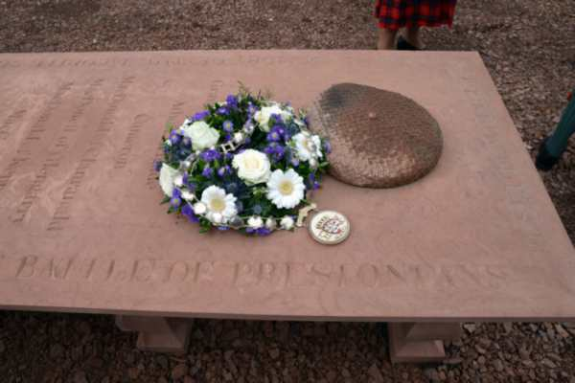

in the James Park Bistro @ The Prestoungrange Gothenburg Prestonpans

The Members unanimously agreed that it was appropriate to further elucidate and exemplify the Objects of the Trust as follows:

That Clause 3 of the Memorandum of Association shall read henceforth as follows:

3. The Charity is established for the purpose of advocacy on behalf of the preservation of the site of the Battle which took place near to Prestonpans on September 21st 1745, the honouring of those who fell, and for the advancement of heritage research and education leading to greater understanding and proper remembrance of the Battle, including studies facilitating the interpretation of all matters leading up to and consequent upon the Battle and the social, political and environmental context in which it was fought, and in so doing making use of all manner of literary, artistic and other representation to enable the widest possible appreciation of the heritage to be discerned. The Trust will seek to establish a Living History Centre to further its Objects and in doing so support the regeneration of the local area and promote human welfare including recreation and other leisure pursuits for the community at large.

