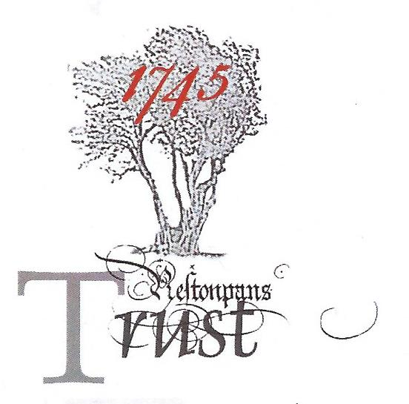

1745 BATTLE TRUST CHANGES DIRECTION …..

It’s an established fact that Prince Charles Edward had expected to be able to charge downhill from Tranent to Prestonpans on September 21st 1745. But what we know as Meadowmill today was then marshy ground and that line of attack was impossible. So he changed his direction of attack by moving the Highlanders overnight from Tranent, along the Riggonhead Defile, to a position just north of Blindwells. In that very same tradition, the 1745 Battle Trust too is changing direction because ….

1. The response from the Heritage Lottery Fund [HLF] to the Battle Trust’s initial proposal in December 2016 to restore the BathHouse at Prestongrange Heritage Museum to display the tapestries and interpret the battle has not been supportive. HLF fundamentally felt it to be [i] at an inappropriate place, too far from the battle site, and [ii] in a non-ideal context where no Master Plan exists for the Prestongrange site overall. HLF also suggested it was [iii] over ambitious and [iv] questioned its economic sustainability - despite the two feasibility studies the Trust has conducted with RGA that indicated it would work if we created a ‘world class facility’. So, HLF has not warmed to our BathHouse proposal!

2. The proposal to locate the Battle Trust Centre at Prestongrange Heritage Museum was suggested by ELC and intended to be in the best ‘overall’ interests of the town. It was determined en passant to interpret the social history of coal mining through the BathHouse as a legacy asset and to act as a major fillip for wider scale development at the museum site. It envisaged eventually an excellent multi-content facility for visitors in a pre-eminent location on the shores of Morrison’s Haven, readily accessible from Edinburgh and the Lothians. That was the ‘noble’ aim but without an ambitious ELC Master Plan for the entire museum, the Trust must now reluctantly accept that it can no longer realistically expect to restore and locate at the BathHouse as it proposed if HLF support is to be expected.

Accordingly, the Battle of Prestonpans (1745) Heritage Trust is now re-examining several possible locations which are as close as possible to the battle site. All interested organisations and individuals will be consulted as we formulate our revised plans.
<ends>

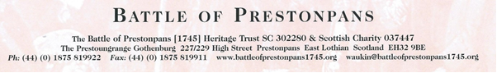

POSSIBLE ALERNATIVE LOCATIONS BEING RE-EVALUATED

4. At such possible alternative locations, the Trust will be looking to take minimum 25 year leases on well designed ‘new’ facilities with good vehicular access and parking. There are seemingly three: [i] the northern tip of the new Blindwells township (the Trust would prefer it to be called Charlestoun) where ‘light industrial/ professional units’ have been approved - which lies south of the eastern battle site; [ii] Scottish Power’s brownfield land vacated by Cockenzie Power Station/ Coal Store – lying just to the north of the western battle site; and [iii] St Joseph’s school site immediately to the west of Blindwells and adjacent to the existing Bing Viewpoint at Meadowmill.

5. Discussions have now been ongoing at Blindwells with developers Hargreaves since 2012. It has a great many attractions for the Trust not least because of its immediate proximity to both the eastern and western areas of the battle and straddles the fabled Riggonhead Defile. Hargreaves, have already gained Master Plan Consents for the area which includes both a Prince’s Park and a Prince’s Loch. And the Trust has already made a bid for the % for the arts to include battle interpretation and a major sculpture of the Prince – which would be Scotland’s first. A two/ three storey new-build in the at NW Blindwells on the Loch would have unimpeded views across the battle site to south and west enabling virtual reality appreciation of the battle itself. Access for visitors by coach and car will need careful attention of course but it is clearly a realistic option if included at this early stage in the evolution of Blindwells and lies close to the A1.

6. Whilst such an approach would give Blindwells new town an immediate sense of place for its incoming residents and create jobs, the Trust is only too well aware that Blindwells also has an early history as Riggonhead Farm and lately as an opencast coal mine.

7. It is as yet too early to open discussions with Scottish Power concerning the options on its brownfield lands to the north of the western area of the battle where the rail tracks remain and the site of the former coal store. But that option will be examined a soon as feasible when the Cockenzie Futures Master Plan is published. Much is set to change in this area with the impending development of InchCape’s SubStation for offshore wind energy. And the future of St Joseph’s site remains uncertain.

8. The Heritage Lottery Fund [HLF] is very aware that the Trust will return with an evolved proposal as soon as sensibly possible . As well as their observations detailed above, at HLF’s formal debriefing session on May 5th 2017 it was noted that the proposal tabled had focused extensively on the Prestonpans Tapestry. Although the tapestry is widely recognised as a unique heritage asset and vital to interpretation of the battle, much else that has been achieved across the community over the past decade should also have been exemplified.

9. The Trust will be in immediate contact with East Lothian Council’s incoming administration, ELC’s Museum Team led by Kate Maynard which was privy to the proposal for the Prestongrange BathHouse, the CRA, the PSG Area Development Partnership, Prestonpans/ Cockenzie & Port Seton Community Councils and the community at large.
<ends>

