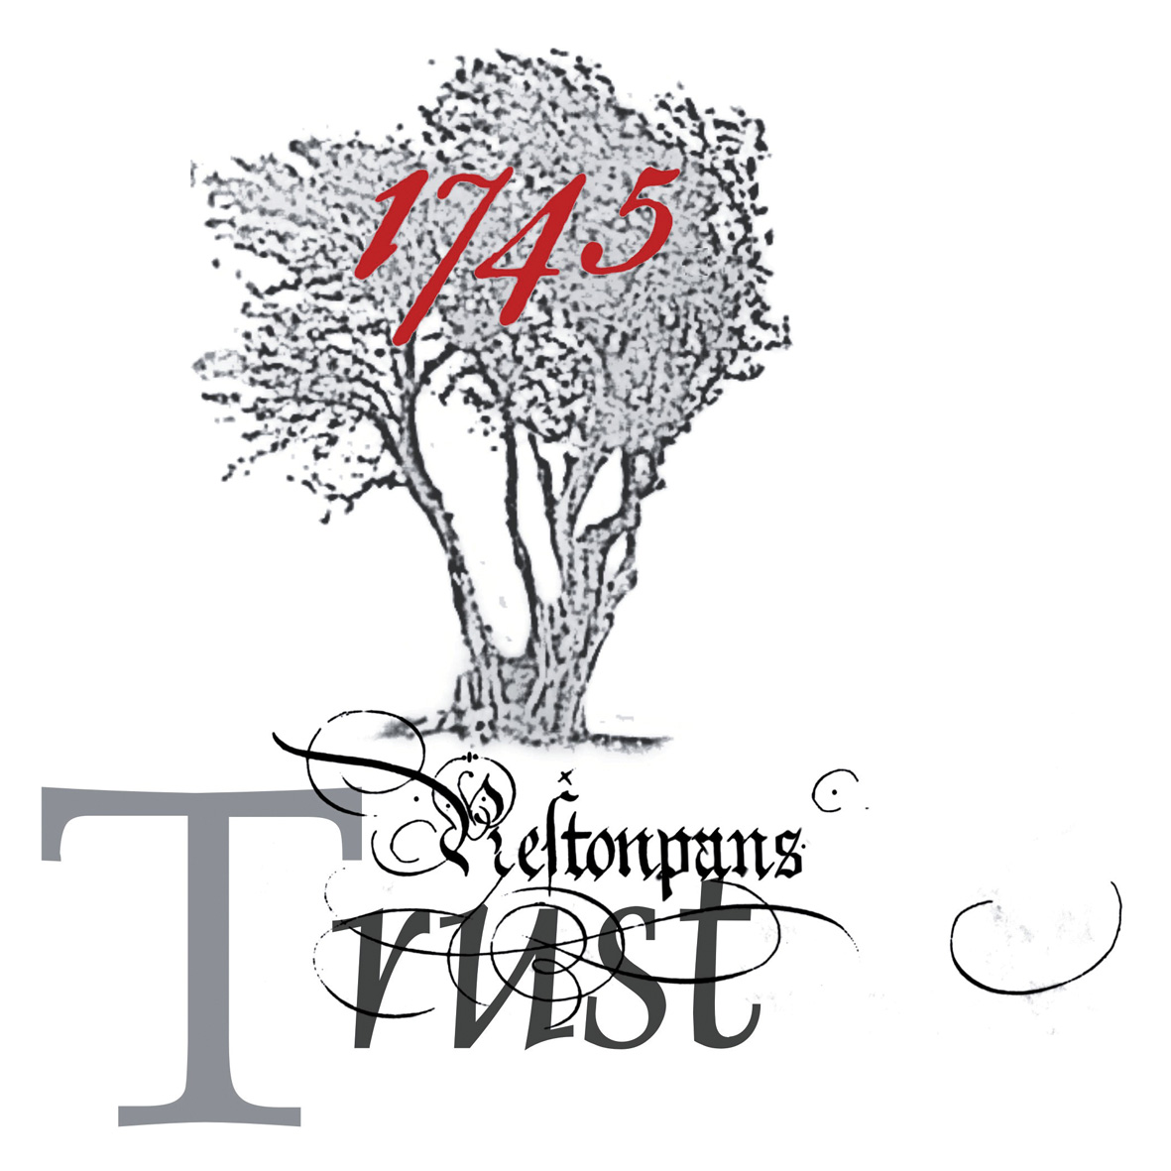

THE BATTLE OF PRESTONPANS (1745) HERITAGE TRUST

MINUTES OF THE 48/12 MEETING OF THE TRUSTEES HELD ON TUESDAY 12th JUNE 2012 at 6.00pm at THE PRESTOUNGRANGE GOTHENBURG, 227-229 HIGH STREET, PRESTONPANS

PRESENT:
Gareth Bryn Jones - Chairman [p/t]
Herbert Coutts - Vice-Chairman
Arran Johnston
Gordon Prestoungrange
Avril Wills

APOLOGIES:

Richard Mackenzie
Sylvia Burgess (Secretary)
John Curtis
Sharon Dabell
Baron of Dolphinstoun
Pauline Jaffrey
Peter MacKenzie
Richard MacKenzie
Sir Garth Morrison
Pat O’Brien
Malcolm Scott
Adam Watters - Agitant
Dorie Wilkie

- MINUTES of 47/12 Meeting of the Trustees held on May 18th 2012 at The
Prestoungrange Gothenburg had been distributed and were Approved.

2 DRAFT HEADS OF AGREEMENT WITH ELC

01 GJ reported no progress following the elections but the Trustees resolved to invite Cllr. Willie Innes, new Leader of the Council, to meet with the Cabinet Secretary on June 14th after the Trust’s own preliminary discussions with her.

02 Noted that the suggestion that the Tapestry might be housed outwith Prestonpans had met with the strongest disapproval locally.

3. VISIT BY CULTURE SECRETARY FIONA HYSLOP MSP

- That details had now been finalized for Thursday prior to the 3rd Biennial
Symposium, and Gordon Prestoungrange be invited to create Bullet Points for
the occasion and circulate to all.

- Attendance was expected to include Martin Ross from HS as well as Cllr.
Peter MacKenzie from ELC / also a Trustee.

4 MOMENTUM & APPEAL FUNDING

.01 GP reported on his discussions with Darren Barker in London and confirmed that a first presentation of the Draft Way Forward will be presented at the 3rd Biennial Symposium, with a view to finalized/ agreed patterns by end July latest.

5 HLF I ADDITIONAL INTERPRETATION BOARDS

.01 Arran Johnston reported on the continuing progress on the final 4 interpretation boards which now awaited Planning Consents. Pauline Jaffray was ready to create the designs when final consent received.

.02 KC reported that the Tapestry closing event at St. Mary’s Cathedral
would offer an opportunity to invite politicians, including Fiona Hyslop, to be
introduced to the Trust’s work. It was however agreed that the Trust should
approach FH to invite her to meet with Trust representatives in Prestonpans.

6 PRIVATE DONOR APPEAL

01 That the Tapestry Appeal continued to attract support and the cumulative takings for the Tapestry appeal collecting box were now nearly £100,000.

- That after the exhibition at St Mary’s Cathedral, which closes August
31st, it was still hoped to be able to exhibit in Inverness, Carnoustie, Aberdeen,
Dundee, London and Glasgow in the near future.

03 That following the successful Exposition in Pornichet/ St Nazaire at end
May, Bayeux had confirmed its commitment to take the tapestry in September/
October 2013.

7 ALAN BRECK REGIMENT

- AJ reported that the Regiment was holding its 5th Anniversary Regimental
Dinner on 30th June with Martin Margulies again in attendance.

- That the Seven Whiskies that the Prince might have drunk en route to
Prestonpans in 1745 will be available for tasting.

- That a Family Day at Prestongrange Museum was being presented on
July 1st.

04 That further debate take place concerning the relocation of the annual re-
enactments to the Greenhills area rather than Cuthill Park.

- Arrangements were being made for the Riggonhead Defile Medal to be
available from September 2012 – on payment of a small fee to be agreed to
meet the cost.

8 LHC EXHIBITION & 3rd BIENNIAL SYMPOSIUM

- AJ/GP reported the visit by Lord Selkirk, HM Lord High Commissioner, to
the Tapestry at the Town Hall on May 19th had gone well.

- All was in hand for the 3rd Biennial Symposium that would follow on
immediately after the meetings with the Cabinet Secretary for Culture, Fiona
Hyslop MSP.

9 DATE OF NEXT MEETING: The next Trust Meeting would be held at 6pm on Thursday 28th June 2012.

