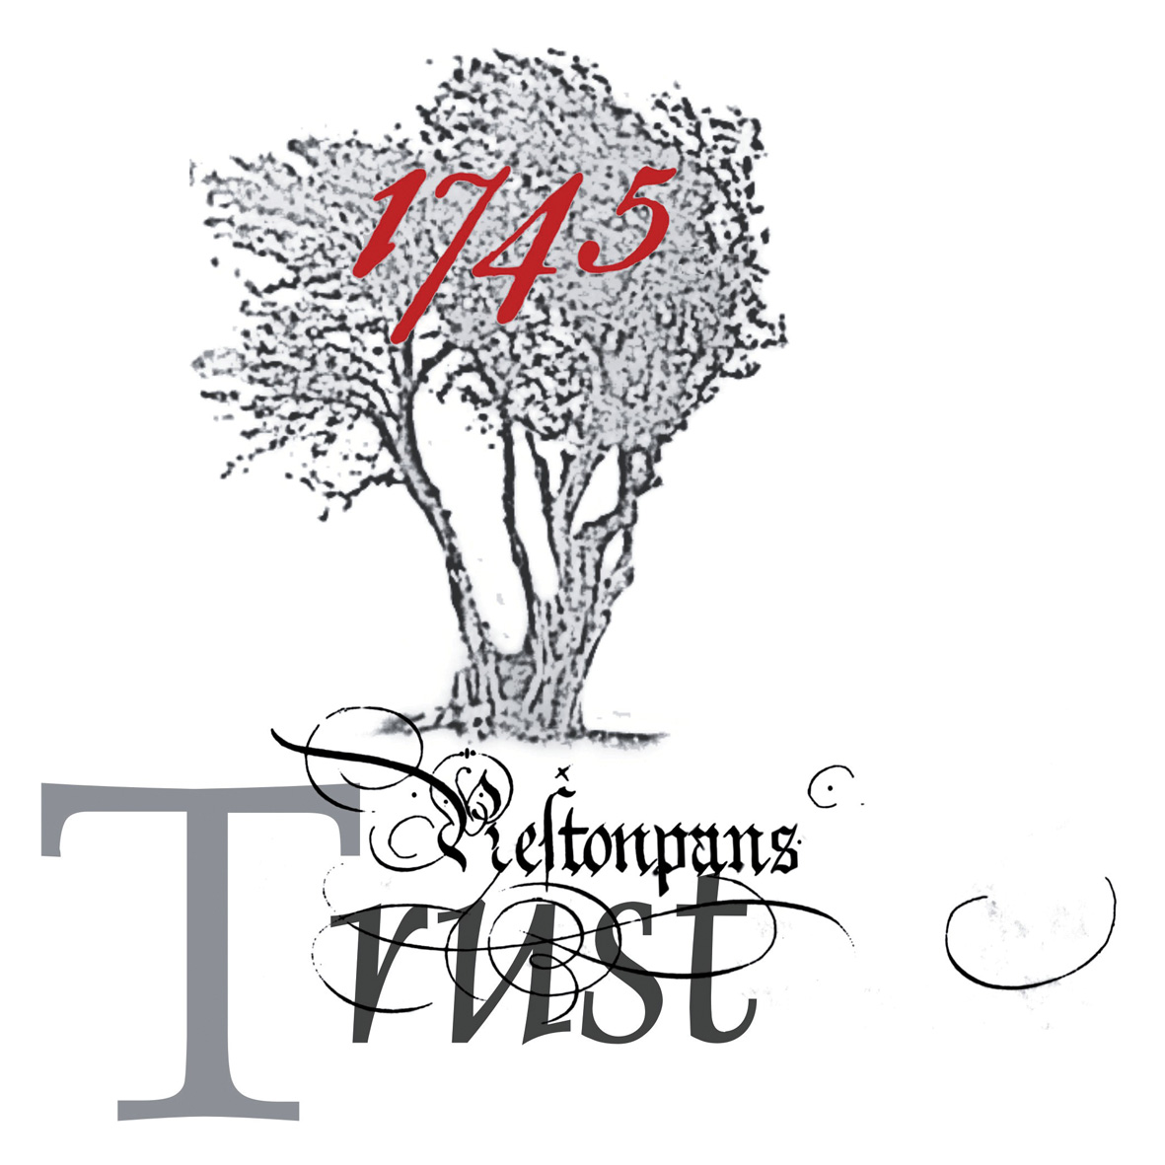

THE BATTLE OF PRESTONPANS (1745) HERITAGE TRUST

MINUTES OF THE 40/11 MEETING OF THE TRUSTEES HELD ON TUESDAY 19th JULY 2011 at 6.00pm at THE PRESTOUNGRANGE GOTHENBURG, 227-229 HIGH STREET, PRESTONPANS

PRESENT:
Gareth Bryn Jones - Chairman
Herbert Coutts - Vice-Chairman
Kristine Cunningham
Arran Johnston
Peter MacKenzie
Gordon Prestoungrange
Dorie Wilkie

APOLOGIES:

Richard Mackenzie
Lady Prestoungrange
Sylvia Burgess (Secretary)
John Curtis
Baron of Dolphinstoun
Sir Garth Morrison
Pat O’Brien
Malcolm Scott
Matthew Wills - Treasurer
Adam Watters - Agitant

1 MINUTES of 39/11 Meeting of the Trustees held on June 21st 2011 at The Prestoungrange Gothenburg had been distributed and were Approved.

2 DRAFT HEADS OF AGREEMENT WITH ELC:

.01 GJ reported that a further draft Heads of Agreement was being prepared and would be distributed to HC, GP and PMcK in advance of the scheduled meeting with Tom Shearer on 4th August. The revised draft would form the basis of negotiations over the Trust’s development of the Prestongrange site and would, as discussed at the previous Trust meeting, address Trustees concerns regarding the timescale for the development and ELC’s firm commitment to producing a masterplan for the site as a whole.

3 ELC PETITIONS COMMITTEE:

.01 GP confirmed that he had scheduled a meeting with Tom Shearer to discuss progress with the 2010 Petition. A full report would be made to the next Trust meeting.

4 ARCHITECTURAL HERITAGE FUND:

.01 GP reported on progress following discussions with Historic Scotland and The Architectural Heritage Fund (AHF). It was noted that Martin Fairley of Historic Scotland had suggested that the Trust consider applying for AHF support towards parts of the development of the Prestongrange site. GP reported that the AHF were able to offer funding support to charitable Trusts for developing feasibility and options appraisals for works to historic (Listed) buildings. GP had spoken to AHF representatives and confirmed that the AHF would consider supporting project development for schemes for the Prestongrange Beam Engine and Kiln, both of which are Listed. Options for the Trust’s role in developing the site were discussed and it was agreed that the Trust should offer to act as facilitator to assist with the Council’s ongoing improvement of the Prestongrange site. Proposals for the Bath House were unlikely to obtain support, as the building was no longer Listed.

5 PROSPECTUS TO THE NATION:

.01 KC reported on the continuing progress with the Trust’s Prospectus to the Nation. Further contact had been made with Iain Gray and with Particia Ferguson, who was also assisting the Trust in its search for a Tapestry venue in Glasgow.

.02 KC reported that the Tapestry closing event at St. Mary’s Cathedral would offer an opportunity to invite politicians, including Fiona Hyslop, to be introduced to the Trust’s work. It was however agreed that the Trust should approach FH to invite her to meet with Trust representatives in Prestonpans.

.03 KC confirmed that Edinburgh’s Lord Provost and the Deputy Mayor of Bayeaux were likely to attend the closing exhibition.

.04 There was discussion of the Trust’s position in seeking to fundraise and raise awareness of the Battle of Prestonpans while the proposed development of Prestongrange could not be reported as a solid proposal until there was firm commitment from ELC. It was noted that the lack of firm support or commitment was effectively hindering the Trust’s work towards the specific proposals and it was agreed that the trust should therefore continue to investigate alternative options for the development of the Battle Centre and Tapestry gallery. Alternative sites included Seton, Bankton and Cockenzie House. It was agreed that the Trust should, following further discussion with ELC, set a deadline for substantial progress to be made with the Prestongrange proposals.

6 PRIVATE DONOR APPEAL:

.01 KC and AJ reported that the Tapestry Appeal continued to attract support and the initial takings for the Tapestry appeal collecting box at St. Mary’s Cathedral were very good. The £20,000 FIL US donation had been received.

.02 There was further discussion among Trustees on the limitations of the appeal until such time as the Trust was able to publicise firm proposals for the Prestongrange site. It was agreed that the Trust should continue to fundraise using the existing Appeal wording until firm proposals could be announced. Donations received for the Tapestry appeal would continue to be ring-fenced. It was agreed that a budget for touring the Tapestry should be set following further investigations into the likely costs of future events, including the proposed tour of the USA and Canada.

.03 KC reported that she was working on the finalisation of arrangements for the fundraising dinner at the St. Mary’s Cathedral Song School.

7 BATTLE BOARDS AND MARKERS:

.01 It was agreed that AJ should try to contact the owner of Seton Farm shop in order to confirm arrangements for the erection of an additional information board and battle marker flags.

8 SCHOOL VISITS:

.01 It was noted that there was a lull in schools activity during the Summer Holidays but the Trust was unable, at present, to extend its schools programme as the otherwise very successful visits had been unable to generate sufficient income to meet their own costs. KC reported that attempts had been made to find alternative means of support for the schools programme but these had, so far, proved unsuccessful. It was agreed that the Trust should continue to seek alternative funding sources or to modify the schools programme, if necessary, to meet funding requirements.

9 BATTLE BUS:

.01 KC reported that she had continued to work with Tim Porteus to improve the interior of the Battle Bus and it was now suitable for use both as a mobile Battle centre and for battle-related storytelling events.

10 TAPESTRY EVENTS:

.01 AJ reported that the July Tapestry events had been successful although attendance at some of the events had been lower than had been hoped for. Further events were scheduled, including a re-enactment weekend involving the Alan Breck and other invited re-enactment groups.

.02 It was noted that the Trust had not to date offered expenses to volunteer’s assisting with Tapestry or other events and it was agreed that expenses could not be offered except in exceptional circumstances.

.03 AJ reported that sales of Tapestry merchandise and books had been strong at St. Mary’s and it was likely that additional supplies of merchandise would be required, certainly before the London and Harrogate exhibitions and probably during the St. Mary’s exhibition. It was noted that the existing merchandise could and should be improved and it was agreed that merchandising should include:
Postcards: to be developed if possible with input from Andrew Crummy;
Embroidery Kits: to be developed by DW with assistance from others;
Bags;
Tea Towels;
Mugs: DW to check source for lower priced supplier;
Coasters;
Children’s Book; KC to identify 10 suitable panels;
White Cockades: Perhaps based on Kate’s examples.

11 ALAN BRECK REGIMENT:

.01 AJ reported that the Regiment was holding its Regimental Dinner on 23rd July.

.02 AJ confirmed that the planned re-enactment event at St. Mary’s had been extended to two days (6th and 7th August) and would be attended by other regiments, including the firing canon of Birkbeck’s Battery.

.03 AJ confirmed that good progress had been made with the 2011 anniversary re-enactments and events in Prestonpans. This would include events on the anniversary of the battle (Wednesday 21st September) with a two day re-enactment event in Cuthill Park along similar lines to that held in 2010.

12 TAPESTRY TOUR:

.01 GP reported that he was making substantial progress with the establishment of links with France with a view to the Tapestry visiting perhaps in the Winter months.

.02 GP reported that he was in the process of establishing a programme for the tapestry tour of the USA and Canada. He had approached Steve Lord (author of Walking with Charlie) with a view to appointing him as tour manager.

.03 AJ confirmed that the tapestry would be hung in blocks rather than doubled up linear form for the exhibition in St Mary’s Haddington.

13 AUDIO GUIDES:

.01 KC and AJ reported that the text was being written for the Tapestry audio guides. It was noted that the voice for the guide had not yet been selected and suggestions were invited. It was also noted that the voice should if at all possible be Scottish.

14 ANY OTHER BUSINESS:

.01 Risk Assessments: AJ confirmed that he would be carrying out the necessary risk assessments and safety briefings for the re-enactment events. It was noted that AJ was also responsible for the preparation of risk assessments for other Trust events, although most of the tapestry exhibitions were the responsibility of the venues themselves. This was noted in the Trust’s exhibition agreements.

.02 Insurance: AJ confirmed that the Alan Breck Regiment carried insurance for the re-enactment events as organizing group. It was however noted that there may be additional requirements for additional public liability insurances to be in place. It was agreed that the detailed arrangements for public liability and Director’s Indemnity insurance should be considered at the next Trust meeting.

.03 Medical Assistance: It was agreed that AJ should investigate options for the provision of formal medical cover (St Andrew’s Ambulance) for the re-enactment events.

.04 Paintings: AJ reported that the Andrew Hillhouse paintings were still with the picture framer but he had reassurances that they would be completed in time for the re-enactment events. It was noted that the four Andrew Hillhouse paintings and two Kate Hunter portraits would be exhibited in The Goth during the battle anniversary.

15 DATE OF NEXT MEETING: The next Trust Meeting would be held at 6pm on Tuesday 13th September 2011.

Post Meeting Note: The date of the next meeting was subsequently altered to Wednesday 28th September 2011.

