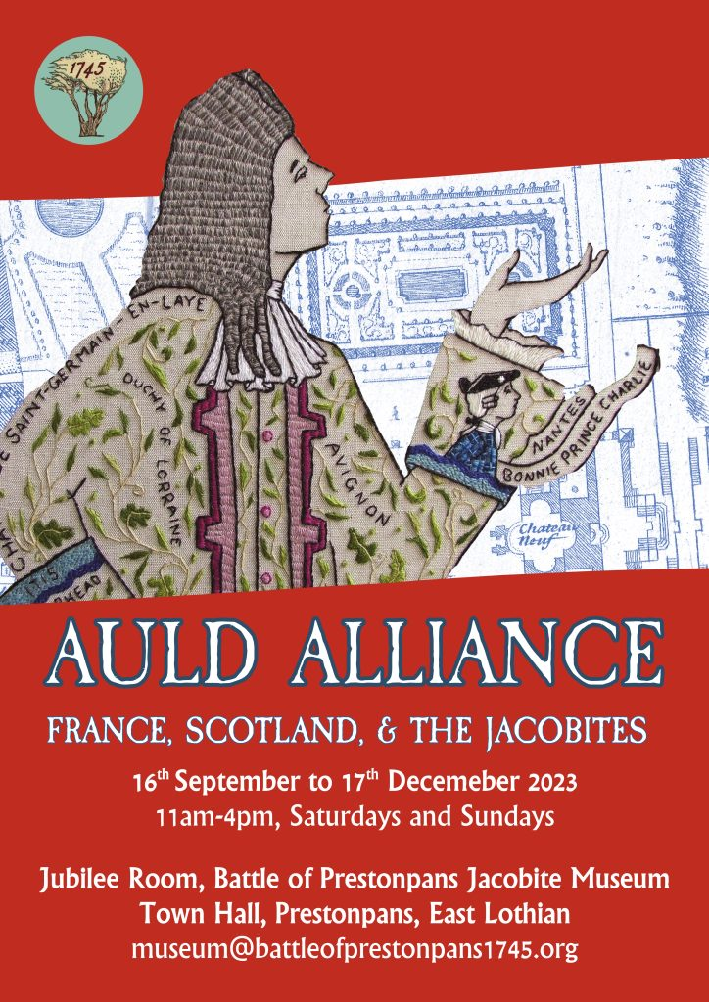

MINUTES OF 141st MEETING OF TRUSTEES OF BATTLE OF
PRESTONPANS [1745] HERITAGE TRUST HELD IN THE COURT
ROOM & BY ZOOM AT THE PRESTOUNGRANGE GOTHENBURG ON
NOVEMBER 16th 2023

PRESENT:
Gordon Prestoungrange [in the Chair]
Sylvia Burgess [z]
Sharon Dabell [z]
Arran Johnston
David Ogilvie
John Unwin [z]
Avril Wills
APOLOGIES
Gareth Bryn-Jones
Brett Fletcher
Joe Goldblatt
Pat O’Brien
Mike Taylor

- MINUTES of 140/23 Meeting of the Trustees held at in the
Court Room at the Prestoungrange Gothenburg on September 21st 2023 which had been circulated by the Secretary, were proposed by David Ogilvie and seconded by Arran Johnston and agreed to be a correct written record subject.

2. MSP’s ‘Living History Centre Workshop’ December 15th

Confirmed: 0.1 That East Lothian’s county MSP, Paul McLennan, had agreed to convene the rescheduled Follow Up Workshop @ 10.30 on December 15th and that to advance discussions it had been agreed that the Trust’s already tabled specification for its putative world class Living History Centre should be re-presented but additionally disaggregated to explore self-sustaining delivery potential as a small/ medium/ large facility.
0.2 That the Trust would continue to reiterate its ‘battlefield proximity preference’ to locate the Living History Centre at the former Coal Store as articulated in the original £150,000 community based Cockenzie Power Station Futures Study commissioned by ELC with financial support from Scottish Enterprise but never formally adopted by ELC Council, which significantly also envisaged the battlefield as a permanent green lung for the community.
0.3 That our present substantive interests at Blindwells concern interpretation of the Riggonhead Defile, street names and the arts initiatives including a statue of the Prince.
0.4 That the outcome from the Trust’s Freedom of Information [FoI] Requests re HES Observations on Planning Consent at Blindwells had revealed that no Observations under Stage 3 Mitigation and Enhancement at the Battlefield had been made as development has proceeded although HES had most recently drawn attention to the details thereof in its August 2016 Note on Historic Battlefields when Managing Change in the Historic Environment which sets out Stage 3 Observations.
0.5 That the FOI Request to East Lothian Council re its adherence to the HES Battlefield Guidance had been submitted at cost of £484 and that the outcome indicates no consideration has been given to Stage 3 Mitigation and Enhancement at the Battlefield although it has lately been suggested street names have been/ will be taken from the list provided by the Trust.
0.6 That in the context of these HES and ELC FOI Requests their representatives have been invited to meet with the Trustees, and potentially to join the next MSP Follow Up Workshop, in order to explore what can be done in respect of Mitigation & Enhancement of the Battlefield at Blindwells; and indeed what the implications are for the protection of the nation’s battlefields generally.

Reported: 0.1 That after attendance at the initial Focus Group session on June 26th of the Economic Development Consultants re Prestongrange Heritage Park re the Trust’s interest in the Bath House, and the follow through with the Trust’s Policy Paper re the socio-economic significance of all the county’s battlefields, no response or further contact howsoever had been received. Indications are that the Report will be ready for discussion by Spring 2025.
0.2 That the formal Expression of Interest [EoI] under the Community Empowerment [Scotland] Act 2015 tabled on May 4th 2023 for the Town Hall 5 year peppercorn lease with ELC to be extended to 10 years [i.e. April 2031] after consultation with Sharon Saunders, had been formally discussed by ZOOM with ELC Officers on August 23rd and lately by telephone, and although a positive decision has apparently been reached no notification has been received except word-of-mouth that ELC was ‘not ready to continue on the peppercorn basis presently extant’ from 2026 but envisaged a rental based on charitable deductions from a commercially achievable rate mentioned initially at £4,000pa + full maintenance responsibilities i.e. an eye catching 4000% increase in rental and landlord responsibilities.

Agreed: 0.1 That when formal notification is received Trustees will be immediately informed but that it remains the Trust’s view that the original establishment of the Hall in 1897 was by public subscription entrusted to the Burgh Council and that the asset created was not and should not be used ‘commercially’ but for the continuing benefit of the community howsoever; further that the benefits accorded to the community via the Town Hall and Bankton Doocot and generally well exceed such open market rental as ELC might otherwise possibly obtain and the One Community Fund Grant received.
0.2 That the arguments for a peppercorn rental were articulated by the late Sir Herbert Coutts as Chairman prior to the initial 5 year lease and remain equally valid with the added evidence of performance delivered at the Town Hall since May 2022 and feedback thereon not to mention the Trust’s enduring investment in excess of £100,000 in its restoration.
0.3 That comments on the matter be sought from key users today of the Hall including the Community Council and Education Leaders at ELC and in schools.

3. Phygital Activities ongoing from the Town Hall

Reported: 01. That the fifth rotation of the Prestonpans Tapestry [#41/50], continues on display in the Hall until December; and that The Auld Alliance with France has been well received on its display in the Jubilee Room.
0.2 That the What If? Hybrid War Game has resumed with a major although inconclusive sea battle in the Channel whilst the Jacobites and French have joined together at Reading and the Elector’s forces remain in London. A climactic resolution is still awaited after which a comprehensive exhibition of all stages of the campaign will be displayed at the Town Hall .
Agreed: 0.1 That the What If? war gaming team should continue exploring how best to share the campaign’s learning as discussed in the sequential YouTubes, arrange to display its exceptional modelling for maximum impact and sustain continuing interest amongst this new group of dedicated Facebook followers.
0.2 To endorse [i] creation of a 15 minutes game play for routine use in the museum; [ii] publication of a full set of Rules for battle gamers; [iii] a full-scale What If? Festival in the Town Hall describing the processes and outcomes during 2023; [iv] integrated publication online of the several YouTubes made during 2023; [v] ‘popularised’ reportage of the What If? 2023 project; [vi] subsequent evaluation of What If? the very battle itself had been differently conducted in the Highlands in August 1745 or in the Lowlands in September 1745 - building on the Enquiry Sir John Cope insisted took place in 1746.
0.3 That the draft programme of exhibitions and displays at the Town Hall and Jubilee Room detailed by the Consultant Curator for 2024/ 2025 be accepted noting particularly the proposals to address the Dark Diaspora, to offer a Community Choice focus and Evaluate the history of re-enactments in Prestonpans especially since the 250th at Meadowmill in 1995.
0.4 That if sufficient support can be garnered for the large scale 2024/ 2025 project Beyond the Battle computing facilities should be provided at the Town Hall for data input by volunteers/ contractors as it unfolds.

4. Educational Programmes for schools and community groups

Reported: 0.1 That ELC’s Head of Education Nicola MacDowell continues with total support of the programmes offered both at the battlefield and in the Town Hall.
0.2 That her support is also forthcoming to deliver Jacobite curriculum insights for all schools via CPD Workshops for Teachers as soon as feasible and to seek greater engagement with secondary schools as well as the county’s primaries.
0.3 That discussions continue with Preston Tower Primary and PL High School for developing a ‘long term’ history project with the support now received from ELC’s Education Trust Fund.
0.4 That it remains a precondition for participation by schools that they must provide written/ digital evaluative feedback reflecting the achievement of CfE competences and skills.
0.5 That Bord na Gaidhlig has indicated it will accept an application in November to deliver the Gaelic language version of key education resources, building on the lul Cuimhneachain – Blàr Sliabh a’ Chlamhain now in print with support from Beathag Mhoireasdan.
0.6 That every effort will be made to involve school visitors and their parents in the annual re-enactments certainly with wreath laying and panels but at the large scale re-enactment in 2024 in diverse ways.

Agreed: 0.1 That the success of the Trust’s Educational Programmes has been and will into the future be a pre-eminent soft benefit of the peppercorn lease at the Town Hall and a demonstrable justification for ELC One Community Fund and private donor support.
0.2 That the Trust should consistently articulate its ‘total flow/ systems model’ of its educational contribution from creating Teacher Awareness via CPD Workshops/ providing pre-visit briefing resources both written and visual/ delivery at visits to either or both battlefield and museum/ post visit feedback/ follow through ideas and support with suggested outcomes/ intergenerational visit encouragement through Junior Guide schemes/ wreath laying participation annually/ specially designed activity programme at triennial re-enactments including participation in parades and banner making.

Reported: 0.7 That inter alia secondary level visits for all 8 streams of Preston Lodge’s 2023 S1 intake were delivered before half term, taking advantage of the hiatus in their educational uplift from primary school to PL because of ceiling safety concerns.

5. Website development & social media

Agreed: 0.1 That a readily visible formal offer of customized group tours should be included at the website.
0.2 That the requirement for proactive social media interventions is increasingly apparent and volunteer initiatives should be sought as well as exploring what contractor services are available for specific focused events and exhibitions.

Reaffirmed: 0.1 The Trust requires the appointment of a dedicated Webmaster as soon as feasible and that it is to be hoped that a suitable volunteer might be able to develop that role.

6. Jacobite Scotland – Alba Seumasach – FESTIVAL 2024

Reported: By Mike Taylor that round robin Updates to members on the Trail continued and the initial invitation to them to join together nationwide for the inaugural ‘Jacobite Festival’ August 17th/ 25th 2024 has been reinforced with encouraging signs of success.

Agreed: 0.1 That steps be taken before Christmas 2023 to confirm that the Festival will proceed nationwide and enquiries should be made to EventScotland and HLF to see what support might be available.
0.2 That a ZOOM meeting be convened in early December to include incoming Trustee John Unwin to take all necessary steps to move it forward, accepting that in its first year the Festival will be presented and evaluated/ serve as a prototype.
0.3 That a further ZOOM session be held with participating members of the Trail in January 2023 to ensure shared understanding of the ambitions being pursued.
0.4 That participation from the 80+ Trail members now listed can be expected to range from formal dedicated ‘events’ to ‘collection close-ups’ all of which would be captured in a flyer available from all 80+ with social media and press coverage playing a significant role.

7. Funding the Interregnum …
Outcome at 31st October 2023 …. Outlook for 2024/2025 .… Risk

Received and Agreed: 0.1 Trustees Report and Year end accounts to October 31st tabled by Tony Gillingham and Sylvia Burgess showing Total Income £77,567 [2022 £92,428] and Expenditure £66,394 [2022 £180,991], giving improved Fund Balances at November 1st 2023 £79,854 [2022 £68,681]; the surplus being attributable to grants received from Hudson Charitable Trust and Barons Courts.

Noted: 0.1 That 2023 Incoming Resources came primarily from ELC One Community Fund and HMRC Exhibition Tax Credits; the former whilst greatly appreciated cannot be relied on in 2024 [although an application has been submitted] or beyond but the latter has been presently guaranteed by the UK Chancellor until at least 2025.

Re-affirmed 0.1 That it remains the case that sufficient funding in 2024/ 2025 and throughout the Interregnum to 2031 will primarily come from successful grant applications in support of creative/ imaginative projects conceived and led by the Trust.
0.2 That secondary funding will come from private donations with Gift Aid/ sales of merchandise and books/ school and other visitor fees/ Museum Exhibition Tax Credits/ ELC.
0.3 That annual unavoidable fixed costs as presently structured will be circa £70,000 [2023 = £66,681] rising by 5%pa provided peppercorn rental agreements continue at the Town Hall and Bankton Doocot [notwithstanding suggestions of 4000% increases post 2026], and that the new Johnnie Cope Baggage Train rental Haddington from January 1st 2024 of £750pa can be sustained.

Confirmed: 0.1 That Museum Exhibition Tax Credits are available from HMRC until 2025 at guaranteed 45%/ 50% of acceptable expenditure, derived from inhouse/ UK based out-of-house exhibitions, and that placed a high premium on ensuring such exhibitions continue in the Town Hall and Jubilee Room and more are arranged not least during the 10th Anniversary ‘Safari’ Displays of the Scottish Diaspora Tapestry countywide during summer 2024.
0.2 All visitors to the Museum will continue to be greatly encouraged to make donations and purchase stocks of merchandise since the Trust is holding fast in its determination to make no entrance charge except for ticketed events and special escorted visits.
0.3 That Applications/ EoI for support for the ‘Beyond the Battle’ project from 2024/ 2025 have been tabled with Scottish Energy Foundation and HES; and a further application with ELC’s One Community Fund 2024/ 2025.
0.4 That all Unrestricted Funding costs including Utilities and Insurances will continue to be met from personal donations, visit fees from schools and groups and merchandise sales.
0.5 That an Application has also lately been tabled for grant support to regenerate the Kitchenette and Green Room space at the Town Hall to ELC’s Regeneration Fund and to Wren.
0.6 That Barons Courts of Prestoungrange & Dolphinstoun have agreed to continue to underwrite the conduct of the Trust’s extant charitable activities to October 31st 2024.

8. 10th Anniversary of Scottish Diaspora Tapestry

Reported: 0.1 That Helmsdale and Orkney Science Festival have confirmed their wishes to present the entire Diaspora Tapestry in September/ October 2024.
0.2 That Veere in the Netherlands has confirmed their full scale exhibition at their Scotch House/ City Hall in Middelburg in
April/ May 2024 when they intended to launch replica panels of their
extant 6 for permanent display there; co-ordinated by Wim Meijer,
Manager of Scotchhaus in Veere.

Agreed: 0.1 Following briefings to ELC partners led by Kate Maynard
that the Tapestry will be displayed across East Lothian using the
Safari model with Swedish & Barga panels at The Prestoungrange
Gothenburg and the Opening and Concluding Festival at Prestonpans
Town Hall.
0.2 That a 4 day exhibition be offered in March 2024 at Dalkeith Palace
and that support of £2,500 from Scotgov’s Scottish Connections Fund
be sought towards the expense involved.

Confirmed: 0.1 That the programmes now agreed will ensure
continuous display of the tapestry from March/ October and that all but
Veere will have the benefit of HMRC Exhibition Tax Credits albeit they
cannot be claimed until after year end October 31st 2024.
0.2 That East Lothian Life has agreed to accept a 4pp full colour
article for its Summer 2024 edition in support of the 10th Anniversary
Safari exhibitions.

9. ELC Conversations re CEO’s Rolling Agenda

Reported: 0. 1 That priority action at Blindwells continues to be the campaign to ensure both proper recognition via street names with little hope presently that they will also use the Gaelic language as well as English, future interpretation boards and arts provision that includes the Riggonhead Defile.
0.2 That FoI Requests Responses from ELC indicate no focussed attempt to carry out Step 3 Government Policy/ HES guidance since 2016 or to honour earlier agreements following the Trust’s Petition and subsequent Cabinet Report.
0.3 That the ‘future’ route of the Riggonhead Defile across the ecotown meriting ‘designation’ howsoever is beginning to become apparent with a significant road section accessible running south/ north already signed as a cycle path.

Confirmed: 0.1 That the formal application for the 5 year lease of Prestonpans Town Hall to be extended to 10 years under the Community Empowerment [Scotland] Act 2015 has been confirmed by Sharon Saunders as being acceptable to ELC subject to formal agreement on rental arrangements and maintenance to be necessarily conducted with Wendy Gillie at ELC Estates.
0.2 That the myriad soft community benefits of the Trust’s presence at the Town Hall including free admission plus its physical restoration had been documented as the key rationale.
0.3 That discussions continue with DJ Johnston-Smith, Chair of Prestonpans Community Council which now routinely meets in the Town Hall, to explore further how the Town Hall can successfully continue as a regenerated facility for the community when the Trust eventually vacates to its putative new Centre or earlier as circumstances may require.

Reaffirmed: 0.1 That whilst not addressing the Impacts of Climate Change directly in our Objects, the Trust would offer any and all appropriate support and advice to The 360 Centre – International Climate Change Centre & Community Park not least in its Objects as it ‘[1] Looks Downwards’ and ‘[2] Around’ i.e. [1] to the industrial legacy particularly through our putative cultural geographical researches/ green lung strategy and [2] to the rich tapestry of arts, culture and music generated from the battle and Jacobite Cause we already espouse; and in doing so we would also argue for the presentation to be bilingual from the outset.

10. Gaelic language initiatives

Agreed: 0.1 That it was important that the momentum of the Gaelic activities of the Trust are maintained in consultation with/ supported by Bòrd na Gàidhlig and in line with ELC’s own GLIA 5 Year Plan.

Reported: 0.1 That Dr. Renate Gertz who had sung at the Canadian Dancers concert in August will continue to assist the Trust on an ad hoc basis to help ensure the Trust sustains its use of Gaelic in honour of the language the Highlanders spoke in 1745; and that plans for Gaelic elements at the 2025 re-enactment are being prepared.

Agreed: 0.2 That an application should be submitted to Bòrd na Gàidhlig’s Taic Freumhan Coimhearsnachd for the translation and pilot conduct of educational programmes at the battlefield and museum from April 2024/ August 2026 by January 16th 2024.

11. Any Other Business

Reported: 0.1 That discussions will continue with Ray Montgomery, John Sneddon and The Rangers to assess the needs for the protection and restoration of the Battle Orchard; but the interpretation board for Grayling butterflies at the bing with text already agreed with John Sneddon still awaits funding.
0.2 That the 2024 full scale Re-enactment will take place on the weekend of September 21st/ 22nd and final checks to ensure we avoid any clash with the Edinburgh Half Marathon’s dates have been made.
0.3 That Arran Johnston and Gordon Prestoungrange have been invited, and have now agreed to present Understanding Victory at Prestonpans to the Jacobite Studies Trust Conference in Florence from 24th/ 26th May 2024.
0.4 That Emma Brown/ Kate Maynard for PSG led a wholesome, well attended and constructive Café Consultation for the next 5 year plan for ‘PSG Heritage’ in the Town Hall on November 14th from 7pm; draft conclusions will be circulated in Spring 2024.
0.5 That HES routinely requests sponsored organisations such as our Trust to review their commitment to the Fair Trade Foundation’s best practices; our internal review seemingly indicates strategic conformance with particular significance attaching to the ‘Open Forum’ offered each month prior to Trustees’ meetings and volunteer meet and share feedback sessions.
0.6 That at the suggestion of ELC’s PSG Officers, the Trust is submitting a ‘My Place Awards’ application to the Scottish Civic Trust by January 14th 2024, seeking public recognition of the Regeneration of the Town Hall.

12. DATES OF FORTHCOMING MEETINGS

Confirmed: 0.1 That occasional ad hoc ZOOM sessions amongst sets of Trustees/ guests will continue to be convened as appropriate in the coming weeks; and that the much appreciated ZOOM option alongside Trustees face-to-face sessions will be continued indefinitely.
0.2 That Arran Johnston’s new book from Pen and Sword, The Battles of Bonnie Prince Charlie, will be launched on line on November 30th 2023.
0.3 That the 3rd Workshop convened for the Trust by Paul McLennan MSP for the Trust will take place at Teams on December 15th 2023.
0.4 That the 142nd Meeting of Trustees will be held on January 11th 2024 in the Court Room at the Prestoungrange Gothenburg from 6pm and by ZOOM access – preceded by Open Forum at the Town Hall from 4pm.
0.5 That the 143rd Meeting of Trustees will be held on March 7th 2024 or earlier on the call of the chair.
0.6 That the Scottish Diaspora Tapestry will be exhibited in Dalkeith Palace from March 15th/ 18th 2024 and immediately thereafter in Veere, The Netherlands.

