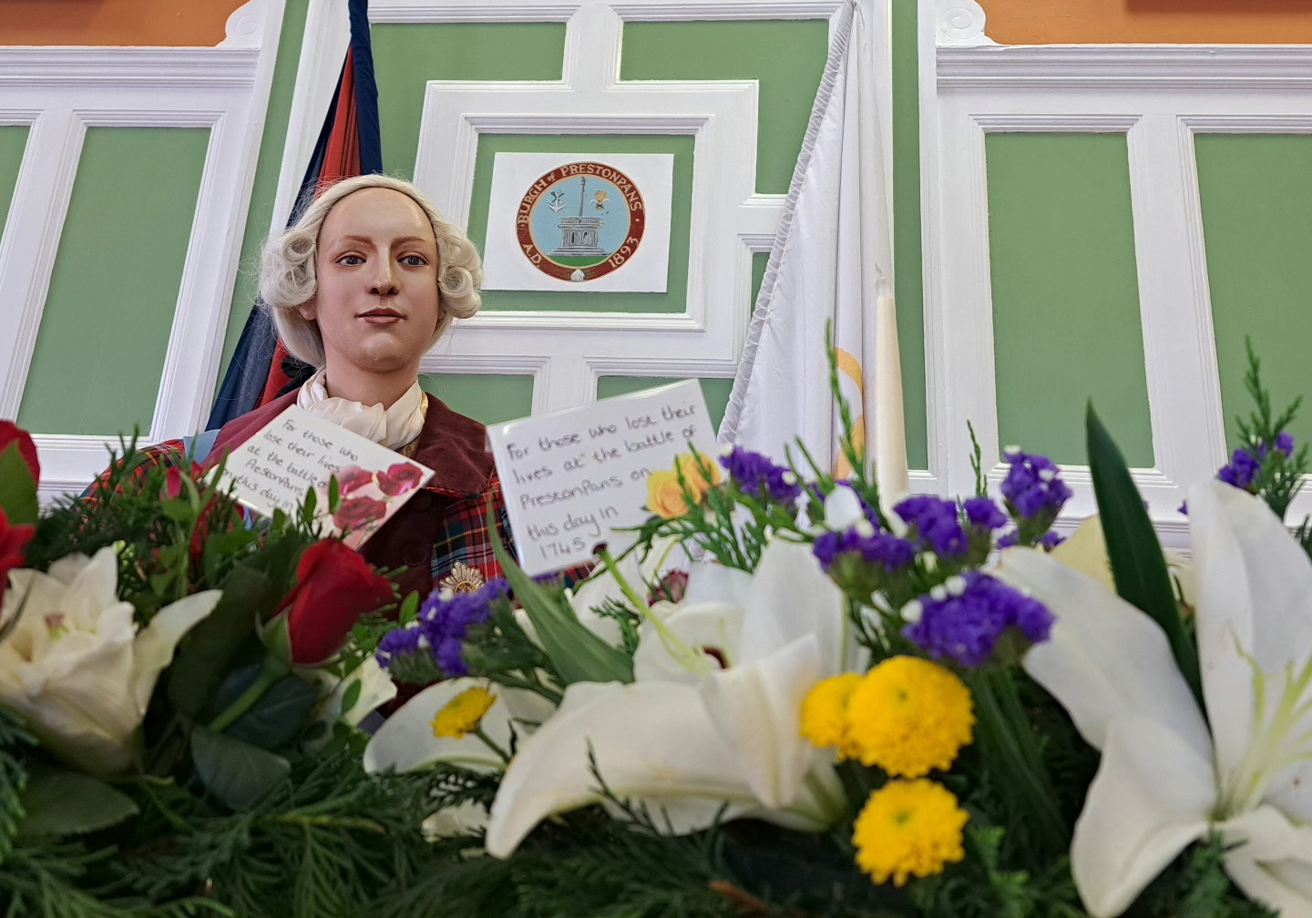

MINUTES OF 140th MEETING OF TRUSTEES OF BATTLE OF PRESTONPANS
[1745] HERITAGE TRUST HELD IN THE COURT ROOM AT THE
PRESTOUNGRANGE GOTHENBURG ON SEPTEMBER 21st 2023

PRESENT:
Joe Goldblatt [in the Chair]
Arran Johnston
David Ogilvie
Gordon Prestoungrange
APOLOGIES
Gareth Bryn-Jones
Sylvia Burgess
Sharon Dabell
Brett Fletcher
Pat O’Brien
Mike Taylor
Avril Wills

- MINUTES of 139/23 Meeting of the Trustees held at the
Prestoungrange Gothenburg and by ZOOM on August 17th 2023 which had been circulated by the Secretary, were proposed by Arran Johnston and seconded by David Ogilvie and agreed to be a correct written record subject to the amendment of Minute 2/Reported 0.2 to read: ‘That it was clear thereat that ELC Officers present were intent …..’

2. Next Steps re Living History Centre Workshop

Confirmed: 0.1 That East Lothian’s county MSP, Paul McLennan, had agreed to convene the rescheduled Follow Up Workshop in October/ November and Joe Goldblatt was presently liaising to agree the date.
0.2 That to advance discussions it had been agreed that the Trust’s already tabled specification for its putative world class Living History Centre should be re-presented but additionally disaggregated to explore self-sustaining delivery potential as a small/ medium/ large facility.
0.3 That the Trust would continue to reiterate its ‘battlefield proximity preference’ to locate the Living History Centre at the former Coal Store as articulated in the original £150,000 community based Cockenzie Power Station Futures Study commissioned by ELC with financial support from Scottish Enterprise but never formally adopted by ELC Council, which significantly also envisaged the battlefield as a permanent green lung for the community.
0.4 That our present substantive interests at Blindwells concern interpretation of the Riggonhead Defile, street names and the arts initiatives including a statue of the Prince.

Noted: 0.1 That the outcome from the Trust’s Freedom of Information [FoI] Requests re HES Observations on Planning Consent at Blindwells had revealed that no Observations under Stage 3 Mitigation and Enhancement at the Battlefield had been made as development has proceeded although HES had just most recently drawn attention to the details thereof in its August 2016 Note on Historic Battlefields when Managing Change in the Historic Environment which sets out Stage 3 Observations

Confirmed: 0.5 That in the context of the HES FoI outcome, both HES and ELC have been invited to meet with the Trustees, and potentially to join the next Follow Up Workshop, in order to explore what can be done in respect of Stage 3 Mitigation & Enhancement of the Battlefield at Blindwells.

Reported: 0.1 That since no responses had been received to Sharon Saunders reference re this request to ELC Officers in the Planning & Growth, Keith Dingwall and Andrew Stewart a formal FoI on the issue had been be tabled with ELC.
0.2 That after attendance at the initial Focus Group session on June 26th of the Economic Development Consultants re Prestongrange Heritage Park re the Trust’s interest in the Bath House, and the follow through with the Trust’s Policy Paper re the socio-economic significance of all the county’s battlefields, that no response or further contact howsoever had been received.
0.3 That the formal Expression of Interest [EoI] under the Community Empowerment [Scotland] Act 2015 tabled on May 4th 2023 for the Town Hall 5 year peppercorn lease with ELC to be extended to 10 years after consultation with Sharon Saunders, had been formally discussed by ZOOM with ELC Officers on August 23rd and a decision is awaited.

3. Phygital Activities ongoing from the Town Hall

Reported: 01. That the fifth rotation of the Prestonpans Tapestry [#41/50], continues on display in the Hall until December; and that The Auld Alliance with France has been well received on its on display in the Jubilee Room.
0.2 That the Ottawa Highland Dance Group display in the Town Hall on August 20th had been well received; Dr Renate Gertz provided song and poetry suited to the occasion; a visit to Tranent heugh made where one member had ancestral military; an exhibition of the 38 Canadian Diaspora Tapestry panels was presented; the Prince was in attendance and a new community banner was unveiled from visiting school groups.
0.3 That the Town Hall Museum participated in East Lothian Archaeology Fortnight in September as is now customary including a Battlefield Walk.
0.4 That the What If? Hybrid War Game was paused during the late summer but is now poised for its climactic resolution.

Agreed: 0.1 That the What If? war gaming team should continue exploring how best to share the campaign’s learning as discussed in the sequential podcasts, arrange to display its exceptional modelling for maximum impact and sustain continuing interest amongst this new group of podcast/ Facebook followers.
0.2 To endorse [i] creation of a 15 minutes game play for routine use in the museum; [ii] publication of a full set of Rules for battle gamers; [iii] a full-scale What If? Festival in the Town Hall describing the processes and outcomes during 2023; [iv] integrated publication online of the several podcasts made during 2023; [v] ‘popularised’ reportage of the What If? 2023 project; [vi] subsequent evaluation of What If? the very battle itself had been differently conducted in the Highlands in August 1745 or in the Lowlands in September 1745 - building on the Enquiry Sir John Cope insisted took place in 1746.
0.3 That the draft programme of exhibitions and displays at the Town Hall and Jubilee Room detailed by the Consultant Curator for 2024/ 2025 be accepted noting particularly the proposals to address the Dark Diaspora and to offer a Community Choice.

4. Educational Programmes for schools and community groups

Reported: 0.1 That ELC’s Head of Education Nicola MacDowell had given total support throughout 2022/ 2023 and agreed to so continue during the ZOOM workshop discussions on August 24th.
0.2 That her support was forthcoming to deliver Jacobite curriculum insights for all schools via CPD Workshops for Teachers as soon as feasible and to seek greater engagement with secondary schools as well as the county’s primaries.
0.3 That discussions continue with Preston Tower Primary and PL High School for developing a ‘long term’ history project with the support now received from ELC’s Education Trust Fund.
0.4 That it remains a precondition for participation by schools that they must provide written/ digital evaluative feedback reflecting the achievement of CfE competences and skills.
0.5 That Bord na Gaidhlig has indicated it will accept an application in November to deliver the Gaelic language version of key education resources, building on the lul Cuimhneachain – Blàr Sliabh a’ Chlamhain now in print with support from Beathag Mhoireasdan.
0.6 That every effort will be made to involve school visitors and their parents in the annual re-enactments certainly with wreath laying and panels but at the large scale re-enactment in 2024 in diverse ways.

Agreed: 0.1 That the success of the Trust’s Educational Programmes has been and will into the future be a pre-eminent soft benefit of the peppercorn lease at the Town Hall and a demonstrable justification for ELC One Community Fund and private donor support.
0.2 That the Trust should consistently articulate its ‘total flow/ systems model’ of its educational contribution from creating Teacher Awareness via CPD Workshops/ providing pre-visit briefing resources both written and visual/ delivery at visits to either or both battlefield and museum/ post visit feedback/ follow through ideas and support with suggested outcomes/ intergenerational visit encouragement through Junior Guide schemes/ wreath laying participation annually/ specially designed activity programme at triennial re-enactments including participation in parades and banner making.

Reported: 0.7 That secondary level visits were already proceeding apace for combined Battlefield and Museum experiences from Preston Lodge High School and from Athelstaneford Primary [home of the Saltire Flag Centre] - with over 250 visitors expected before October half term which greatly exceeds levels in 2022.

5. Website development, social media and archives

Reported: 0.1 That the requirement to give comprehensive access to Trust’s archives since 2006 via links from the new server has been resolved and access is now available via a Home Page ‘Archive’ link.
0.2 That 2023 traffic at the Trust’s main website since January continues strongly with 323,000 visitors to date [48% female/ 52% male] c/p with 385,000 for full year 2022. Facebook has 5000+ followers and YouTube 584 subscribers with 29,195 views up 67% on 2022. The News elements captured at Facebook will in future have a more disciplined transfer to the main website.
0.3 That the modest Gaelic initiatives by the Trust have now been captured more comprehensibly and given a more accessible location at the website in part completion of the Bòrd na Gàidhlig grant held by the Trust.

Agreed: 0.1 That a readily visible formal offer of customized group tours should be included at the website.

Reaffirmed: 0.1 The Trust requires the appointment of a dedicated Webmaster as soon as feasible and that it is to be hoped that a suitable volunteer might be able to develop that role.

6. Jacobite Scotland – Alba Seumasach - THE TRAIL[S]

Reported: By Mike Taylor that he has still not been able to gather together nominees for the proposed shared management team but that additional venues and resources continue to be added at the website.
0.2 That round robin Updates to members on the Trail continue with the initial invitation to them to join together nationwide for a Jacobite Festival August 17th/ 25th 2024 reinforced, for which EventScotland and/ or HLF support will be sought.

Agreed: 0.1 That by the next meeting the listing of possible participants in August 2024 should be tabled so that formal design and grant support applications can be made and a ZOOM session arranged.

7. Funding the Interregnum … Outcome 2023 …. Outlook for 2024 … Risk

Re-affirmed 0.1 That it remains the case that sufficient funding throughout the Interregnum will primarily come from successful grant applications in support of creative/ imaginative projects conceived and led by the Trust.
0.2 That secondary funding will come from private donations with Gift Aid/ sales of merchandise and books/ school and other visitor fees/ Museum Exhibition Tax Credits.
0.3 That annual unavoidable fixed costs as presently structured will be circa £70,000 rising by 5%pa provided peppercorn rental agreements continue at the Town Hall and Bankton Doocot, and that the Johnnie Cope Baggage Train rental of £5,000 can be avoided by formal purchase of a 40’ container.

Confirmed: 0.1 Museum Exhibition Tax Credits will garner £16,000 support to 31.10.2023; the campaign by Bruce Tait Associates led to a donation of £15,000 from the Hudson Charitable Trust; Coalfield Regeneration Trust contributed £1,700 to Volunteer Induction together with AIM; plus ELC’s Educational Trust & One Community Fund £27,510.

Agreed: 0.1 That the continued political and financial support by ELC was fundamental to success across the Interregnum and beyond but repeated grant income therefrom cannot be relied upon in the exceptional financial circumstances prevailing for them presently.
0.2 That Museum Exhibition Tax Credits are available from HMRC until 2025 at guaranteed 45%/ 50% of acceptable expenditure, derived from inhouse/ UK based out-of-house exhibitions, and that placed a high premium on ensuring such exhibitions continue in the Town Hall and Jubilee Room and more are arranged not least during the 10th Anniversary ‘Safari’ Displays of the Scottish Diaspora Tapestry countywide during summer 2024.
0.3 All visitors to the Museum will continue to be greatly encouraged to make donations and purchase stocks of merchandise since the Trust is holding fast in its determination to make no entrance charge except for ticketed events and special escorted visits.
0.4 That since ELC Estates will not acceded to granting a £1pa peppercorn rental for our present warehouse the transfer to a 40’ Container must be expedited at minimal capital cost.
0.5 That Sylvia Burgess in consultation with Arran Johnston and Roddy Tulloch should ensure the 40’ Container and all assets transferred well before Christmas so that no further Gift Aid supported ELC warehouse monthly lease payments of £417 are required in 2024.

Confirmed: 0.1 The location agreed for such 40’ Container at peppercorn rental in Haddington with a least cost purchase/ installation budgeted cost of £6,000/ £8,000 towards which, in expectation that the ELC Community Capital Fund Application tabled will not be successful, a Gift Aid donation of £7,500 has been accepted from Barons Courts.
0.2 That Applications/ EoI for support for the ‘Beyond the Battle’ project from 2024/ 2025 have been tabled with Scottish Energy Foundation, AIM/ NLHF and HES; and that further applications will be tabled including ELC’s One Community Fund 2024/ 2025 if calls are made in November 2023.
0.3 That all Unrestricted Funding costs including Utilities and Insurances will continue to be met solely from personal donations, visit fees from schools and groups and merchandise sales.
0.4 That Barons Courts of Prestoungrange & Dolphinstoun has agreed to continue to underwrite the conduct of the Trust’s extant charitable activities to October 31st 2024.

10th Anniversary of Scottish Diaspora Tapestry

Reported: 0.1 That Veere in the Netherlands has made a provisional
reservation to exhibit at their Scotch House/ City Hall in Middelburg in
April/ May 2024 when they intended to launch replica panels of their
extant 6 for permanent display there.
0.2 That Wim Meijer, Manager of Scotchhaus in Veere, will be in Prestonpans to discuss details during week 40.

Agreed: 0.1 That the Tapestry will be displayed across East Lothian
using the Safari model with Swedish panels at The Prestongrange
Gothenburg and the concluding festival at Prestonpans Town Hall.
0.2 That the offers by Sharon Saunders, Caroline Rodgers and Kate
Maynard to facilitate finding East Lothian partners in museums and
town halls and libraries should be gratefully accepted with a planning
group established by mid November 2023.
0.3 That Joe Goldblatt will lead discussions with Paul McLennan
MSP and the Scottish Parliament to arrange a Workshop there with a
small temporary exhibition of selected panels ideally at St Andrew’s Day
2024; and to seek complementary visits to Prestonpans by the
incumbent Cabinet Secretary/ Minister for Culture at Holyrood.
0.4 That a determined effort be made by Gordon Prestoungrange to
seek a location on Merseyside, one of the strongest concentrations of
Scottish settlement south of the Border not thus far reached.
0.5 That an repeat exhibition at Helmsdale led by local stitchers there
in October 2024 was also most acceptable.

9. ELC Conversations re CEO’s Rolling Agenda

Reported: 0. 1 That priority action at Blindwells is seeking to ensure both proper recognition via street names with little hope they will also use the Gaelic language as well as English, future interpretation boards and arts provision that includes the Riggonhead Defile.
0.2 That FoI Requests have been tabled in this respect to begin focussed campaign to carry out Step 3 Government Policy/ HES guidance since 2016 and earlier agreements following the Trust’s Petition and subsequent Cabinet Report.
0.3 That the ‘future’ route of the Riggonhead Defile across the ecotown is beginning to become apparent and a significant road section that is accessible running south/ north is already signed as a cycle path.

Confirmed: 0.1 That the formal application for the 5 year lease of Prestonpans Town Hall to be extended to 10 years had been discussed under the Community Empowerment [Scotland] Act 2015 with Caitlan Johnston and Caroline Rodgers by ZOOM on August 23rd.
0.2 That the myriad soft community benefits of the Trust’s presence at the Town Hall including free admission plus its physical restoration had been documented as the key rationale as well as emphasising that without a longer horizon the successful search for charitable support is rendered virtually impossible; and an excellent basis for ELC One Community funding of £27,500 received 2022/ 2023.
0.3 That discussions continue with DJ Johnston-Smith, Chair of Prestonpans Community Council which now routinely meets in the Town Hall, to explore further how the Town Hall can successfully continue as a regenerated facility for the community when the Trust eventually vacates to its putative new Centre or earlier as circumstances may require.

Agreed: 0.1 That whilst not addressing the Impacts of Climate Change directly in our Objects, the Trust would offer any and all appropriate support and advice to The 360 Centre – International Climate Change Centre & Community Park not least in its Objects as it ‘[1] Looks Downwards’ and ‘[2] Around’ i.e. [1] to the industrial legacy particularly through our putative cultural geographical researches/ green lung strategy and [2] to the rich tapestry of arts, culture and music generated from the battle and Jacobite Cause we already espouse; and in doing so we would also argue for the presentation to be bilingual from the outset.

Noted: 0.1 That ELC had perforce suspended pro tem all new expenditures including community support due to its budgetary crisis and the implications/ impact thereof are not yet clear.

10. Gaelic language initiatives

Confirmed: 0.1 That the Trust’s website would continually gather together the disparate Gaelic contributions for convenient public access at the website, next steps to include the Gaelic wording appearing on Interpretation boards around the battlefield and at the top of the bing.

Agreed: 0.1 That it was important that the momentum of the Gaelic activities of the Trust are maintained in consultation with/ supported by Bòrd na Gàidhlig and in line with ELC’s own GLIA 5 Year Plan.

Reported: 0.1 That Dr. Renate Gertz had sung at the Canadian Dancers concert on August 20th; and that she will continue to assist the Trust on an ad hoc basis to help ensure the Trust sustains its use of Gaelic in honour of the language the Highlanders spoke in 1745.

11. Any Other Business

Reported: 0.1 That discussions will continue with Ray Montgomery, John Sneddon and The Rangers to assess the needs for the protection and restoration of the Battle Orchard; but the interpretation board for Grayling butterflies at the bing with text already agreed with John Sneddon still awaits funding.
0.2 That no response had yet been received to the letter sent to HM King Charles III, copied to the Lord Lieutenant, inviting him to visit the Museum and battlefield, the scene of a Victory in 1745 of one who himself hoped to become King Charles III for the Jacobite Cause.
0.3 That the 2024 full scale Re-enactment will take place on the weekend of September 21st/ 22nd and final checks to ensure we avoid any clash with the Edinburgh Half Marathon’s dates have been made.
0.4 That the invitation to present and share at the Jacobite Studies Trust Conference in Florence, postponed from 2020 due to the pandemic, has been reissued for 24th/ 26th May 2024.
0.5 That enquiries should be made to identify potential video games creators who could potentially carry the What If? processes further forward.
0.6 That Emma Brown/ Kate Maynard for PSG are creating a 5 year plan for ‘PSG Heritage’ which will publicly consult initially in the Town Hall on November 14th from 7pm.
0.7 That HES has requested the Trust to review its commitment to the Fair Trade Foundation’s best practices which seemingly indicates conformance particularly through the Open Forum offered each month.

12. DATES OF FORTHCOMING MEETINGS

Confirmed: 0.1 That occasional ad hoc ZOOM sessions amongst sets of Trustees/ guests will continue to be convened as appropriate in the coming weeks; and that the much appreciated ZOOM option alongside Trustees face-to-face sessions will be continued indefinitely.
0.2 That the 3rd Workshop convened by Paul McLennan MSP for the Trust will take place in October/ November when a date can be finalized.
0.3 That the Alan Breck’s will re-enact the battle by invitation at Leith Hall, Aberdeen September 23rd/ 24th.
0.4 That the 141st Meeting of the Trustees followed by the 17th AGM of the Members will be held on November 16th 2023 in the Court Room at the Prestoungrange Gothenburg from 6pm and by ZOOM access – preceded by Open Forum at the Town Hall from 4pm.
0.5 That the 142nd Meeting of the Trustees will be held on January 11th 2024 at the Prestoungrange Gothenburg and by ZOOM.
0.6 That the 143rd Meeting of Trustees will be held on March 7th 2024 or earlier on the call of the chair.

