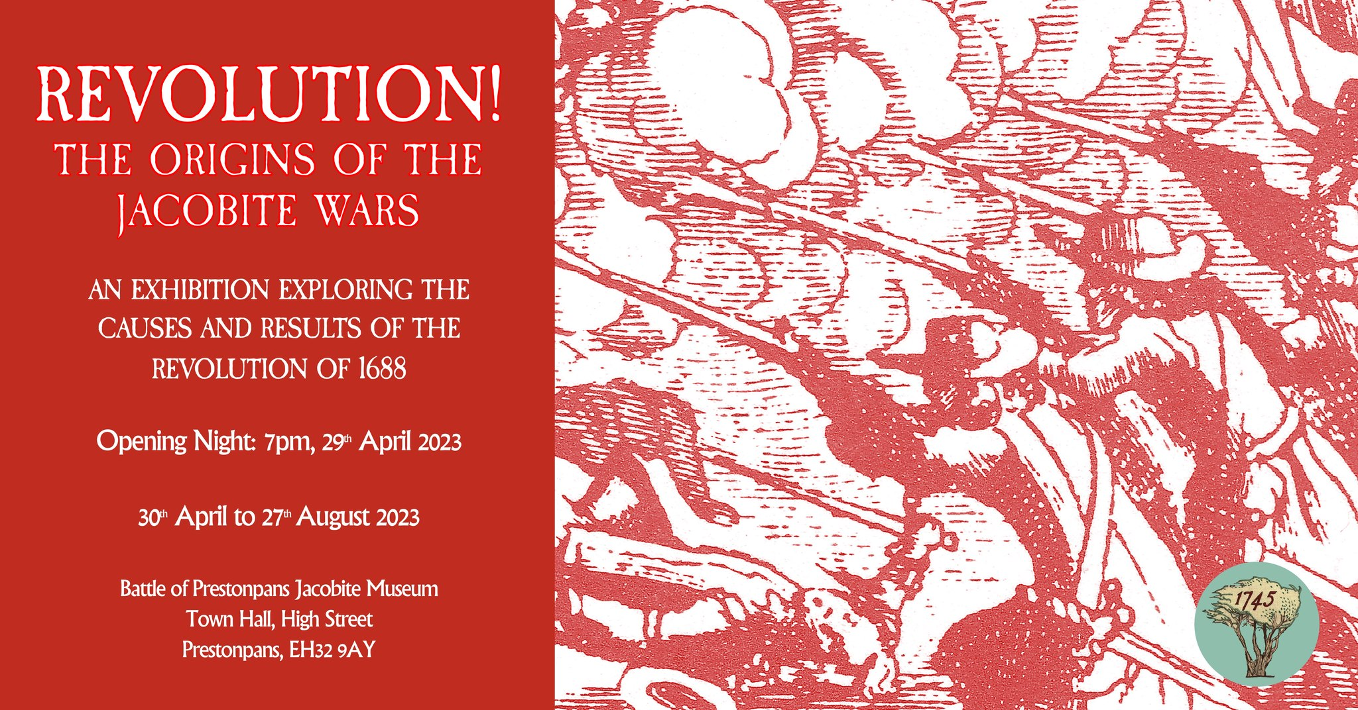

MINUTES OF 138th MEETING OF TRUSTEES OF BATTLE OF PRESTONPANS
[1745] HERITAGE TRUST HELD BY ZOOM ON JUNE 28th 2023

PRESENT VIA ZOOM:
Joe Goldblatt [in the Chair]
Sylvia Burgess
Sharon Dabell
Arran Johnston
David Ogilvie
Gordon Prestoungrange
Mike Taylor [e]
APOLOGIES
Gareth Bryn-Jones
Brett Fletcher
Pat O’Brien
Avril Wills

1. MINUTES of 137/23 Meeting of the Trustees held in the Court Room at the Prestoungrange Gothenburg and by ZOOM on May 18th 2023 which had been circulated by the Secretary, were proposed by Sharon Dabell seconded by Arran Johnston and agreed to be a correct written record after noting that whilst Sharon Dabell had circulated her comments she had not attended via ZOOM.

2. Living History Centre Follow Up Workshop July 10th 2023

Reported: 0.1 That East Lothian’s county MSP, Paul McLennan, has confirmed that his rescheduled Follow Up Workshop will take place on July 10th from 1.00pm at the Town Hall in the Jubilee Room.

Agreed: 0.1 That Joe Goldblatt will liaise with the MSP’s office to ensure invitations are dispatched to the original invitees and to other parties as identified in Paul McLennan’s letter dated May 11th to the Provost.
0.2 That the Trust would prioritise its preference to locate the Living History Centre at the Bath House and that our remaining substantive interests at Blindwells concern interpretation including street names and the arts initiatives including a statue of the Prince.
0.3 That Freedom of Information Requests re HES Observations on Planning Consent at Blindwells be now made.
0.4 That attendance at the initial Focus Group session of the consultants on June 26th to be followed through with a policy paper re the socio-economic significance of the county’s battlefields.

Reported: 0.2 That since the timescale implicit in the proposals now being followed by ELC meant that the Interregnum at Prestonpans Town Hall will necessarily run well beyond the initial 5 year lease a formal Expression of Interest under the Community Empowerment [Scotland] Act 2015 had been tabled on May 4th 2023 for the lease to be thus extended to 10 years with ELC in consultation with Sharon Saunders but no response had yet been received.
0.3 That no response had been received from ELC to the second Expression of Interest under the Act for the Bath House tabled on May 22nd 2023 or from Craig Hoy MSP for South Scotland who made a public offer to support applicants to the UK wide Community Ownership Fund.

3. Phygital Activities ongoing from the Town Hall

Reported: 01. That the fourth rotation of the Prestonpans Tapestry [#31/40], Crossing the Forth is now on display in the Hall; and that The Revolution of 1688 – The Origins of the Jacobite Wars has been well received on its on display in the Jubilee Room.
0.2 That the What If? Hybrid War Game has now reached a climatic moment and the team involved are exploring how best to share the campaign’s learning as discussed in the sequential podcasts and to display its exceptional modelling for maximum impact. Specific proposals are being developed to sustain the high levels of engagement achieved via the campaign with >1000 visitors to the each of the podcasts including ZOOM talks/sessions.

Agreed: 0.1 To congratulate the Curator and all involved with the What If? Campaign and ask him to prepare a discussion paper on the opportunities for the next meeting of the Trustees.

Reported: 0.3 That the next exhibition in the Jubilee Room will make extensive use of the Diaspora panels focused on The Auld Alliance and that Joe Goldblatt would approach the French Consul in Edinburgh to explore what sharing/ support might be possible to ensure the French community in Scotland is well aware.
0.4 That the Ottawa Highland Dance Group will be giving a display in the Town Hall on August 20th when they visit Scotland and the 28 Canadian Diaspora Tapestry panels, recently returned from Ontario/ PEI, will also be on short display in the Main Hall at that time.
0.5 That ‘interest group’ visits to the Museum continued including those with dementia and from NTS Edinburgh Branch and ELAFNS.
0.6 That the Town Hall Museum will participate in East Lothian Archaeology Fortnight as usual.
0.7 That the search for funding support for the Interregnum’s next major project following What If? is well characterized as ‘cultural geography’ focused on the battle event in our community and possible links with Professor Rebecca Finkel at QMU, an expert in this field, will be explored.

4. Educational Programmes offered to schools and community groups

Reported: 0.1 That the programmes, with full support of ELC’s Head of Education Nicola MacDowell, liaising via Ann Robertson, still envisage a CPD Workshop for Teachers as soon as feasible; and that a formal Review & Future Plans meeting with Nicola MacDowell is scheduled for August 17/18th.
0.2 That discussions with Preston Tower Primary School have been launched to develop a ‘longterm’ history project but the application tabled for support from ELC’s Education Trust Fund has still received no response.
0.3 That it remains a precondition for participation by schools that they must provide written/ digital evaluative feedback reflecting the achievement of CfE competences and skills.
0.4 That the Gaelic education resource remains in preparation with ELC’s Ann Robertson although if good progress cannot be achieved consideration will be given to the Trust creating its own, building on the lul Cuimhneachain – Blàr Sliabh a’ Chlamhain already in print with support from Beathag Mhoireasdan.
0.5 That a donation has been offered to further the ‘intergenerational’ initiative to encourage student visitors to subsequently bring parents along; 100 x £10 family vouchers towards lunch afterwards at the Prestoungrange Gothenburg will be made available.
0.6 That every effort will be made to involve school visitors and their parents in the annual re-enactments certainly with wreath laying but in the full scale re-enactment in 2024 in more diverse ways.
0.7 That considerable rescheduling/ relocation awaits S1 students in August/ September as PL High School will be unable to provide classroom accommodation because of structural concrete failures; the Trust will do anything it can to help PL address this exceptional challenge. The first use of the Town Hall in 1897 was for school classes that could not use their own facilities!

Agreed: 0.1 That the success of the Trust’s Educational Programmes has been and should into the future be a very significant benefit from the lease at the Town Hall and a clear justification for ELC and donor support.

5. Website development, social media and archives

Reported: 0.1 That the requirement to give comprehensive access to Trust’s archives since 2006 via links from the new server has been resolved and access will be via an Archive link.
0.2 That 2023 traffic at the Trust’s main website since January continues strongly but most interaction is via Facebook. The News elements captured at Facebook will in future have a more disciplined transfer to the website.
0.3 That the Gaelic initiatives by the Trust will be captured more comprehensibly and given a more accessible entrance at the website in part completion of the Bòrd na Gàidhlig grant held by the Trust.

Reaffirmed: 0.1 That the robust proactive campaign to promote a bundle of benefits to develop membership for the Friends of the Bonnie Prince is still needed, building on the base so far achieved and that a core level annual subscription of £30 be introduced as soon as feasible.
0.2 That all the Trust’s digital services and their further development require the appointment of a dedicated Webmaster as soon as feasible and that it is hoped that a suitable volunteer might be able to develop that role.

6. Jacobite Scotland – Alba Seumasach - THE TRAIL[S]

Confirmed: 0.1 That Mike Taylor has still not been able to gather together nominees for the proposed shared management team but that additional venues and resources continue to be added at the website.
0.2 That Mike Taylor had initiated a round robin Update to members on the Trail and invited them to join together nationwide for a Jacobite Festival August 17th/ 25th 2024, for which EventScotland and/ or HLF support will be sought.

7. Funding the Interregnum … Budget 2023 … Risk

Reported: 0.1 That our 3rd ‘Broadened Engagement’ Application to NLHF for support over the coming 24 months had been unsuccessful on the grounds that ‘it did not meet their outcomes sufficiently and constituted less value for money than competitive bids they had received’.
0.2 Museum Exhibition Tax Credits routines have now garnered £16,000 support to 31.10.2022 and will be of great benefit not least by giving the opportunity for support when presenting the 10th Anniversary Displays of the Scottish Diaspora Tapestry nationwide.
0.3 All visitors to the Museum are being greatly encouraged to make donations and purchase stocks of merchandise since the Trust is holding fast in its determination to make no entrance charge except for ticketed events and special escorted visits.
0.4 That our urgent request for transfer from £5,000pa to a £1 peppercorn rental at the Johnnie Cope Baggage Train had been unsuccessful but the suggestion from Estates that the Trust rent/ acquire containers is being followed up provided the promise to locate them on ELC land is met; an EoI for capital support has been tabled with the Rural Development Fund.

Noted: 0.1 That sufficient Restricted Funds are available, as shown in the Annual Accounts to October 31st 2022, and underwritten by the Barons Courts Charity, to continue trading throughout 2023.
0.2 That Unrestricted Funding is presently available only from donations and merchandise sales arising and the Museum Exhibition Tax Credits received.

Agreed: 0.1 That the Trustees accepted that it was necessary to ensure a robust funding strategy throughout what is likely to be an open ended Interregnum whilst simultaneously seeking to advance the campaign for the world class Living History Centre.
0.2 That resourcing Trust activities will be increasingly reliant during the Interregnum on unpaid volunteers and that updates on the campaign to recruit and train them will be reported at the next meeting.

8. 10th Anniversary of Scottish Diaspora Tapestry

Noted: 0.1 That 2023/ 2024 was the 10th Anniversary of the launch
of the Tapestry in Prestonpans officially opened by now First Minister
Humza Yusef MSP on behalf of then Cabinet Secretary Fiona Hyslop.

Agreed: 0.1 That Joe Goldblatt was leading the search for such
locations to include the Scottish Parliament.
0.2 That the exhibition ‘design’ known colloquially as ‘The Pub
Crawl’ should be considered as a further option.
0.3 That determined effort be made to seek a location on Merseyside,
one of the strongest concentrations of Scottish settlement south of the
Border not thus far reached.

Reported: 0.1 That Veere in the Netherlands had already asked for a
provisional reservation to exhibit at their Scotch House/ City
Hall Middelburg in April/ May 2024 when they intended to launch replica
panels of their extant 6 for permanent display there.

9. ELC Conversations re CEO’s Rolling Agenda

Reported: 0. 1 That priority action at Blindwells is presently seeking to ensure both proper recognition via street names with little hope they will also use the Gaelic language as well as English, future interpretation boards and arts provision that includes the Riggonhead Defile.

Confirmed: 0.1 That the formal application for the 5 year lease of Prestonpans Town Hall to be extended to 10 years has been tabled under the Community Empowerment [Scotland] Act 2015.
0.2 That the recent announcement of the UK wide ‘Community Ownership Fund’ publicly championed locally by Craig Hoy MSP had been the appropriate opportunity for the Trust to complete an Expression of Interest therefor and also to table in parallel a necessary formal request to lease the Bath House at Prestongrange Museum with ELC.

Reported: 0.2 That discussions continue with DJ Johnston-Smith, Chair of Prestonpans Community Council which now routinely meets in the Town Hall, to explore further how the Town Hall can successfully continue as a regenerated facility for the community when the Trust eventually vacates to its putative new Centre or earlier as circumstances may require.
0.3 That a review meeting has been arranged with Sharon Saunders on July 10th which will inter alia seek to identify whether the substantial support received from ELC’s One Community Fund in 2023/ 2024 may be reasonably expected to be continued in 2024/ 2025.

10. Gaelic Language Initiatives

Confirmed: 0.1 That the Trust’s website would continually gather together the disparate Gaelic contributions for convenient public access.

Agreed: 0.1 That it was important that the momentum of the Gaelic activities of the Trust are maintained in consultation with/ supported by Bòrd na Gàidhlig and in line with ELC’s own GLIA 5 Year Plan.
0.2 That following discussions with Dr. Renate Gertz she would be invited to assist the Trust on an ad hoc basis to help ensure the Trust develops its use of Gaelic in honour of the language the Highlanders spoke in 1745.
0.3 That Arran Johnston should liaise with Renate Gertz.

11. Any Other Business

Reported: 0.1 That discussions are continuing with Ray Montgomery, John Sneddon and The Rangers to assess the needs for restoration of the Battle Orchard but the interpretation board for Grayling butterflies at the bing still awaits funding.
0.2 That a letter has been sent to HM King Charles III inviting him to visit the Museum and battlefield, the scene of a Victory in 1745 of one who himself hoped to become King Charles III for the Jacobite Cause. It has already been announced that during July HM will be visiting the Great History of Scotland Tapestry in Galashiels.
0.3 That the 2024 full scale Re-enactment would take place on the weekend of September 21st/ 22nd and final checks to avoid and clash with the Edinburgh Half Marathon’s dates were being made.
0.4 That Dr Joe Goldblatt would be standing down as a Trustee and as Co-Chairman at the 17th AGM but would continue to give advice and support as may be feasible thereafter.

12. DATES OF FORTHCOMING MEETINGS

Confirmed: 0.1 That ZOOM sessions amongst sets of Trustees will continue to be convened as appropriate in the coming weeks; and that the much appreciated ZOOM option alongside Trustees face-to-face sessions will continue routinely.
0.2 That the 139th Meeting of the Trustees will be held on August 17th 2023.
0.3 That the Ottawa Dance Group would perform at the Town Hall on August 20th with the opportunity taken to display the Scottish Diaspora Canadian panels then and to give publicity to its rationale and content.
0.4 That the 140th meeting will be held on 21st September and associated Walking of the Riggonhead Defile howsoever and related wreath laying.
0.5 That the 141st meeting of Trustees and the 17th AGM of the Members will be held on November 16th 2023 at the Prestoungrange Gothenburg.

