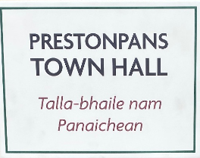

MINUTES OF 129th MEETING OF TRUSTEES OF BATTLE OF PRESTONPANS
[1745] HERITAGE TRUST HELD AT THE PRESTOUNGRANGE
GOTHENBURG, PRESTONPANS & BY ZOOM ON APRIL 28th 2022

PRESENT:
Gordon Prestoungrange [in the Chair]
Sharon Beck
Sylvia Burgess [z]
Joe Goldblatt [z]
John Home-Robertson
Arran Johnston
Dolina Maclennan [z]
Avril Wills
APOLOGIES:
Martha Bryce
Gareth Bryn-Jones
Sharon Dabell
Brett Fletcher
Pauline Jaffray
Pat O’Brien

The Meeting recorded with deepest regret the sudden death on April 11th of immediate former Joint Chairman, Herbert Coutts, remembering his contribution to the work of the Trust during the past decade and his kindly personal advice and support to us all. It was resolved in formal tribute to him that we would all “redouble our efforts to ensure that the Equestrian Statue of The Prince he had so particularly and consistently championed is erected”.

1. MINUTES of 128/22 Meeting of the Trustees held in the Prestonpans Town Hall and the 129/Pt1 Interim Meeting held by ZOOM on March 17th & April 4th respectively, which had been circulated by the Secretary, were proposed by John Home-Robertson, seconded by Arran Johnston and confirmed to be a correct written record.

2. Our Gaelic Moments ….

Re-affirmed 0.1 Aon / Dha / Tri / Ceithir / Coig / Sia / Seachd / Ochd / Naoidh / Deich… .... agus … oidhche mhath … 1-10 …. and Good night! .. Good evening! Feasgar mhath! Good [Big] health! Slàinte mhòr! Good morning friends! Maduinn mhath a chairdean!

Introduced: 0.1 By Dolina Maclennan, “Good evening friends. Feasgair math a' chairdean. Welcome to Prestonpans Town Hall! Fàilte gu Talla-bhaile nam Panaichean! “

3. Town Hall Opening & Phygital Activities May/ December 2022

Reported: 0.1 That final arrangements for opening the Town Hall exhibition without entrance fees to the general public on April 30th/ May 1st and all subsequent weekends are nearing completion; the initial 10 metres of the Prestonpans Tapestry to be displayed is titled “I am Come Home!” which will be followed in 4 monthly sequences by all the other panels; and that the Alan Brecks will be in attendance to meet with visitors.
0.2 That a ‘soft’ launch to an invited audience will take place from 7pm on April 29th with the Provost of East Lothian as our Distinguished Guest.
0.3 That weekdays will henceforth be available for fee paying group bookings and tour and school groups have already started taking this service up.
0.4 That evaluative feedback on the exhibition per se will be captured from the outset and emendations introduced as may be advisable on a rolling basis.
0.5 That a popular ‘Guide for Visitors’ to the exhibition and all the other services of the Trust including the battlefield is in production and is targeted for publication before the 130th meeting on June 9th .
0.6 That Martha Bryce was implementing PR and social media coverage for the Opening and Marie Sharp was ensuring additional press coverage. Doli Maclennan had set in hand reporting by BBC Alba for Gaelic audiences with emphasis on the bilingual approach being taken to interpretation.
0.7 That the Visit East Lothian website is now publicizing the offers being made by the Trust.
0.8 That Tom Ewing is completing his mural on the wall of the Entrance corridor and that Janet McCrorie has accepted the commission to paint gathered impressions being ‘Memories of the Community in its Town Hall’ for the 125th Anniversary in August 2022.

Confirmed: 0.1 That the campaign to recruit and induct Volunteers & Guides supported by VisitScotland and NLHF in 2021 will be continuing; and that seven responses have already arrived.
0.2 That a series of webinars and ticketed events will be offered to December.
0.3 That with support from PSG Heritage Network and Salt of the Earth the community research to honour the 125th Anniversary of the Town Hall’s Opening will continue through to Jubilee Celebration Weekend August 6th/7th; a medal to commemorate the occasion has been struck for sale and Janet McCrorie has been commissioned to create a new artwork that captures community memories.
0.4 That the next exhibition in the Jubilee Room will be in June with the Royal Diaspora Connections tapestry selection from the Diaspora Tapestry.
0.5 That the determination initially to offer free entry to the general public at weekends must necessarily be matched by a determination to boldly seek donations from all visitors to contribute to the operational expenses arising.
0.6 That a contract to act as Consultant Curator from May 1st / December 31st 2022 had been offered to Trustee Dr Arran Johnston, and accepted by him, such contract to be funded from Restricted Funds.

4. Educational Programmes offered to schools

Agreed: 01. That Educational Programmes are one of the highest priorities at the Town Hall throughout the Interregnum and beyond and that every effort will continue to be made to add the Trust to the venues that enable schools to claim HES’s £250 bus allowance.
0.2 That an initial contract to develop and deliver the key elements of the Educational Programmes from May 1st to December 31st 2022 be offered to Sharon Beck drawing on Restricted Funds; all fee income arising to be hypothecated back to further support the programmes.

Reported: 0.1 That the programmes had the full support of ELC’s Head of Education liaising via Ann Robertson with the immediate opportunity to further promote them to MidLothian and Edinburgh; and that the initial teachers’ briefings will begin on May 13th with the opportunity taken then to finesse all programme details.
0.2 That the approach included prior resourced engagement with teachers including CPD credits and intergenerational follow through via the badged Junior Guide scheme for students’ own families.
0.3 That it was a precondition for participation by schools that they must provide written/ digital evaluative feedback reflecting the achievement of CfE competences and skills.
0.4 That a Gaelic education resource is also in preparation with ELC’s Ann Robertson supported by Dolina Maclennan and Ann Patterson.

5. Website development, mastering, social media, archives and APPs

Reported: 0.1 That unfortunately the Trust’s website had been hacked just as the Museum opens and so it has not yet been possible to include appropriate details there including News postings alongside the already very successful populating of the Trust’s Facebook page.
0.2 That the requirement to give access to Trust’s archives since 2006 is still being addressed in consultation with Technovisual/ Raeltec.
0.3 That following the termination of services from ATOM Engine, original providers of the three APPs which all required system and content updates, Technovisual have now completed the total transfer and updating of the Diaspora Tapestry with the Battlefield/ 1722 Waggonway transferred but still awaiting updates re the Town Hall and Memorial Tables; it will be continuing with the third APP, Arts Treasures and Murals Trail, in consultation with James Baker and PSG Heritage Groups that have their own evolving APP planned that will include the War Memorial and Preston Tower.
0.4 That East Lothian Life has agreed to take a 4pp feature article of the Town Hall’s 125th Anniversary and the Trust’s Museum and activities therefrom for its Autumn 2022 edition, deadline July 18th.

Confirmed: 0.1 That a proactive campaign to develop and then promote the bundle of benefits to build membership for the Friends of the Bonnie Prince is still needed, building on the base so far achieved and that a core level annual subscription of £30 be introduced as soon as feasible.

6. Jacobite Scotland – Alba Seumasach - THE TRAIL[S]

Reported: 0.1 That the design and development of the Jacobite Scotland website continues with Mike Taylor who has now entered more than 50 venues.

Agreed: 0.1 That as intended from the outset a broadly based group of representatives from venues across the nation would be invited to share in its future management and development; and that Mike Taylor should identify the most appropriate small group for an initial meeting in June.
0.2 That the Trust confirm its intention intended to continue formal ownership
of the website and to provide the legal framework for its conduct and accounting
but would invite benefiting venues to share in the costs of its continuing
management, with an initial contributing level of £100pa suggested and agreed
at the Colloquium.
0.3 That the initiative had led to the realisation that there was very considerable benefit in fostering a ‘community’ of Jacobite heritage venues, sharing experiences, cross marketing offers and highlighting/ supporting particularly significant Jacobite events/ exhibitions at the website; the relevant link for these has yet to be activated.
0.4 That adopting the Jacobite Heritage Centre theme in Prestonpans has made the Trust a suitable anchor in the initiative and options for seeking VisitScotland support will be followed through as may prove feasible.
0.5 That the ‘Jacobite Brittany’ Trail developed for the Trust by Thierry Guiheneuf, Hubert Chemereau and Jean Cevaer since exhibiting The Prestonpans Tapestry at Pornichet will be added as a ‘venue’ at Jacobite Scotland as a precursor for similar initiatives for Ireland, England and North America.

7. Funding the Interregnum with BTA support

Reported: 0.1 That the failure of the initial Application NM-21-00353 to NLHF and the consultations with and a debriefing from its Investment Manager David Clelland had given rise to a second Application NM-21-00673 which had also unfortunately been unsuccessful; this despite its agreed focus on Greater Engagement/ Understanding/ Skilled Commitment with an ever wider community with particular emphasis on the proposed intergenerational visitor programme beginning with school visits and teacher CPD which have the strong support of East Lothian Council’s Head of Education Nicola McDowell.
0.2 That this second Application NM-21-00673 to NLHF was the only source of funding for the Interregnum thus far contemplated although eligibility for HMRC Museum Exhibition Tax Credits has been confirmed and a formal request submitted for the three exhibitions presented thus far in 2020/ 2022.
0.3 All visitors to the Museum will be greatly encouraged to make donations since the Trust is holding fast in its determination at the outset to make no entrance charge except for ticketed events and special escorted visits, although this pattern will necessarily be kept under review.
0.4 That best current estimates of impending gross annual costs May 2022/ April 2023 for curatorial services, educational programmes and ‘normal’ utilities/ caretaking expenses at the Town Hall and at the Johnnie Cope Baggage Train will be £70,000.
0.5 That all remaining balances on proforma expenditure estimates at December 31st 2021 had now been deployed to defray completion expenses at the Town Hall and Contractors fees to April 30th 2022.

Confirmed: 0.1 That accordingly Restricted Funds were now being deployed to December 31st 2022 to meet the shortfall arising until such time as greatly enhanced Interregnum funding initiatives succeed.
0.2 That these initiatives were a matter of most considerable urgency since Restricted Funds borrowed for such ends must necessarily be repaid either by new donations and/or such attributable Exhibition Tax Credits as may be received. [Noted that most grants the Trust might in future receive will normally be hypothecated to future activities rather than available to repay any such borrowings.]
0.3 That the advice of BTA is being taken on how to improve the content of 2nd Application NM-21-00673 , and a further ZOOM consultation has been arranged with NLHF [Kate O’Driscoll] on May 17th before a 3rd Application for support is tabled with them which is targeted for end June 2022.
0.4 That NLHF’s rejection of the 2nd Application for Interregnum NM-21-00673 support had been explained as: not sufficient value for money, need for more partnerships; requirement for greater detailing of the programmes planned and finally need for greater attention to the legacy uses of the Town Hall when the Trust moves on to Blindwells. All these aspects are being as appropriately addressed as feasible.
0.5 That BTA is already active in identifying several other potential supporters of the Trust during the Interregnum and ZOOM discussions and Town Hall meetings with their consultants Shona Blakeley and Marla Cunningham led by Bruce Tit are proceeding.

8. Blindwells Living History Centre Concept Design & Statue

Reported: 0.1 That Iain Slater had confirmed by email in response to the Chairman’s formal letter that Hargreaves were willing for the Trust to join the Town Centre Planning Group forthwith and to enter into discussions concerning the creation of the statue to Prince Charles Edward. Hargreaves were supportive of the Trust’s campaign for bilingual street signage in line with ELC’s GLIA 5 year plan.
0.2 That Hargreaves signature on the formal Agreement for the designated venue location was still awaited and this will be taken up yet again with Iain Slater.

Agreed: 0.1 That Gareth Bryn-Jones be asked to join an early initial Taskforce Meeting re the Town Centre planning to be arranged by Sylvia Burgess and the Chairman.
0.2 That a Taskforce with Hargreaves and ELC to advance the campaign for the Prince’s statue at Blindwells should be established.
0.2 That Sharon Saunders be asked to convene a meeting for the Trust with relevant ELC officers and Hargreaves so that steps to locate and create the statue of The Prince can be advanced not least in the agreed recognition of the contribution of Herbert Coutts to the Trust over the past decade.

9. Capex Scoping and Funding to 2027 with BTA

Reported: 0.1 That BTA has now commenced its contracted 100 days role inter alia as Capex Scoping Consultants to the Trust as unanimously agreed on April 4th 2022 by the Trustees during the ZOOM consultations subsequent to the Minute Agreed 8.1/ 8.2 of the 128th Meeting.
0.2 That the outcome of the Scoping Review commissioned would resolve whether or not the Trust’s ambition for a world class self-sustaining Centre was an achievable goal and the conclusions arrived at would determine the Trust’s next steps which, if the Review was favourable, would potentially see all Restricted Funds invested as Starter Funding.

Noted: 0.1 That the Treasurer’s Recommendation to invite Bruce Tait Associates to proceed immediately using Restricted Funds had been accepted.
0.2 That the agreed delay in commissioning support from Bruce Tait Associates until all Trustees who had perforce left early at the 128th Meeting or were not able to attend had the further opportunity to express their views on the Recommendation had taken place at pace.
0.3 That the Minute suggesting that such delay should remain in place until a legally binding agreement had been concluded with Hargreaves for the Trust’s option on the site including its landscape/ town centre context at Blindwells and the outcome of the outstanding follow-on Application to NLHF is known, was not followed through because of the impacts on the Trust’s immediate financial situation.

Confirmed: 0.1 That payment to BTA is by 6 monthly instalments with monthly reporting on progress against the revised Gantt schedule that gives the strongest priority to funding the Interregnum. A formal report on progress will be tabled prior to the next meeting of Trustees on June 9th.

10. ELC Conversations re CEO’s Rolling Agenda

Confirmed: 0.1 That ELC had tabled its views to Government on NPF4 jit for the national deadline on March 31st 2022 and had not met its promise to inform the Trust of any revised comments. No further comments had been received in respect of the SEA studies which include the battlefield to which the Trust and HES took exception.

Reported: 0.1 That the field visit at the Battle Bing with Eamon John on March 16th had led to formal agreement that ELC’s staff would ensure the Bing area including fences is kept free of litter and vegetation tidied as required with that support led by Andrew Hogarth.
0.2 That Nick Morgan, Countryside Access Officer with ELC had visited the Trust at the Town Hall following notification that the Bing was a unique habitat for the Grayling butterfly [again pictured here below], a priority protected species, and has agreed to provide suitable interpretation at the Bing.

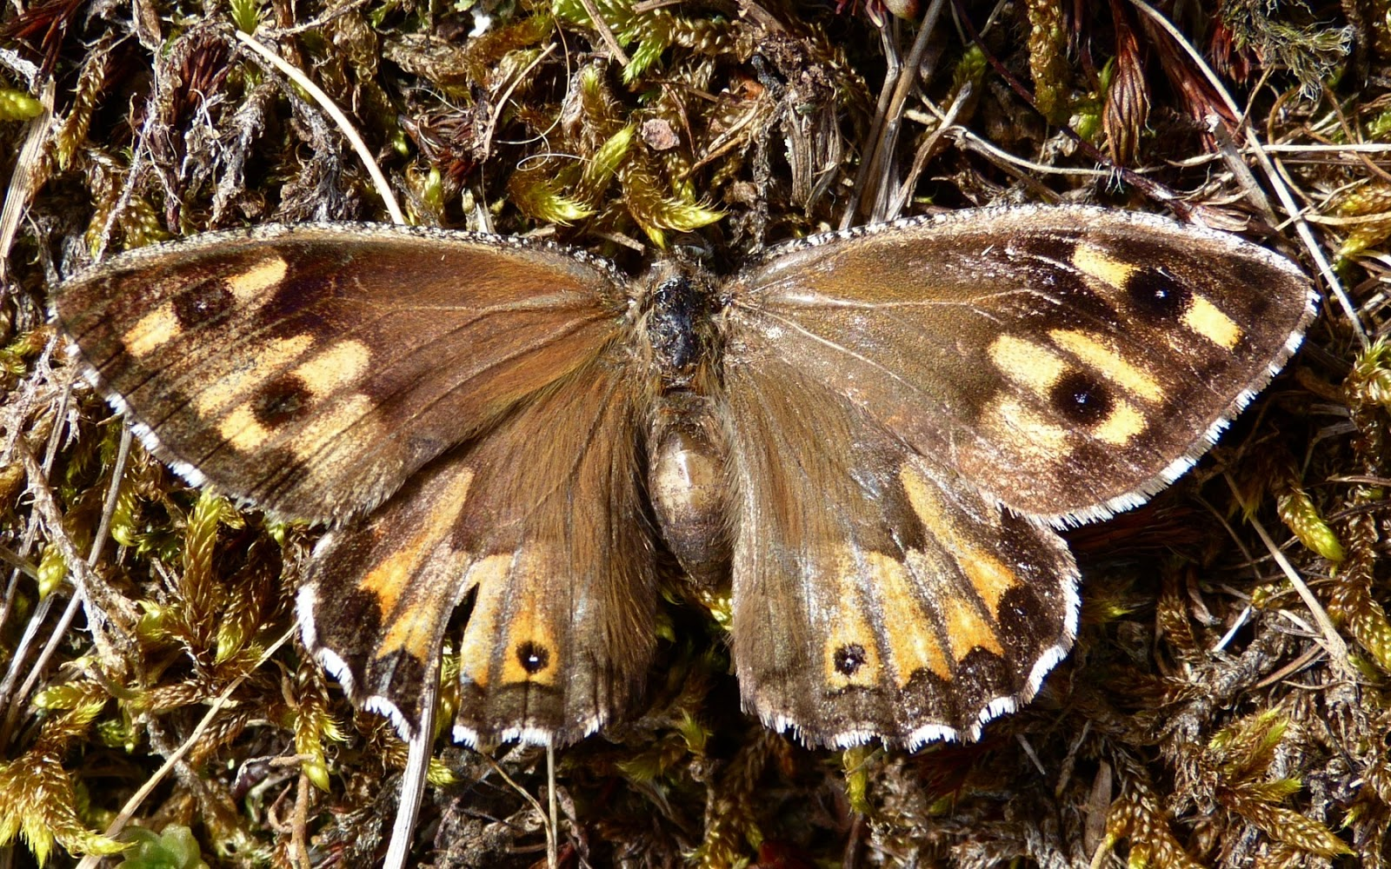

0.3 That the Prince’s flag will soon be flying again at the Bing following the ravages of recent storms; and an appropriate flag at the Town Hall - where Eric Yule has lately completed external redecoration of the northern Entrance.

Noted: 0.1 The most recent annotated feedback from Sharon Saunders to the several items on ELC’s CEO Agenda and expressed continuing gratitude for the myriad links she has engineered from Education to Estates which have enabled Trust driven initiatives to evolve well for schools and at the Town Hall.

Resolved: 0.1 That it was appropriate now to plan for the promised formal meeting with the CEO to advance a coherent and integrated approach to all that is going forward at Blindwells in the context of its role as an HES Designated Battlefield; and once Council elections are completed a meeting should we sought with the senior responsible Councillors to continue discussions that had been initiated in 2021 by Herbert Coutts and John Home-Robertson with Cllr. Norman Hampshire and by Gordon Prestoungrange with the Provost Cllr. John MacMillan.
0.2 That the overwhelmingly important issue was that there is seemingly no positive attention being given to the Battlefield Context by either Hargreaves or ELC and such as was occurring was piecemeal and only in response to Trust initiatives. Critical elements include: [i] Town centre planning to incorporate the putative world class Centre for the Battle & Jacobite Heritage; [ii] Interpretation whether by bilingual and commemorative street signage, arts works or explanatory boards. Presently, incoming residents to Prince’s Gate and Prince’s Loch might ask: What Prince and Why?
0.3 That consideration should be given to simultaneously drawing the attention of Ministers, MSPs and HES to the national planning requirement that “after development the heritage involved should be better interpreted”, accepting that as originally identified by Biddy Simpson, the County Archaeologist, there is also a need to interpret the area’s heritage in agriculture and open cast coal mining which is currently not being addressed.

Noted: 0.2 That further discussions had been initiated with James Baker and Sharon Saunders at ELC and DJ Johnston-Smith at Prestonpans Community Council to explore how the Town Hall can successfully continue as a regenerated facility for the community when the Trust eventually vacates to its putative new Centre - as addressed at Minute 7 Confirmed 0.4 above.
0.2 That ELC had been formally requested to grant an ‘option’ for a further 5 years to the Trust to hold the lease at the Town Hall i.e. to April 30th 2031, in response to queries raised by NLHF and potential donors and on the basis that until further progress emerges from BTA and Hargreaves it is not possible for the Trust to know whether the targeted date for the new Centre of 2027 will be achievable.

11. Gaelic Language Initiatives

Reported: 0.1 By Dolina Maclennan that, whilst it still remained too early to begin activities with Preston Lodge school before Autumn 2022, myriad other initiatives were emerging in line with the support the Trust is receiving from Bòrd na Gàidhlig.
0.2 That Margaret Stewart’s ticketed celebration of the Gaelic Heritage for Prestonpans is now scheduled for late summer and initiatives with Ingrid Henderson and Danny West will commence as soon as feasible at The Gothenburg or the Town Hall.
0.3 That Ann Patterson was now working with Dolina Maclennan to progress the agreed programmes.
0.4 That BBC Alba/ Gaelic in Scotland had given good coverage to the opening of the bilingual exhibition at the Town Hall.

Noted: 0.1 That Bòrd na Gàidhlig has been informed of the continuing unavoidable delays and accepted a revised end date for their project funding which is still held as Restricted Funds.

12. Recruitment and Resignation of Trustees

Reported: 0.1 That Joe Goldblatt will follow up further with Tom Brock, formerly of the Seabird Centre in North Berwick, and with Professor Susan Deacon from QMU, on his return from the USA; and in discussion with Sharon Beck, possible relevant graduates from QMU.
0.2 That Dolina Maclennan is discussing potential interest in the Trust with Ann Patterson and David Ogilvie.
0.3 That Herbert Coutts, immediately prior to his death, and Kenneth Cameron had both resigned as Trustees and OSCR and Companies House notified accordingly by the Secretary.

Agreed: 0.1 To evaluate the incoming volunteers at the Town Hall to identify individuals who may be willing and appropriate to become Trustees.

13. Any Other Business

Reported: 0.1 That the submission made to SCVO for its Charity of the Year Awards programme in respect of the Trust’s work during 2021 had not been met with acclaim!
  - That a Visitors’ Guide is being prepared for the Town Hall and the 3rd
Edition of the Scottish Diaspora Tapestry’s Official Guide has now been printed and delivered.
  - That Edinburgh Construction had approached the Trust for suggested
names for some of its residential property development in Prestonpans.
  - That an approach has been made to Edinburgh Art Centre to see
whether it might provide a suitable venue for exhibiting the Diaspora Tapestry which, once the Canadian panels are returned from PEI after their three centre exhibitions there at Kent Chatham, Guelph and Charlottetown, will be available for the foreseeable future to resume touring subject only to focused content displays in the Jubilee Room. Such exhibitions held in the UK not only ensure continuing enjoyment of the artwork but all potentially attract Exhibition Tax Credits for curating and preparatory work and afford opportunities for the sale of merchandise.
  - That the 3rd Edition of BarkerLangham’s ‘Prospectus for our Nation’
up to and including the Town Hall Museum, Jacobite Trail and Design Concept is being finalized by Martha Bryce, covering as it does all the Trust’s activities since 2006.
  - That in September 2022 cameo re-enactments and activities will be
presented in partnership with Scottish Battlefields Trust under the aegis of East Lothians Battlefields that will include a Walk of the Riggonhead Defile as presently accessible.

14. DATES OF FORTHCOMING MEETINGS & EVENTS

Confirmed: 0.1 That ZOOM sessions amongst sets of Trustees and with BTA will continue to be convened as appropriate in the coming weeks; and that the much appreciated ZOOM option alongside Trustees face-to-face sessions will continue routinely.
0.2 That the 130th Meeting of the Trustees will be held on Thursday June 9th 2022 commencing at 6pm at the Prestoungrange Gothenburg - with optional visits to the Town Hall from 4pm to see in particular the Scottish Diaspora display of ‘royalty associated’ panels to coincide with celebrations of the Platinum Jubilee of HM Queen Elizabeth I & II.
0.3 That the 131st Meeting of the Trustees will be held on Thursday August 4th 2022 commencing at 6pm.
0.4 That the 125th Anniversary Celebrations of Prestonpans Town Hall will be held over the weekend August 6th/ 7th 2022
0.5 That the 132nd Meeting of Trustees will be held on September 17th 2022 commencing at 6pm and the 277th Anniversary of the Battle commemorated September 17th/ 18th 2022.

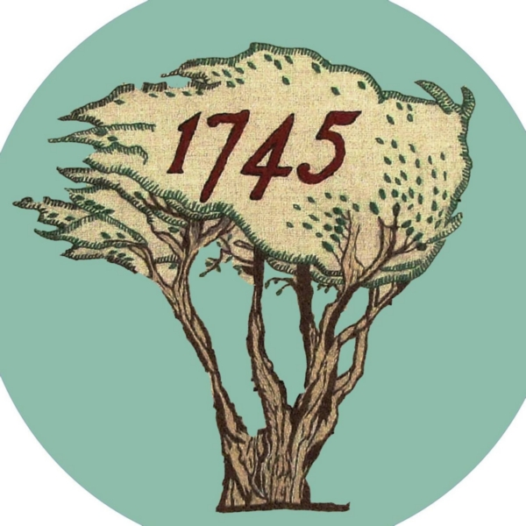
PROGRESS REPORT ANNOTATIONS: April 28th 2022
Trust’s annotations are given next to ELC’s Comprehensive Summary of the original ZOOM Meeting March 15th 2021 with their Douglas Proudfoot [DP]*, Sharon Saunders [SS] and ELC colleagues re the Trust’s AGENDA for agreed meeting with CEO Monica Patterson post pandemic
*Now designated Director Place; replaced as Head of Development by Michaela Sullivan

1 Blindwells Proposed Heritage Centre - request for Council statement of support and for Capital Budget investment: DP will consider a general statement of support for the aspiration of the Trust to create a Heritage Centre within Blindwells – Trust to clarify what is required. DP to liaise with Cllr Hampshire re consideration of future years’ ELC capital budget and determination of any support possible, sought by the Trust in the region of £1M.
April 28th: Trust still awaits final Hargreaves agreement but has shared the Draft Design Concept from Gareth Bryn-Jones. Proposal for a Joint Taskforce for the High Street has been accepted to ensure our Centre is optimally located. Bruce Tait Associates [BTA] is advancing the Scoping for the Capex Appeal and current funding search for the Interregnum in the Town Hall and Johnnie Cope’s Baggage Train.

2 NPF4 and Consideration of HES Consultation Feedback: AS [Andrew/ Andy Stewart: ELC Project Manager Development] will consider and reflect on consultation responses in the round within forthcoming report to Council re ClimatEvolution Zone et al, noting the content of both the Trust’s response and also that provided by Historic Environment Scotland. As indicated it was not possible to predetermine the outcome of the consultation exercise, including in response to the Trust’s and HES submissions, as such a decision is for the Council. It will be for the Council to determine whether to adopt the Vision and whether it should be shared with the Scottish Government. A June meeting of the Council is now targeted for a decision.
April 28th: ELC’s Draft NPF4 has been revised and lodged at ScotGov on March 31st 2022 without any of the promised further contact with the Trust; but reassurances have been given by ELC that the SEA suggestions for the initial engagement area of the battlefield objected to by the Trust and HES are under review. The Trust’s and SBT’s Comments have been tabled with the National Government and the Minister of Culture, Neil Gray MSP, re NPF4 and with Murdo Fraser MSP.

3 Leased Farm Land and Eastern Bing assistance with maintenance, footpath signage (dual language) and confirmation of National Inventory Status being formally considered at next time of offering to market: Trust to liaise direct with leasee re access to the fields. Infrastructure Services will continue with current level of assistance / support re ground maintenance. As and when signage is introduced/replaced by the Council, dual language will be applied.
April 28th: No contact has been possible re lease of Farm Land but confirmation it will remain under cultivation until alternative plans for the Cockenzie Power Station lands emerge; Meeting with Eamon John, Andrew Hogarth & Sharon Saunders at the Bing on March 16th has agreed that ELC officers will tend to the Bing vegetation and litter issues arising and subsequent meeting with Nick Morgan re Grayling Butterfly habitat which requires conservation has led to provision of on site interpretation.

4 Art work as a Condition of Planning Permission in Principle on the Blindwells developers: As advised that there is a condition on the Planning Permission in Principle for the Blindwells site that indicated artworks are to be provided nearby or on the site. No detailed proposals have been put forward by Hargreaves at this stage, so as advised that the Trust may wish to approach them on the point of the statue proposals and interpretation
April 28th: The Trust has reminded Iain Slater of Condition 10 of planning permission in principle 14/00768/PPM and he has confirmed that funds are available. The passing of Herbert Coutts has triggered the strongest determination to see this matter resolved asap and a Taskforce will be established to address both design and location at Blindwells and will appropriately include consultations with the Council’s Principal Art’s Officer.

5 Street naming Protocol for Blindwells - request for the Trust to be involved and for key names to be incorporated i.e. Riggonhead Defile and Robert Anderson: DP will discuss with KD.
April 28th: Hargreaves has confirmed their support for the Trust’s wishes and responsible officers at ELC are still addressing the issues. No street names yet seemingly issued. GLIA Plan proposes taking advantage of opportunities for bilingual signage when contractors are undertaking development.

6 Lease Prestonpans Town Hall for 5 years:
April 28th: Prestonpans CC and Heritage Network collaborations [Emma Brown] ongoing with support grants of £5,000 [PSG] and £1,750 [Salt of the Earth] gratefully received for 2021/ 2022. Museum exhibition formally opening to public at weekends from April 30th/ May 1st. Educational visits as required throughout the year on weekdays with CPD sessions for teaching staffs. Collaboration agreed with Head of Education Nicola McDowell to optimise school engagement co-ordinated by Ann Robertson. 125th Anniversary Celebrations on August 6/7th 2022. Bilingual street signage for the Town Hall has been requested via James Baker indicating Town Hall/ Battle & Jacobite Heritage Museum.

7 Gaelic Language initiatives in support of East Lothian Gaelic Language Plan: Trust to progress ongoing engagement with Council services e.g. Museums Service, Connected Communities Service and Education Service et al re promotion of community events, exhibitions and learning initiatives in support of the objectives of ELC’s Gaelic Language Plan 2021/2025.
April 28th: Dolina Maclennan meetings held with Ann Robertson [ELC/ Midlothian/ Borders] and Ann Paterson [Edinburgh] with Primary 2 learning resource development for the battle. Bòrd na Gàidhlig cultural initiatives although delayed remain scheduled. ELC has an internal group overseeing the Gaelic Language Plan and taking stock of implementation for submission of ELC’s progress monitoring report to the Bòrd. The Trust’s public comments and actions in support of the implementation of the Plan are much appreciated. Bilingual signage has been installed on the exterior of the Town Hall and both Town Hall and John Gray exhibitions offer bilingual interpretation as will all museum exhibitions from 2022.

________________________
S Saunders: Head of Communities, Directorate Place [March 15th 2021]

