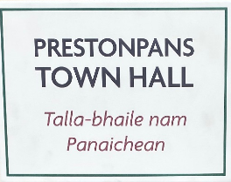

MINUTES OF 128th MEETING OF TRUSTEES OF BATTLE OF PRESTONPANS
[1745] HERITAGE TRUST HELD AT THE ABOVE ON MARCH 17th 2022

PRESENT:
Herbert Coutts [in the Chair]
Sharon Beck
Tom Brock*
Gareth Bryn-Jones
Sylvia Burgess
Sharon Dabell [z]
Joe Goldblatt [z]
John Home-Robertson [p/t]
Arran Johnston
Dolina Maclennan [p/t]
Gordon Prestoungrange
Michael Taylor [z]
Avril Wills
APOLOGIES:
Kenneth Cameron
Brett Fletcher
Pauline Jaffray
Pat O’Brien

*The Chairman welcomed Tom Brock as a visitor at Joe Goldblatt’s invitation.

1. MINUTES of 127/22 eMeeting of the Trustees held by ZOOM on January 13th 2022 which had been circulated by the Secretary were proposed by John Home-Robertson, seconded by Arran Johnston and confirmed to be a correct written record subject to the following:

Agreed: 0.1 That the phrase Athbhliain faoi mhaise ! … agus .. Bliain Nua Rathúil! was surely Irish and should be deleted from Minute 2. Confirmed 0.3.

Reaffirmed: 0.1 That the Draft Observations on slavery now prepared and tabled by Martha Bryce under Minute 11 Agreed 0.3 were not for publication but to be held ready as a considered response should occasion so require including the Trust’s view of the involvement of the Du Teillay in the slave trade.

2. Our Gaelic Moments ….

Re-confirmed 0.1 Aon / Dha / Tri / Ceithir / Coig / Sia / Seachd / Ochd / Naoidh / Deich… .... agus … oidhche mhath … 1-10 …. and Good night!
0.2 Good evening! Feasgar mhath! Good [Big] health! Slàinte mhòr!

Introduced: 0.1 Good morning friends! Maduinn mhath a chairdean!

Confirmed: 0.3 By Dolina Maclennan, that BBC Scotland’s Gaelic Channel wished to present the Opening of the bilingually interpreted exhibition at the Town Hall and it would present a good opportunity to highlight ELC’s 5 Year GLIA Plan and the Trust’s own activities.

3. Phygital Activities and Events Programme 2022/ 2024

Reaffirmed: 0.1 That the campaign to recruit and induct Volunteers & Guides supported by VisitScotland and NLHF in 2021 will be continuing.
0.2 That a Spring Series of webinars will be offered.
0.3 That with support from PSG Heritage Network and Salt of the Earth the community research to honour the 125th Anniversary of the Town Hall’s Opening will continue through to Jubilee Celebration Weekend August 6th/7th .
0.4 That school visits would be continuing, provided on demand with proactive preparations planned for 2022 and beyond in partnership with ELC including an Open Briefing for Teachers during May as soon as the major Town Hall Exhibition opens to make ready for autumn visits.
0.5 That the Salt of the Earth exhibition focused on the Prestonpans Co-operative is taking place currently in the Jubilee Room to be followed in June by the Royal Diaspora Connections tapestry selection.
0.6 That the launch 10 metre selection of Prestonpans Tapestry will be entitled “I am Come Home!”
0.7 That the Opening schedule will shortly be circulated and suggestions for invitees to either the Friday 29th evening ‘soft’ occasion or during the weekend should be sent to Arran Johnston as soon as possible.

Agreed: 01. That the Educational Programme was one of the highest priorities throughout the Interregnum and beyond and that every effort should be made to add the Trust to the venues that enable schools to claim HES’s £250 bus allowance.

Confirmed: 0.1 That Martha Bryce was planning PR and social media coverage for the Opening and would liaise with BBC Gaelic as well as other media.

4. Website development, mastering, social media, archives and APPs

Reported: 0.1 That the arrangements for access to the Trust archive since
2006 have yet to be resolved and there is a requirement for sustained, timeous postings to the website alongside the already very successful populating at the Trust’s Facebook page.
0.2 That social media activities and campaigning have been effectively
contracted to Soundbite PR for support. with immensely impressive outcomes as reported in to EventScotland and NLHF and included in fresh applications.
0.3 That following meetings with ATOM Engine, original providers of the three APP which now all require system and content updates and alternative suppliers, it has been agreed that Technovisual should take on responsibility for transferring all APPs as agreed to Wordpress and that this is now proceeding at a budgeted cost of £6000.
0.4 That details for inclusion in the updates had now been received from the 1722 Waggonway Heritage Group but those from the battlefield and Town Hall awaited finalisation by end April.
0.5 That East Lothian Life has agreed to take a 4pp feature article of the Town Hall’s 125th Anniversary and the Trust’s Museum and activities therefrom for its Autumn 2022 edition, deadline July 18th.

Confirmed: 0.1 That a proactive campaign to develop and then promote the bundle of benefits to build membership for the Friends of the Bonnie Prince is needed, building on the base so far achieved and that a core level annual subscription of £30 be introduced as soon as feasible.
0.2 That MODES Compact Edition Collection Management software is now being deployed to hold records of the Trust’s assets in that nationally recognized format; and that access to ELC’s Battle and Jacobite Collection [which uses similar software] has been confirmed following a visit to the Town Hall by ELC’s Collections Officer.

5. Jacobite Scotland – Alba Seumasach - THE TRAIL[S]

Reported: 0.1 That the 2nd Colloquium at the National Story Telling Centre on March 3rd had reviewed and endorsed the design and development of the Jacobite Scotland website which Mike Taylor was continuing to populate and in which the Trust had now invested approaching £10,000 since 2018.

Agreed: 0.1 That as intended from the outset a broadly based group of representatives from venues across the nation would be invited to share in its future management and development.
0.2 That the Trust intended to continue formal ownership of the website and to
provide the legal framework for its conduct and accounting but would invite
benefiting venues to share in the costs of its continuing management, with an
initial contributing level of £100pa suggested and agreed at the Colloquium.
0.3 That the initiative had led to the realisation that there was very considerable benefit in fostering a ‘community’ of Jacobite heritage venues, sharing experiences, cross marketing offers and highlighting/ supporting particularly significant Jacobite events/ exhibitions at the website.
0.4 That adopting the Jacobite Heritage Centre theme in Prestonpans has made the Trust a suitable anchor in the initiative and options for seeking VisitScotland support will be followed through as may prove feasible.

6. Funding the Interregnum

Reported: 0.1 That following the failure of Application NM-21-00353 to NLHF consultations with and a debriefing from its Investment Manager David Clelland had led to the Trust tabling a follow up Application seeking support from May 1st 2022/ November 30th 2024; it focusses on Greater Engagement/ Understanding/ Skilled Commitment with an ever wider community. Particular emphasis was given to the proposed intergenerational visitor programme beginning with school visits and teacher CPD which have the strong support of East Lothian Council’s Head of Education Nicola McDowell; EducationScotland is also expected to be ready to share details since the programme directly pursues several aspects of the Curriculum for Excellence.
0.2 That this second Application to NLHF is the only source of funding for the Interregnum thus far sought although eligibility for HMRC Museum Exhibition Tax Credits is being explored and all visitors to the Museum will be greatly encouraged to make donations.
0.3. That it is not intended at the outset to charge for entry to the Museum except for ticketed events and special escorted visits although this pattern will necessarily be kept under review.
0.4 That best current estimates of net shortfall on ‘normal’ utilities/ caretaking expenses at the Town Hall and at the Johnnie Cope Baggage Train will be £70,000pa.
0.5 That the remaining balances on proforma expenditure estimates at December 31st 2021 had all now been deployed to defray completion expenses at the Town Hall and Contractors fees to March 31st .

Agreed: 0.1 That it was necessary and appropriate pro tem to borrow from Restricted Funds to meet ongoing trading and marketing expenses until such time as greatly enhanced Interregnum funding initiatives succeed.
0.2 That this was a matter of most considerable urgency since Restricted Funds borrowed for such ends must necessarily be repaid either by new donations and/or such attributable Exhibition Tax Credits as may be received. [Noted that most grants the Trust might in future receive will normally be hypothecated to future activities rather than available to repay any such borrowings.]

7. Blindwells Living History Centre Concept Design & Statue

Reported: 0.1 That Gareth Bryn-Jones initial draft Concept Design for the Centre had been approved via ZOOM by the Trustees and formally shared with Iain Slater at Hargreaves.
0.2 That a ZOOM discussion with Iain Slater on even date had brought assurances that Hargreaves were now ready to formalise the Trust’s option on the red marked site at Blindwells.
0.3 That the ZOOM discussion had made it clear that a Joint Working Group on the planning of the High Street at Blindwells was vital to ensure the facility to be created would be seen and enjoyed as a significant national destination that can operate on a self-sustaining trading basis.

Agreed: 0.1 That Gordon Prestoungrange should write immediately to Iain Slater setting out the Trust’s views and interests if it is to proceed at Blindwells.
0.2 That Martha Bryce be invited to propose how presentation of the Design Concept in the public domain might be well managed in due course.

Confirmed: 0.1 That Herbert Coutts would continue to explore with Hargreaves and ELC’s Arts Officers how the % for the Arts might be used to advance the project for the Prince’s statue; and its suitable location.

8. Capex Funding Action Lines to 2027

Reported: 0.1 That three consultants had been invited to submit proposals to work with the Trust and following ZOOM and face-to-face meetings Bruce Tait Associates had been invited to submit its formal proposal to initiate Action Lines over an initial 100 days project costed at £40,000 + VAT.
0.2 That advices from all three had been consistent that [i] the Town Hall must be seen as a transitional showcase for the Trust’s competences and [ii] that no capex campaign should be publicly launched until a Scoping Review of all possible funders had been undertaken.

Noted: 0.1 That Bruce Tait Associates proposed to meet the two above criteria by [a] prioritising the funding of the Interregnum as was clearly required under Minute 6 above; [b] additionally seeking to replenish the Restricted Funds to be deployed of £48,000; and [c] conducting the Scoping Review.
0.2 That the outcome of the Scoping Review would resolve whether or not the Trust’s ambition for a world class self-sustaining Centre was an achievable goal and the conclusions arrived at would determine the Trust’s next steps which, if the Review was favourable would potentially see all Restricted Funds invested as Starter Funding.

Received: 0.1 The Treasurer’s Recommendation to invite Bruce Tait Associates to proceed immediately using Restricted Funds.

Agreed: 8.1 To delay commissioning support from Bruce Tait Associates until all Trustees who had perforce left early or were not able to attend had the further opportunity to express their views on the Recommendation - which should be solicited at pace.
8.2 Further, that such delay should remain in place until a legally binding agreement had been concluded with Hargreaves for the Trust’s option on the site including its landscape/ town centre context at Blindwells and the outcome of the outstanding follow on Application to NLHF is known.

Reiterated 8.1 By the Treasurer that responsible conduct of the Trust’s financial affairs requires immediate steps to seek professional support to ensure sufficient present and future funding during the Interregnum and to make preparations for the launch of the Capex Funding Campaign irrespective of the Centre’s final location or the outcome of the current NLHF Application.

9. NPF4/SEA Consultation/ ELC Conversations re CEO’s Agenda

Agreed: 0.1 The formal response to the nationwide Consultation on NPF4 tabled commending the strategies for green lungs; and that it be now submitted to the March 31st deadline.

Confirmed: 0.1 That no further developments have been reported on the redrafting of the specific SEA proposals by ELC to which the Trust and HES had objected in respect of their impacts especially on the privately owned area of the eastern battlefield.

Reported: 0.1 That Sharon Saunders had arranged a field visit at the Battle Bing for Gordon Prestoungrange with Eamon John on March 16th which had led to agreement that ELC’s staff would ensure the Bing area was kept free of litter and vegetation tidied as required with that support led by Andrew Hogarth.
0.2 That during the visit attention was drawn to the unique habitat it provided for the Grayling butterfly, a priority protected species, and that contact would shortly be made with Nick Morgan, Countryside Access Officer and biodiversity ELC colleagues.

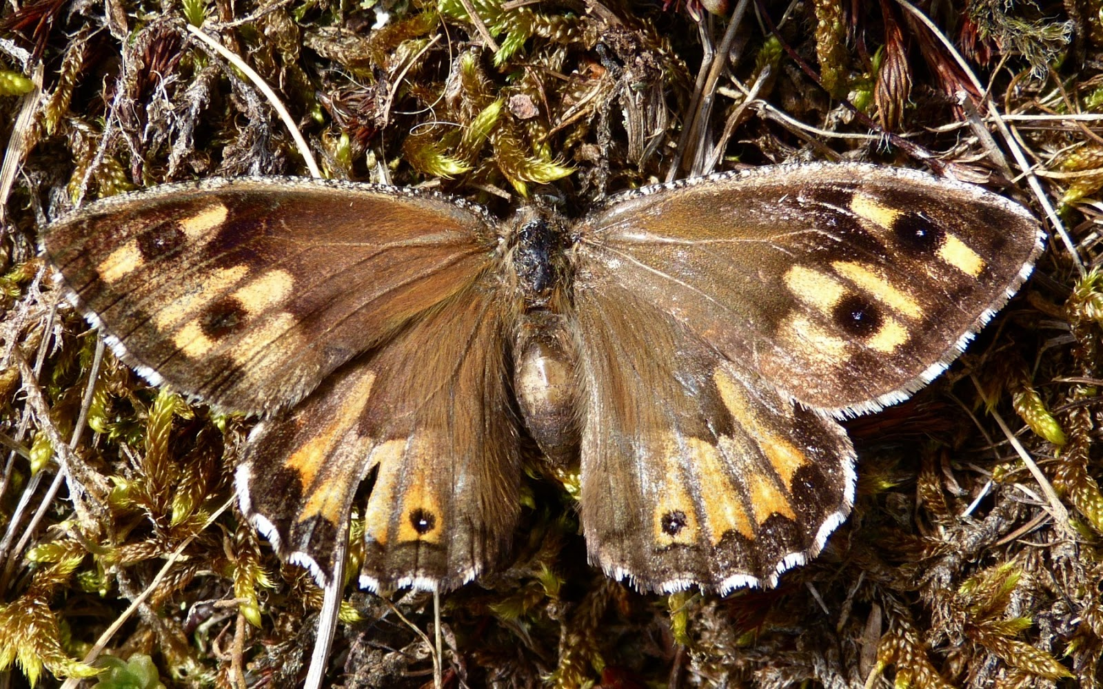

0.3 That the Prince’s flag would be flying once again at the Bing following the ravages of recent storms.
0.4 That Ann Robertson was ready to convene formal Briefings for ELC teachers at the Town Hall from May once the museum was open in order to take school bookings for the autumn and beyond.

10. Gaelic Language Initiatives

Reported: 0.1 By Dolina MacLennan that, whilst it still remained too early to begin activities with Preston Lodge school, myriad other initiatives were developing in line with the support the Trust is receiving from Bòrd na Gàidhlig.
0.2 That Margaret Stewart’s ticketed celebration of the Gaelic Heritage for Prestonpans has been postponed until Spring 2022.
0.3 That initiatives with Ingrid Henderson and Danny West will commence as soon as feasible at The Gothenburg or the Town Hall.
0.4 That BBC Alba/ Gaelic in Scotland was seeking to cover the opening of the bilingual exhibition at the Town Hall at end April/ early May and Dolina Maclennan would act as liaison for this with Martha Bryce.

Noted: 0.1 That Bòrd na Gàidhlig has been informed of these unavoidable delays and accepted a revised end date for their project funding of May 31st 2022 which is still held as Restricted Funds.

Reaffirmed: 0.1 That Ann Robertson from the Lothians and Borders is meeting shortly with Dolina Maclennan and taking forward under ELC’s GLIA Plan the development of a Battle of Prestonpans Gaelic learning resource for 2nd Level Primary learners which builds on ELC’s previous Gaelic development for primary schools and she is exploring piloting options e.g. Preston Tower Primary/ St Gabriels’ Primary; further developments might include a ‘guide project of the battlefield site’ with the learners themselves leading tours as Junior Guides for their families/community partners as has been pioneered in Edinburgh with Ann Patterson.

11. Recruitment of Additional Trustees

Welcomed: 0.1 Tom Brock, formerly of the Seabird Centre in North Berwick and Professor Susan Deacon from QMU, to tours and briefings at the Town Hall at the invitation of Joe Goldblatt who will follow through with them during his stay in the USA and on return therefrom.

Suggested: 0.1 That an invitation be extended to Ann Paterson to see whether she might be interested in the work of the Trust especially the use of the Gaelic, and that Dolina Maclennan should make the approach.
0.2 That David Olgivie should be invited to a briefing on the work of the Trust and that Dolina Maclennan would explore whether he might be interested.
0.3 That the Trust might consider advertising for Trustees focused on missing skills sets amongst Trustees.

12. Any Other Business

Reported: 0.1 That Marks & Spencer had lately resolved to sell their closed premises at the Mercat Centre at Kirkcaldy so it would not now be possible to exhibit portions of the Scottish Diaspora Tapestry there in 2022 as planned.

  - That a submission had been made to SCVO for its Charity of the Year
Awards programme in respect of the Trust’s work during 2021.
  - That the loan of a mortar attributed to the 1745 Campaign has been
received with thanks from Kedleston Hall in Derbyshire, following the much appreciated earlier gift of the Prince Charles’ mannequin by Derby Museum remaindered from its Exeter Room now permanently on display in the Town Hall.
  - That a Visitors Guide was being prepared for the Town Hall and the 3rd
Edition of the Scottish Diaspora Tapestry’s Official Guide would be printed during the Spring.

13. DATES OF FORTHCOMING MEETINGS & EVENTS

Confirmed: 0.1 That ZOOM sessions amongst sets of Trustees will continue to be convened as appropriate in the coming weeks; and that the much appreciated ZOOM option alongside Trustees face-to-face meetings will be continued.
0.2 That the 129th Meeting of the Trustees will be held on Thursday April 28th 2022 commencing at 6pm at the Prestoungrange Gothenburg - with optional visits to the Town Hall from 4pm.
0.3 That the Grand Opening of the Battle of Prestonpans Jacobite Heritage Centre will take place Saturday/ Sunday April 30th/ May 1st 2022 with a ‘soft’ Opening on the previous evening April 29th – details to follow.
0.4 That the 130th Meeting of the Trustees will be held on Thursday June 9th 2022 commencing at 6pm – with optional visits to the Town Hall from 4pm.
0.5 That the 131st Meeting of the Trustees will be held on Thursday August 4th 2022 commencing at 6pm.
0.6 That the 125th Anniversary Celebrations of Prestonpans Town Hall will be held over the weekend August 6th/ 7th 2022

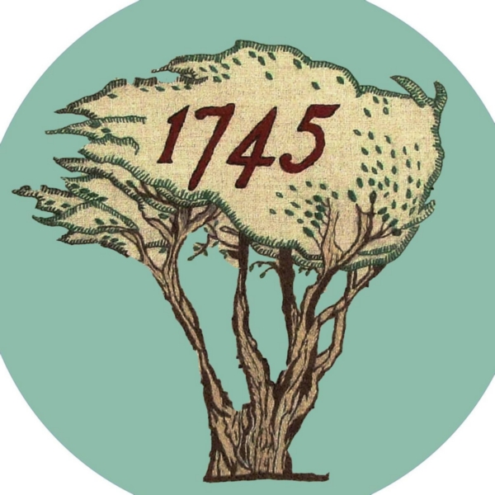
PROGRESS REPORT ANNOTATIONS: March 17th 2022
Trust’s annotations are given next to ELC’s Comprehensive Summary of the original ZOOM Meeting March 15th 2021 with their Douglas Proudfoot [DP]*, Sharon Saunders [SS] and ELC colleagues re the Trust’s AGENDA for agreed meeting with CEO Monica Patterson post pandemic
*Now designated Director Place; replaced as Head of Development by Michaela Sullivan

1 Blindwells Proposed Heritage Centre - request for Council statement of support and for Capital Budget investment: DP will consider a general statement of support for the aspiration of the Trust to create a Heritage Centre within Blindwells – Trust to clarify what is required. DP to liaise with Cllr Hampshire re consideration of future years’ ELC capital budget and determination of any support possible, sought by the Trust in the region of £1M.
March 17th: Trust still awaits final Hargreaves agreement but has shared the Draft Design Concept from Gareth Bryn-Jones. Request for a Joint Taskforce for the High Street has been tabled to ensure our Centre is optimal. Bruce Tait Associates has been commissioned to advance Scoping for the Capex Appeal and funding search for the Interregnum in the Town Hall.

2 NPF4 and Consideration of HES Consultation Feedback: AS [Andrew/ Andy Stewart: ELC Project Manager Development] will consider and reflect on consultation responses in the round within forthcoming report to Council re ClimatEvolution Zone et al, noting the content of both the Trust’s response and also that provided by Historic Environment Scotland. As indicated it was not possible to predetermine the outcome of the consultation exercise, including in response to the Trust’s and HES submissions, as such a decision is for the Council. It will be for the Council to determine whether to adopt the Vision and whether it should be shared with the Scottish Government. A June meeting of the Council is now targeted for a decision.
March 17th: ELC’s Draft NPF4/ SEA has still not yet been tabled by planners with full Council. Comments have been tabled with the National Government and the Minister of Culture, Neil Gray MSP and Murdo Fraser MSP.

3 Leased Farm Land and Eastern Bing assistance with maintenance, footpath signage (dual language) and confirmation of National Inventory Status being formally considered at next time of offering to market: Trust to liaise direct with leasee re access to the fields. Infrastructure Services will continue with current level of assistance / support re ground maintenance. As and when signage is introduced/replaced by the Council, dual language will be applied.
March 17th: No contact has been possible re lease of Farm Land; Meeting with Eamon John, Andrew Hogarth & Sharon Saunders at the Bing on March 16th has agreed that ELC officers will tend to the Bing vegetation and litter issues arising. Notification to follow through with Nick Morgan of Grayling Butterfly colony that requires conservation. Further meeting scheduled.

4 Art work as a Condition of Planning Permission in Principle on the Blindwells developers: As advised that there is a condition on the Planning Permission in Principle for the Blindwells site that indicated artworks are to be provided nearby or on the site. No detailed proposals have been put forward by Hargreaves at this stage, so AS advised that the Trust may wish to approach them on the point of the statue proposals and interpretation

March 17th: The Trust has reminded Iain Slater of Condition 10 of planning permission in principle 14/00768/PPM and he confirmed that funds are available. Herbert Coutts has withdrawn from the Trust effective March 23rd so alternative arrangements will be required
including consultations with the Council’s Principal Art’s Officer before reaching a decision.

5 Street naming Protocol for Blindwells - request for the Trust to be involved and for key names to be incorporated i.e. Riggonhead Defile and Robert Anderson: DP will discuss with KD.
March 17th: No response yet formally received but details resent on request to Andy Stewart and to Prestonpans Community Council incoming Chairman with whom a meeting was held in January 2022. No street names yet issued. GLIA Plan requires bilingual new signages with Gaelic.

6 Lease Prestonpans Town Hall for 5 years: March 17th: Prestonpans CC and Heritage Network collaborations [Emma Brown] ongoing with support grants of £5,000 [PSG] and £1,750 [Salt of the Earth] gratefully received for 2021/ 2022. Formal big exhibition opening from April 30th/ May 1st at weekends. Educational visits as required throughout the year and collaboration agreed with Head of Education Nicola McDowell to optimise school engagement co-ordinated by Ann Robertson. 125th Anniversary Celebrations on August 6/7th 2022. Street signage has been requested but not achieved yet to match recent new indicating Town Hall/ Battle & Jacobite Heritage Museum.

7 Gaelic Language initiatives in support of East Lothian Gaelic Language Plan: Trust to progress ongoing engagement with Council services e.g. Museums Service, Connected Communities Service and Education Service et al re promotion of community events, exhibitions and learning initiatives in support of the objectives of ELC’s Gaelic Language Plan 2021/2025.
March 17th: Dolina Maclennan meetings held with Ann Robertson [ELC/ Midlothian/ Borders] and Ann Paterson [Edinburgh] with Primary 2 learning resource development for the battle. Bòrd na Gàidhlig cultural initiatives are now scheduled. ELC has an internal group overseeing the Gaelic Language Plan and taking stock of implementation for submission of ELC’s progress monitoring report to the Bòrd. The Trust’s public comments and actions in support of the implementation of the Plan are much appreciated. Bilingual signage has been installed on the exterior of the Town Hall and both Town Hall and John Gray exhibitions offer bilingual interpretation as will the museum exhibitions from 2022.

________________________
S Saunders: Head of Communities, Directorate Place [March 15th 2021]

