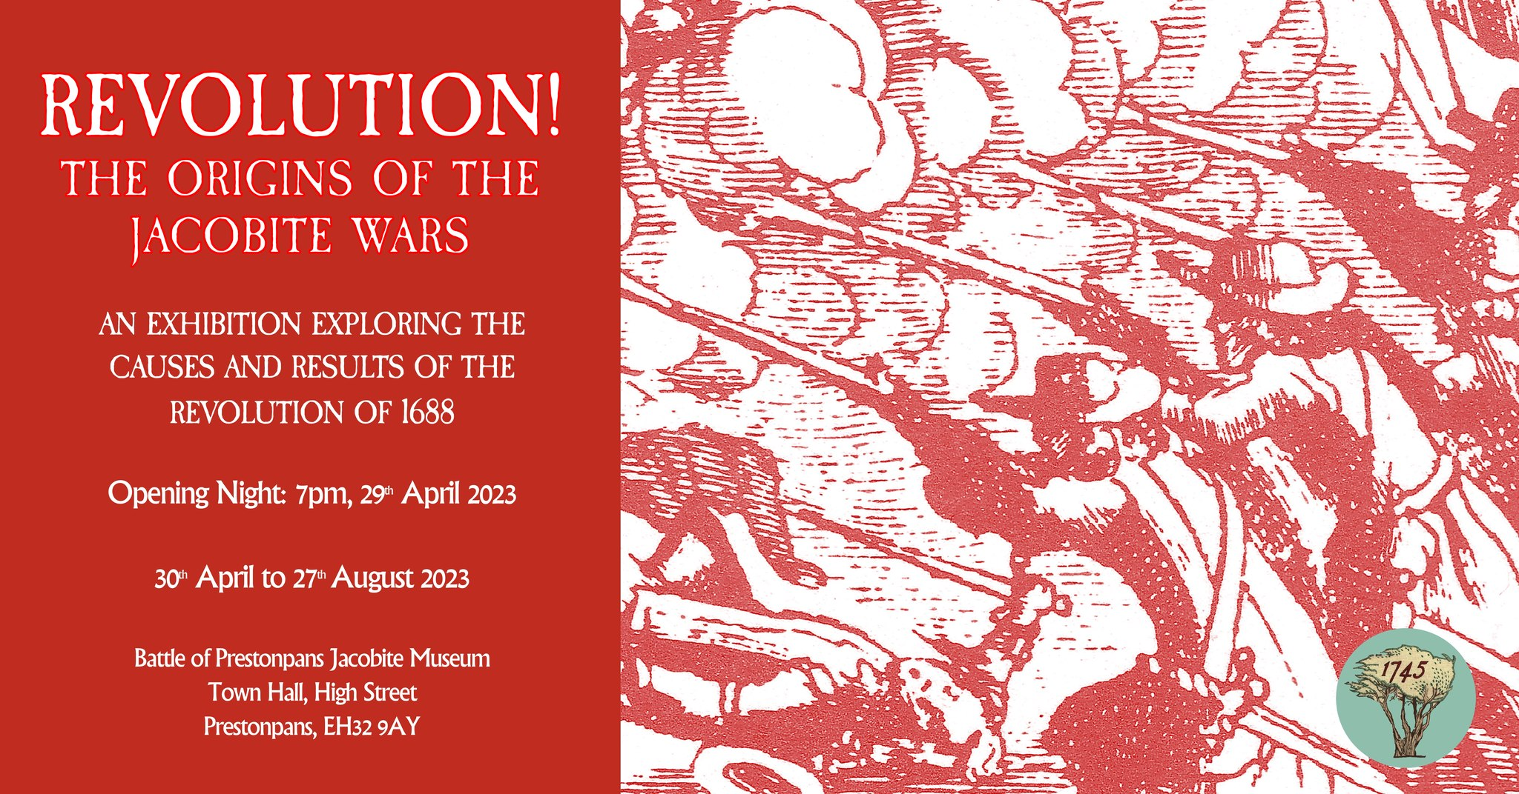

MINUTES OF 136th MEETING OF TRUSTEES OF BATTLE OF PRESTONPANS [1745] HERITAGE TRUST HELD IN THE COURT ROOM AT THE
s PRESTOUNGRANBGE GOTHENBURG ON APRIL 27th 2023

PRESENT:
Joe Goldblatt [in the Chair]
Sylvia Burgess [z]
Arran Johnston
Gordon Prestoungrange
Mike Taylor [z]
Avril Wills
APOLOGIES
Gareth Bryn-Jones
Sharon Dabell
Brett Fletcher
Pat O’Brien
David Ogilvie

1. MINUTES of 135/23 Meeting of the Trustees held in the Court Room at the Prestoungrange Gothenburg on March 16th 2023 which had been circulated by the Secretary, were proposed by Arran Johnston and seconded by Avril Wills and agreed to be a correct written record.

2. Living History Centre Workshop March 17th 2023

Reported: 0.1 That East Lothian’s county’s MSP, Paul McLennan, had convened the Workshop in the Jubilee Room to explore the next steps for the Trust’s proposals for its putative Living History Centre with the Provost Cllr. John MacMillan, Bruce Lindsay of Hargreaves/ Blindwells and Jean Scott from Queen Margaret University.

0.2 The Trust shared its present positions re the putative Centre at both Blindwells and Prestongrange Heritage Park/ Museum and sought support for the Trust’s wish to submit proposals to potential funders e.g. HES and NLHF.
0.3 That notwithstanding the Trust’s positive Economic and Tourism Feasibility Studies for the Centre, ELC’s Provost had confirmed that a broadscale analysis of ‘the economic and tourism potential of the entire area of the western approaches to Prestonpans’ was shortly to commence with external consultants; and that the ELC endorsement previously given by Cllr. Willie Innes in 2016 for the Trust to make use of the Bath House could not be considered or revived until that analysis was completed.

Agreed: 0.1 That the Trust would be invited to engage with the consultants at the earliest opportunity.
0.2 That the Trust’s preference between the two putative locations was the BathHouse at Prestongrange Heritage Park.
0.3 That the timescale implicit in the proposals now being followed by ELC meant that the Interregnum at Prestonpans Town Hall will necessarily run well beyond the initial 5 year lease; and that a formal request be tabled for the lease to be extended to 10 years with ELC in consultation with Sharon Saunders.

Thanked: 0.1 Paul McLennan MSP for convening the meeting and agreed that a follow through review should be convened in June to which the relevant planning officers for Blindwells re Arts/ Interpretation should also be invited.

3. Phygital Activities ongoing from the Town Hall

Reported: 01. That the third rotation of the Prestonpans Tapestry [#21/30], Raising the Standard at Glenfinnan, has hung since January 21st in the main Hall to be followed by the fourth rotation, Crossing the Forth [#31/40]; and that the ‘The Vikings Saga’ is being replaced in the Jubilee Room from April 30th by The Revolution of 1688 – The Origins of the Jacobite Wars.
0.2 That the What If? Hybrid War Game continues to meet its ambitious expectations with myriad creative Jacobite initiatives explored e.g. Edinburgh and Stirling castles have fallen, Tullibardine has taken Glasgow, Wade has lost at Dunbar and retreated to Newcastle where he has again been defeated. Sir John Cope has experienced another defeat at Soutra Hill in the Borders and, retreating to join Wade at Dunbar, was killed in the battle there. However Cumberland has advanced from London with mercenaries to confront the Prince south of Newcastle.
0.3 Reports of the battles and campaigns have been widely viewed in 7 Podcasts thus far, each of these attracting more than 1000 visits.
0.4 Face to face Visitor numbers since opening are to be announced at the 1st Birthday Celebrations of the Town Hall Museum on April 30th as having reached 3,150 of which 759 have come as school groups across the Lothians.
0.5 That the 360 degree Museum video tour has been created by a professional donor is now available under the ‘Museum’ selection and is particularly for use by school groups.
0.6 That the Ottawa Highland Dance Group will be giving a display in the Town Hall on August 20th when they visit Scotland and the 28 Canadian Diaspora Tapestry panels, recently returned from Ontario/ PEI, will also be on short display in the Main Hall at that time having finally been Carnet acknowledged as returned by HMRC Edinburgh.

4. Educational Programmes offered to schools and community groups

Reported: 0.1 That the programmes, with full support of ELC’s Head of Education liaising via Ann Robertson, envisage a CPD Workshop for Teachers as soon as feasible. Holiday and disadvantaged groups are also now planning further visits.
0.2 That discussions with Preston Tower Primary School have been launched to develop a ‘longterm’ history project and an application tabled for support from ELC’s Education Trust Fund.
0.3 That it remains a precondition for participation by schools that they must provide written/ digital evaluative feedback reflecting the achievement of CfE competences and skills.
0.4 That the Gaelic education resource remains in preparation with ELC’s Ann Robertson although if good progress cannot be achieved consideration will be given to the Trust creating its own, building on the lul Cuimhneachain – Blàr Sliabh a’ Chlamhain already in print with support from Beathag Mhoireasdan.
0.5 Regrettably, that tutorial and development funding for our educational programmes in 2023 cannot be wholly dependent on the modest but insufficient fees paid by each school.
0.6 That a donation has been offered to further the ‘intergenerational’ initiative to encourage student visitors to subsequently bring parents along; 100 x £10 family vouchers towards lunch afterwards at the Prestoungrange Gothenburg will be made available.
0.7 That every effort will be made to involve school visitors and their parents in the annual re-enactments certainly with wreath laying but in the full scale re-enactment in 2024 in more diverse ways.

5. Website development, social media, archives and APPs

Reported: 0.1 That the requirement to give comprehensive access to Trust’s archives since 2006 via links from the new server is still being addressed in consultation with Technovisual.
0.2 That the What If? campaign running presently is bringing repeat visits as it evolves from fresh visitors which augurs well for the Trust to achieve annual visit numbers approaching the 50,000 recorded at the height of the pandemic.

Reaffirmed: 0.1 That the robust proactive campaign to promote a bundle of benefits to develop membership for the Friends of the Bonnie Prince is still needed, building on the base so far achieved and that a core level annual subscription of £30 be introduced as soon as feasible.
0.2 That all the Trust’s digital services and their further development require the appointment of a dedicated Webmaster as soon as feasible and that it is hoped that a suitable volunteer might be able to develop that role.

6. Jacobite Scotland – Alba Seumasach - THE TRAIL[S]

Confirmed: 0.1 That Mike Taylor has still not been able to gather together nominees for the proposed shared management team but that additional venues and resources continue to be added at the website.
0.2 That it remains the case that there is very considerable benefit in fostering a ‘community’ of Jacobite heritage venues, sharing experiences, cross marketing offers and highlighting/ supporting particularly significant Jacobite events/ exhibitions at the website although the relevant link for these has yet to be activated.
0.3 That adopting the Jacobite Heritage Centre theme in Prestonpans makes the Trust a suitable anchor in the initiative and options for seeking VisitScotland support will be followed through as may prove feasible.

Agreed: 0.1 Following discussions with Mike Taylor, that a round robin Update should go now to members on the Trail inviting them inter alia to join together nationwide for a Jacobite Festival August 17th/ 25th 2024, for which EventScotland and/ or HLF support would be sought.

7. Funding the Interregnum … Budget 2023 … Reserves Policy & Risk

Reported: 0.1 That our 3rd ‘Broadened Engagement’ Application to NLHF has been tabled for support over the coming 24 months.
0.2 Museum Exhibition Tax Credits routines have now been mastered and will be of great benefit not least by giving the opportunity for support in presenting the 10th Anniversary Displays of the Scottish Diaspora Tapestry nationwide.
0.3 All visitors to the Museum are being greatly encouraged to make donations and purchase stocks of merchandise since the Trust is holding fast in its determination to make no entrance charge except for ticketed events and special escorted visits.
0.4 That our urgent request for transfer from £5,000pa to a £1 peppercorn rental at the Johnnie Cope Baggage Train from January 2023 still fails to find traction with ELC Estates and alternative low cost locations are still being sought.

Confirmed: 0.1 That our application for support to ELC’s One Council Partnership Fund during the year 2023/2024 has been successful in the sum of £27,500 with most particular requirement to develop the volunteer bases and engagement of our community.
0.2 That the application for £3,000 support from Coalfields Regeneration CIP for volunteers ‘to welcome, engage with and heighten sense of place amongst incoming residents at Blindwells’ has now seen confirmation of a 50% grant i.e £1,460 to be wholly devoted to Volunteer training.

Noted: 0.1 That sufficient Restricted Funds are available, as shown in the Annual Accounts to October 31st 2022, and underwritten by the Barons Courts Charity, to continue trading into 2023 until the outcome of the application for support to NLHF is determined but Unrestricted Funding is presently available only from donations and merchandise sales arising and the Museum Exhibition Tax Credits received.

Confirmed: 0.3 That in accord with best practice and as commended by OSCR the Trust had reviewed its ‘Risk Register’, and at this meeting approved it subject to it being kept under regular review; and had further formulated and approved details of the Trust’s ‘Reserves Policy’ as recommended by SCVO and AIM.

8. Location of Centre at Blindwells &/or Prestongrange Museum
with Blindwells Interpretation & Prince’s Statue

Confirmed: 0.1 That no progress had been made on any of these issues
and that any progress on the location of the eventual world class centre will
necessarily await the outcome of ELC’s pending Economic & Tourism
Development Consultancy being co-ordinated by Jamie Baker, Service
Manager for Economic Development.
0.2 That the issue of arts and interpretation at Blindwells was the subject
of correspondence from Paul McLennan MSP with both Hargreaves and ELC
and for discussion at the upcoming June follow through workshop.

9. ELC Conversations re CEO’s Rolling Agenda

Reported: 0.1 That Sharon Saunders had provided further annotations. 0.2 That the Prince’s flag pole at the Bing continues to pose engineering challenges following the ravages of recent storms but the Eric Yule has been asked to take it down for repair asap; the Prince’s appropriate flag now flies regularly at the Town Hall.
0.3 That priority action at Blindwells is presently seeking to ensure both proper recognition via street names with little hope they will also use the Gaelic language as well as English and the arts provision being coordinated by oobe.

Confirmed: 0.1 That the informal request tabled mid-2022 with Sharon Saunders/ ELC to grant an ‘option’ for a further 5 years to the Trust to hold the lease at the Town Hall i.e. to April 30th 2031 had been rejected by ELC Estates; and following advice, a formal application to do so will now be tabled under the Community Empowerment [Scotland] Act 2015 to that identical end.

Reported: 0.4 That discussions continue with DJ Johnston-Smith, Chair of Prestonpans Community Council which now routinely meets in the Town Hall, to explore further how the Town Hall can successfully continue as a regenerated facility for the community when the Trust eventually vacates to its putative new Centre or earlier as circumstances may require.
0.5 That a formal presentation to the Community Council of our ambition to make use of the Bath House had been given.

10. Gaelic Language Initiatives

Confirmed: 0.1 That the Souvenir Guide prepared in English by Arran Johnston as now translated into Gaelic by Beathag Mhoireasdan, Blar Sliabh a’ Chlamhain, has been published; that the 3rd Edition of Official Guide to the Scottish Diaspora Tapestry continues its use of Gaelic – Greis-bhrat Diaspora na h’Alba; and that John Unwin’s cartoon volume Blar Sliabh a’ Chlamhain, translated by the late Seonaidh A. Mac a’ Phearsain, remains in print.

Agreed: 0.1 That it was important that the momentum of the Gaelic activities of the Trust are maintained in consultation with/ supported by Bòrd na Gàidhlig and in line with ELC’s own GLIA 5 Year Plan.
0.2 That following proposals and discussions with Dr. Renate Gertz she be invited to assist the Trust on an ad hoc basis to help ensure the Trust develops its use of Gaelic in honour of the language the Highlanders spoke in 1745.
0.3 That Renate Gertz be asked to share her thoughts at the next meeting of the Trust on May 17th.

Reported: 0.1 That the Trust had received a consultancy proposal from MarcasMac an Tuairneir following discussions with Joe Goldblatt, which was much appreciated but not felt to address the particular needs of the Trust at this time.

11. Any Other Business

Confirmed: 0.1 That the ‘new’ Prince re-enactor will be introduced amongst the Alan Brecks Regiment on April 29th in a re-enactment of the Commission of Regency in Rome conducted by Jacobite King James VIII & III.

Reported: 0.1 That discussions are proceeding with John Sneddon to assess the needs for restoration of the Battle Orchard.
0.2 That Eric Yule is making long overdue repairs to the flag pole on the Battle Bing.

12. DATES OF FORTHCOMING MEETINGS

Confirmed: 0.1 That ZOOM sessions amongst sets of Trustees will continue to be convened as appropriate in the coming weeks; and that the much appreciated ZOOM option alongside Trustees face-to-face sessions will continue routinely.
0.2 That the 138th Meeting of the Trustees will be held on June 29th 2023 in parallel if possible with the follow through June Workshop to be convened by Paul McLennan MSP.
0.3 That subsequent meetings will be held on 10th August and 21st September.

