Gillian Hart reports: The 1st Arts Festival Expedition to Barga in May 2008

Meeting as we did at 3 a.m. outside The Prestoungrange Gothenburg on a warm May morning, it seemed quite ridiculous to be leaving the beautiful sunrise appearing across the Firth of Forth. A group of nine artists were on their way to Barga. Much had been said about this Tuscan hillside town following its East Lothian twinning with Prestonpans, Cockenzie and Port Seton in 2006, but no one from the group had actually visited before. So it was with great trepidation and expectation that we set off to Prestwick airport worrying [i] whether we would all get along; [ii] whether we would indeed get there, and [iii] whether we were over the luggage weight limited because of our painting materials.

We needn’t have worried. After a perfect flight, we arrived in Pisa and were welcomed by our pre-booked transport to take us to Barga. The drive to our hotel, The Alpino, was beautiful, if not a little hair-raising on the sharp corners and sharper drops. Once settled in The Alpino it was time to explore. We were centrally based and therefore it was easy to get around and investigate without getting too lost.

Medieval Walled City: Barga is a medieval walled city with beautiful scenery. It is situated in the valley of the river Serchio on the edge of the Garfagnana Region and is well known for is historic monuments and artistic richness. It is divided up into two distinct areas - Barga Vecchia (the old town) and Barga Giardino (the new town). Barga Vecchia with its medieval wall, is a network of narrow climbing streets with numerous restaurants, shops and galleries. At the top of the climb is the Duomo (cathedral) build between the 11th and 16th centuries, and is the main example of Romanesque art in the Serchio Valley. It is positioned on the crown of the hill around which the whole town clusters. At the front there is a terrace that gives an almost unbroken 360 degree view of the surrounding hills and valleys. The view from the Cathedral is unrivalled. The red rooftops, the lush farmland surrounded by the Apuan Alps make it a popular place to paint.

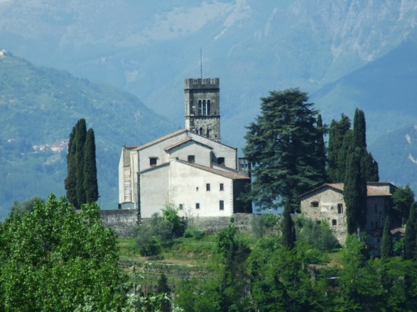

Barga Vecchia is where you can find the Tourist Office whose staff converse in good English about their town, what to see and do plus details on public transport to be enable us to explore the surrounding villages.

Barga is said to be the most Scottish-Italian town and this is immediately apparent when you explore the town. The warmth and generosity of the local people is unsurpassed. After a few days, it truly felt like home.

There are several places around town to enjoy a rest and just to watch the world go by. The favourites of our group included Vanda’s La Gelateria which serves probably the best homemade ice creams we’d ever tasted, L’Osteria restaurant frequented by locals and visitors alike serving excellent food in a wonderful atmosphere, and Aristos - one of the focal meeting places known for its impromptu music sessions. Hanging in the bar is a battered old guitar that has constantly been used by anyone who so wishes to play music outside in Piazza del Commune

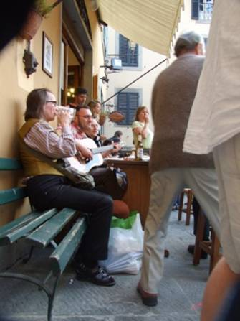

Locals and tourists come along and join in the music whether it be singing, playing or dancing around. On some nights the square would be full of music. So we were fortunate enough to have a brilliant jazz guitarist (George Pitbladdo) in our group who was able to strum a few good tunes. The other fortunate meeting was with Hamish Moore, a skilled Scottish piper and pipe maker, who was working in Barga as artist-in-residence [pictured below]. We spent many an hour listening to Hamish, his friend Ken Campbell and our George jamming throughout our stay. Another fellow traveller, Martine Robertson, who is a member of Sangstream, was often persuaded to sing some beautiful Scottish Traditional songs.

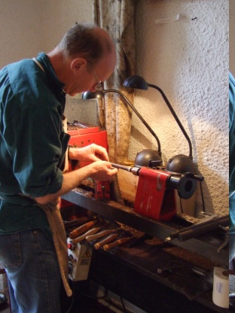

There always seems to be something happening in Barga, whether it be a new exhibition opening, a concert or religious festival.

One sunny morning whilst out for a stroll a couple of the group came across a new shop being opened. The opening was blessed by the local priest and was officially opened with much pomp and ceremony by the Mayor of Barga, Umberto Sereni. We were introduced to Umberto by one of our ‘new’ friends, and when he found out that we were part of a group from Prestonpans, he immediately invited us all out for lunch. We spent a lovely afternoon with him and we were honoured to each be presented with a beautiful book about Barga.

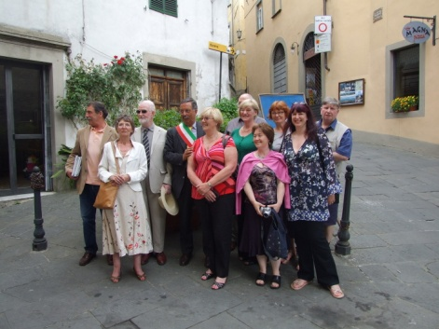

Why Were We There? The main purpose of our visit was to explore our creative personalities through drawing and painting, photography and literature. Because many people come to paint in Barga you felt at ease just sitting on a bench with a drawing pad and pencil and sketching away. Not only are the views exceptional, but the intricate architectural features were also a favourite to draw. So welcoming were the locals that we were also invited into their gardens to paint. On our return to Scotland we proudly exhibited the work produced at an exhibited in Prestonpans Community Centre during the 3 Harbours Arts Festival in June 2008.

So impressed were the group by their myriad experiences in Barga that many arranged to return later in the year. And because of the music connection forged a concert of Scottish Traditional Music was arranged on 24 September at the Teatro dei Differenti there in Barga. The concert featured Hamish Moore, Mairi Campbell and Dave Francis, Sangstream, Ken Campbell and Prestonpans very own George Pitbladdo, to name just a few.

