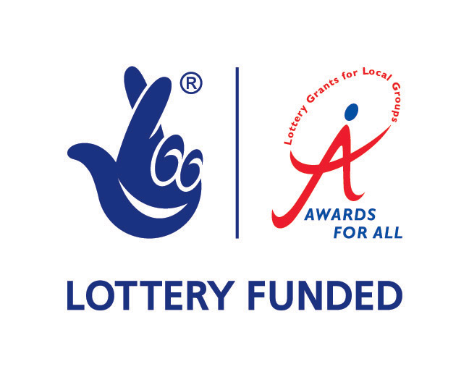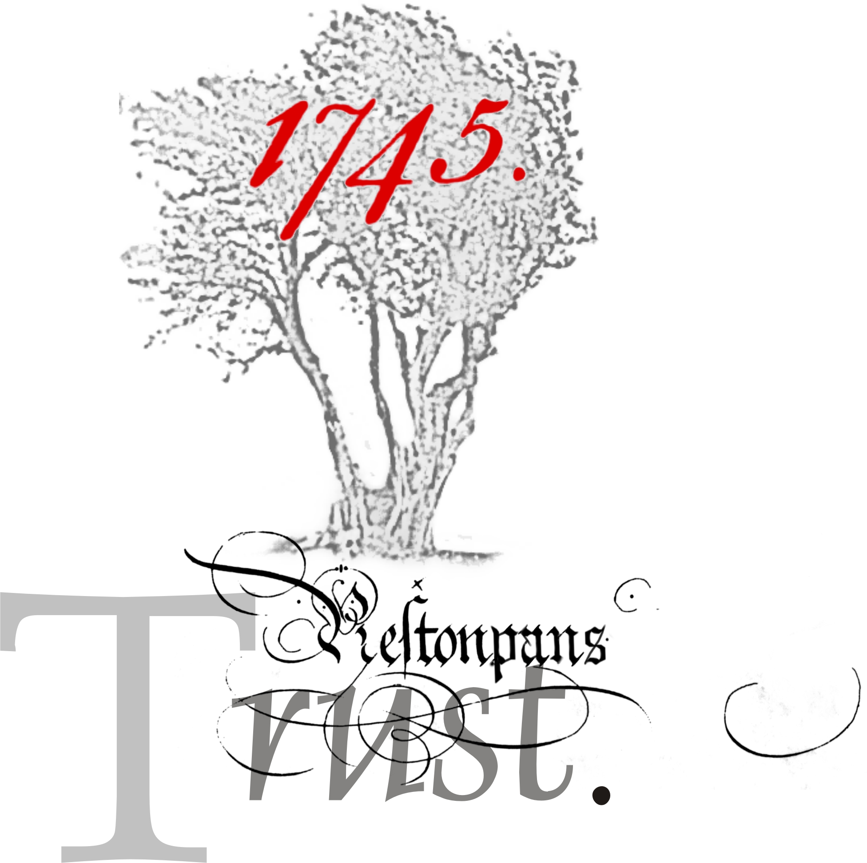

BATTLE OF PRESTONPANS SCHOOLS’ VISITS

- Storytelling
- Battle Gaming
- Weapons Demonstrations
- Literature and DVD film material
- Mobile Exhibition Unit

Until the autumn of 2010 schools in East Lothian will have the unique opportunity to receive free visits by professional storytellers and other experts who can vividly bring to life the 1745 Jacobite rising.

The specially developed material will focus on the Battle of Prestonpans and its important role in the conflict, but will also provide an overall understanding of the uprising and its aftermath.

Organised by the Battle of Prestonpans Heritage Trust, with funding from the National Lottery Awards for All programme, these visits are designed to teach children in the East Lothian area about the significance of the battlefield which lies right on their doorstep.

The aim is very much to bring the battle and the Jacobite rising to life for the children and to make the visits relevant within the Curriculum for Excellence ethos.

It is anticipated that the subject matter will be of greatest interest to P6-S1 classes which is when the Jacobite rising is most often covered.

The various components of the visits can however be tailored to different age-groups. Storytelling, in particular, can be made relevant to any stage – from nursery to S6 - and our storytellers are experienced with audiences of all ages.

The following provides a brief outline of each component of the programme. We want to be as flexible as possible in providing a tailored service to each school, depending on the ages and number of children involved and the teachers’ own priorities.

Storytelling

Sessions will be coordinated by the current recipient of the Battle of Prestonpans Storytelling Fellowship, Greg Dawson Allen. Greg has over 18 years’ experience in storytelling and is a particular expert on the Jacobite era. He will lead most of the sessions personally, dressed in traditional Highland
plaids, and will use a wealth of anecdotes and tales to bring the subject matter to life.

Greg is also able to incorporate traditional songs of the period, encouraging audience participation.

For P1 and P2, the maximum is 30 children per session which will last for around 1 hour. For older children the maximum is 50, although around 30 is preferable.
http://www.telliesperie.co.uk/

Weapons Demonstration

Local weapons expert and professional character actor, Adam Watters, can hold young audiences spellbound with his talk on Jacobite dress and weapons.

Adam has appeared in countless TV and film productions and is to be seen regularly on the Royal Mile where he collects money for the Anthony Nolan Trust in the guise of William Wallace.

His own passion for Scottish history shines through as he demonstrates how the Highland warriors lived, dressed and fought.
http://www.adamthebraveheart.co.uk

Miniature Wargaming

Miniature wargames are hugely popular and provide a creative and social alternative to video and computer games.

They can be based on real historical events or on fantasy scenarios and involve the creation and painting of the miniature figures and the scenery on which the battles are fought. Participants can play in teams or individually and through the use of dice become familiar with probabilities and strategy.

Wargames are played by people of all ages, from primary school to adulthood and there are a host of local, regional and national clubs and events.

The Battle of Prestonpans Heritage Trust is very fortunate to have the support of twice-European gaming champion Gordon Veitch. He has created a 10ftx8ft model of the area where the Battle of Prestonpans was fought and has developed a game specifically based on the battle participants.

He will bring his board to school and work with groups of pupils who will have the chance to help paint figures and play the Battle of Prestonpans game. In
the process they will learn how the battle was fought, and develop numeracy, strategic planning and creative skills.

Participants who are interested in following up these sessions can join one of Gordon Veitch’s local clubs and take part in a planned annual championship event.

The Battle wargame is best suited to children from P6 upwards. Sessions can take between 1 – 2 hours and groups of (tbc) can take part at a time.
http://en.wikipedia.org/wiki/Miniature_wargaming

Children’s Guide to the Battle and Battle DVD

The Battle Trust has commissioned a short book, by well-known author and historian Stuart McHardy, aimed at children aged 10 – 14. It explains the battle and its context in an easily absorbed format and includes lots of interesting anecdotes about the personalities involved.

The book is scheduled to be available by November 2009 and will be presented in a ring-binder format, for easy photocopying by schools. It will also be accompanied by Teachers’ Notes which have been produced for the Trust by retired head teacher, author and storyteller Senga Munro.

Also available is a 20 minute DVD, presented in a documentary style and using footage of re-enactments of the battle in Prestonpans. It provides an excellent visual account of the battle and sets it in the context of the local landscape as it is now.

Copies of both the book and the DVD are available to schools free of charge.

The Battle Bus Exhibition

A converted mobile library provides the transport for the Battle Team and contains an exhibition on the battle and its context. The colourfully decorated Battlebus can also double as a small storytelling venue if required.

Suggested Format for Visits

The funding available to the Battle Trust means that up 35 schools in east Lothian can receive a full day’s visit free of charge. This may be divided into two half-day visits if that is preferable.

For infant schools and younger age groups, the books and wargaming is not so suitable, so the visit can be limited to the storytelling and weapons demonstration, perhaps being supplemented by a creative or musical element.

The visits will be allocated to schools on a first come basis.

Once a booking has been made, the Trust would supply copies of the book and the DVD for the school to use ahead of the visits if so required.

The Trust aims to be as flexible as possible to meet the needs of individual schools, but in outline, we foresee a typical schedule as follows:

Activity | AM sessions  9.30am-12.30pm | PM sessions  1.30pm – 3pm | Max children per session
Storytelling | 2 x 50 minutes | 1 x 50 minutes | 30 - 50
Weapons Demonstrations | 2 x 20 minutes | 1 x 20 minutes | 30 - 50
War games | 2 x 60 minutes | 1 x 60 minutes | tbc
Exhibition | Ongoing through day |  | 10 at a time.

Storytelling and weapons demonstrations can take place in individual classrooms, or any enclosed space free from other distractions.

The battle model, however, takes up considerable space and is not instantly portable, so a dedicated and secure space such as a gym or spare classroom would be preferable.

It is also possible to use an outside venue, such as the Prestonpans Community Centre or similar, although any associated costs would have to be met by the school.

To maximise the use of our resources, the visits will only be available on Thursdays.

For further information, please contact:

Martine Robertson, Tel: 07784 840979 E-mail: hill4tin@googlemail.com
Kristine Cunningham, Tel: 07904 520640
E-mail: kcunningham@blueyonder.co.uk

