COMPARATIVE STUDY OF INTERPRETATION CENTRES
RELEVANT TO THE AMBITIONS OF THE
BATTLE OF PRESTONPANS (1745) HERITAGE TRUST

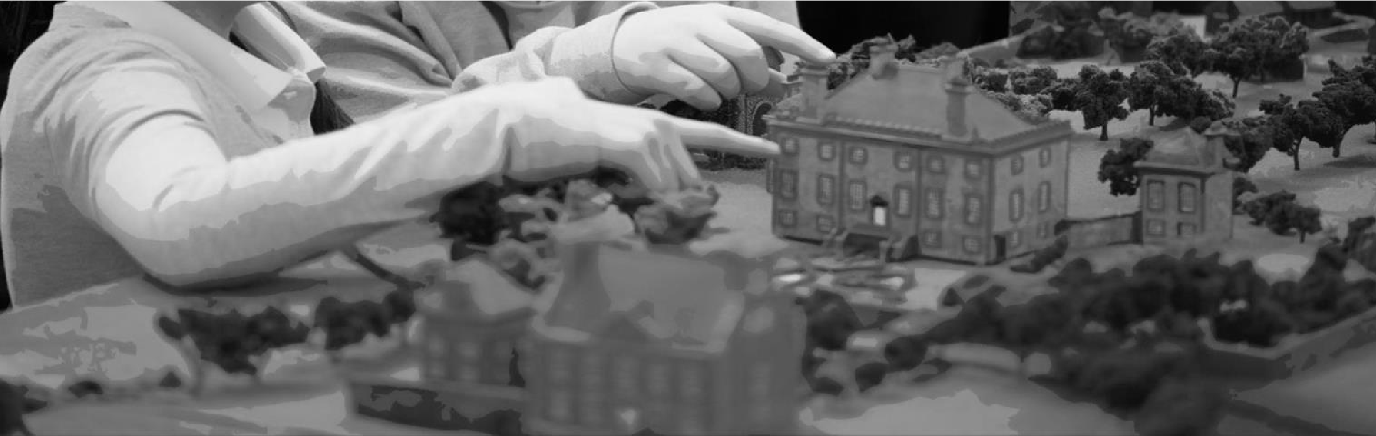

January 2019

Arran Johnston Heritage Services
www.arranjohnston.co.uk

INTRODUCTION

The purpose of this paper is to provide the Battle of Prestonpans (1745) Heritage Trust with a considered study of a range of approaches to battlefield interpretation centres, in order to inform the Trust’s considerations as to a possible centre at Prestonpans Battlefield.

This paper therefore identifies a wide range of relevant comparators from which it is possible to reflect upon issues which are relevant to the Trust’s own future planning, with special attention paid to:
- Organisational models, funding and revenue;
- Interpretation approaches and techniques;
- Activity programming
- Engagement with local, national and international narratives and interests; - Balances between conservation, interpretation, education and tourism.

A shortlist of relevant sites was compiled and divided according to geography. These sites were then studied through a combination of accessing online materials, considering visitors reviews, making direct enquiries, and through site visits wherever possible. All the Scottish and English sites referenced have been visited with the exception of Shrewsbury which was visited prior to the opening of the new exhibition. Visitor reviews on the online service TripAdvisor were examined for alternative perspectives on attractions, with both positive and negative issues being taken on board for consideration in the analysis. YouTube videos taken by visitors were also searched as aidememoires. The reporter’s experience of tour guiding, battlefield study, interpretation planning and museum work have all been applied in drawing the conclusions presented as a result of the study.

Sites have been classified according to the following:

Battlefield – battlefield site with un-staffed permanent interpretation but no dedicated centre
Battlefield & Visitor Centre – battlefield site with permanent visitor facilities
Visitor Centre/Museum –permanent facility not in direct vicinity of subject of relevant collection
Tapestry centre – permanent exhibition facility relevant to the Trust’s tapestries rather than theme

Their location types have been classified according to the following:

Rural – countryside location not immediately adjacent to significant settlement
Suburban rural – countryside setting close or within reach of to significant settlement
Surburban – location surrounded by settlement(s)
Urban – sited within a heavily built-up area

Operational structures have been identified as either:

National Body (charity) – operated by a major national charity, independent of government
National Body (agency) – operated by an agency of the national government
Local authority – operated by the local council or equivalent
Independent – operated by a focused charity, independent of local or national government Commercial – operated for profit-making entity

This paper focuses on sites within the UK and Ireland. Research is ongoing as to sites further afield.

SITES CONSIDERED

SCOTTISH BATTLEFIELD CENTRES
Culloden Battlefield & Visitor Centre
Battle of Bannockburn Experience
National Wallace Monument
Killiecrankie Visitor Centre

ENGLISH BATTLEFIELD CENTRES
Bosworth Battlefield and Country Park
Battlefield1403, Shrewsbury
1066 Battle of Hastings Battlefield and Abbey
Richard III Experience, York Walls
Other sites of relevant interest

IRISH BATTLEFIELD CENTRES
Battle of Aughrim Interpretive Centre
Battle of the Boyne 1690
Ballinamuck 1798 Battlefield Visitor Centre

FINDINGS

A number of important conclusions can be gleaned from a synoptic evaluation of battlefield interpretation centres in the UK and Ireland which are likely to have value for the considerations at Prestonpans. These are presented here, separated into thematic subdivisions. The basis for the findings is presented in the pages which follow the findings, presented as a database of sites considered.

Scale and Scope

- Dedicated battlefield visitor centres are few in number. In Scotland, there are a maximum of 4, only 2 of which are dedicated solely to their specific battle, whilst there are 40 battlefield sites on the official Inventory of Historic Battlefields.

- Battlefield centres tend to be limited to sites of special national interest, engagements which had major political or cultural repercussions. However not all sites worthy of such status can boast a visitor centre.

- There are only 2 major battlefield centres in Scotland (Bannockburn and Culloden) and 2 major site-specific centres in England (Bosworth and Hastings). These 4 sites are high-profile nationally-promoted sites with large foot-falls, and three of them are run by national heritage bodies (National Trust for Scotland, English Heritage) and one by a local authority.

- Other than the 4 major centres, battlefield visitor centres tend to be fairly modest and often associated with other facilities or attractions (eg, Sedgemoor 1685 centre housed within a church).

- It is therefore possible to conclude that centres are either operating at a very modest local level, with limited tourism or economic impacts, or as high-profile nationally-significant attractions generating higher foot-falls.

Location & Facilities

- Successful centres benefit from the added value for visitors provided by access to parkland, walking trails or significant views. These can be either natural environments or manicured landscapes, but they increase the opportunities for repeat visits, outdoor events/reenactments, and family appeal.

- Setting contributes to the sense of experience, and the landscaping/approach to the centre is important in creating lasting impressions for visitors. If an outdoor space is to be used for living history events etc, then its landscaping and security should be considered during the planning stages.

- Monuments, statues, or iconic photographic locations are an important part of the experience and the building of sense of place. These range from Soldiers’ Leap at Killiecrankie to the Pilkington-Jackson statue at Bannockburn, or the risen crown sculpture at Bosworth.

- Some sites own their outdoor areas whilst others are able to arrange short-term access for special events and have established walking trails through long-term landowner partnerships. In some cases the grounds can be accessed for free (parking is usually charged), independently of attending the battlefield centre.

- The level of access to the battlefield is important, as proximity to the historical location creates an authenticity in the experience. However some centres have peripheral relationships with the battlefield proper, which can be mitigated through connectivity to path networks, tours, viewpoints, or iconic/photogenic monuments.

- Accessibility is an important factor in success. Centres which could be described as “off the beaten track” struggle to command large visitor numbers and therefore do not attract reinvestment. Most centres are able to draw upon audiences on easy tourist routes or, as in the case of Bosworth and Culloden for example, relatively densely populated catchment areas even in relation to countryside locations.

- Most centres provide on-site retail and catering facilities. The latter is often subcontracted to specialist providers, in return for rental income to the centre as opposed to direct centre management. The quality of both environment and produce is an important factor for visitors in their appreciation of the experience, as evidenced in a study of visitor feedback. Café/restaurant facilities are often light spaces, providing views, and the most memorable encountered was that at Bosworth in the medieval tithe barn. Visitor feedback emphasises that these facilities are an important part of the overall experience.

- Retail space is important for economic sustainability, with Culloden reporting that books and adult clothing accessories (eg. scarves) are the biggest successes. Unique site specific merchandise of good quality can also be popular, although many centres provide a fairly generic souvenir range.

- Venue or room hire options can be used as addition revenue generation opportunities, ranging from weddings to business meetings or academic conferences. Thought should be given to these opportunities during the planning stages, so that attractive and flexible spaces can be offered whilst minimising impact on standard operating practices.

Interpretation

- Most interpretation techniques date over time: old mannequins and costumes look faded and awkward, animations or interactives can seem clunky and uninteresting, and even the once cutting-edge 3D technology of Bannockburn compares poorly to computer graphics available just a few years on. Projection technology requires regular maintenance.

- With the exception of Bannockburn, few sites rely on a single method of interpretation. Variety is important, but so is a cohesive experience in which different interpretation techniques are not in competition.

- The most memorable sections of exhibitions feature tactile objects and free-flow spaces, making visitors feel integrated within the displays. At Culloden for example, weapons are mounted in transparent displays so you retain a sense of being amongst them rather than looking at them. Likewise, at the Kingmaker exhibit in Warwick you can walk amongst the characters, feeling like you are eavesdropping on the past.

- Battles are about people; the most successful interpretation of battles reminds visitors of this whilst narrating the wider tactical story. Most sites make some use of terrain modelling or aerial perspectives (physical or digital), whilst also retaining individual narrative perspectives. The balance between the macro and micro level perspectives is perhaps the biggest interpretational challenge facing a new battlefield centre at its formation.

- Most sites retain a specific interpretive/narrative focus, as this is what roots the centre in its location. But the strength of a centre over an unsupported outdoor interpretation trail is that it facilitates exploration of contexts, aftermaths and wider significances, as well as aiding visualisation and understanding through multimedia and artefact display techniques.

- Widening the scope of the theme opens potential opportunities for wider markets, but the appeal of visiting a battlefield centre is rooted in its sense of place. Bosworth, for example, does not attempt to act as a national War of the Roses centre, although as the end-point in that conflict it is able to present its significance in a nationally relevant manner. Culloden broadens its interpretation to the extent that it narrates through various means the whole 1745-6 conflict, with a dedicated space for the Derby council of war for example, but it nevertheless maintains focus for its main display on the specifics of the battle at Culloden. Killiecrankie however, with part of its centre dedicated to geology and nature and part to the battle, seems to lack that level of focus and accordingly the experience is less engaging in regard to the battlefield narrative.

- The most memorable sites provide a “moment” or centre-piece location within the experience which generates anticipation or creates memories for the visitor.

- Interpretation focused on appealing to younger visitors has many advantages, but risks alienating the adult or special interest market, with interactive displays frequently being cited as being pitched solely at children. One way to avoid this is to provide focus spaces and discrete experiences for children, and the Richard III Experience’s use of the “pavilion” space is an interesting example.

- Some visitor feedback shows that large crowds of school children can be disruptive to other visitors, so dedicated education spaces are an important consideration to relieve that pressure (in restaurant areas for example).

Activities and Programming

- The most successful sites have busy activity schedules and the best have dedicated spaces (indoor or out) which can accommodate the kinds of activities which will drive repeat visits, from lecture halls to re-enactment fields.

- Activity programming allows expansion of the historical theme beyond the constraints of the permanent interpretation, and encourages repeat visits.

- Programming lectures, panel discussions, study days etc., can facilitate academic credibility for the centre, and provides an opportunity for the facility to become the interface between popular interest and academic study.

- Surprisingly few centres have large spaces for temporary exhibitions programmes; although where they do exist they can be used successfully to generate repeat visits or to extend themes beyond the main interpretation space.

- Live-action/costumed interpretation can be very effective when done well and undertaken within an appropriate setting, but increases staffing (and training) requirements. The best examples occur within specially created spaces integrated into the wider experience. The authenticity of clothing/equipment used by interpreters should match the academic rigour shown in the permanent interpretation.

- Activity schedules ought to remain relevant to the setting and context of the interpretation, as deviation from that (an observed example being a dog show) can dilute the sense of place and purpose of a battlefield centre.

- School visits are important drivers for long-term interest and sustainability, and Bannockburn and Culloden both benefit from the availability of travel subsidies for school groups. School visits are chargeable, and can range from the provision of activities and handling objects for teacher-led visits to tailored staff-led sessions and courses.

- Accessibility is an increasingly important consideration, with places such as the National Civil War Centre introducing initiatives such as dedicated “quiet hours” to encourage disadvantaged visitors to feel comfortable in the environment. Sites which have inherited access problems (old staircases, architectural restraints etc), can be totally inaccessible unless alternative facilities are provided at accessible levels. At the Wallace Monument for example, disabled visitors are only able to reach the catering facilities and lounge.

Ownership and Operations

- Most battlefield visitor centres are fairly long-established, including those which have benefited from rebuilding and refurbishment. This means that even new facilities such as Bannockburn were building on an existing market presence. The exception is Shrewsbury, but the battlefield there is used as an additional USP rather than the core purpose of the attraction.

- In Scotland, three of the four battlefield centres analysed are operated by the National Trust for Scotland. The National Wallace Monument is run by a local charity which operates a number of other tourist facilities locally in Stirling, with a board comprised of volunteers. In England, Hastings is operated by a national heritage body (English Heritage), and the same form of model is applicable to sites of interest such as Leeds Armouries (Royal Armouries) and the Trafalgar Experience (National Museum of the Royal Navy); Bosworth is operated by the local authority and thus stands out favourably compared to other local authority-run sites such as Aughrim in Ireland. The levels of investment and staffing at Bosworth reflect the site’s perceived tourism value, whilst historical integrity is maintained in its interpretation and programming.

- Commercially operated sites are rare: Shrewsbury is one example, as mentioned in point 10; the Barnet interpretation at Warwick Castle is another. Both sites have a far broader focus than the battlefield history. No example appears to show a site-specific independent trust which is responsible for all aspects of operation. There is a small visitor space in a church at Sedgemoor (1685) Battlefield in south-west England, but its scale is most comparable with the smaller sites described in Ireland.

- With the exception of Bosworth, local authority run facilities appear to be under-staffed and under-resourced. Another exception is the new National Civil War Centre in Newark, which assumes the mantle of the town museum and so is believed to dominate the council’s museum service budget.

- Visitor feedback not only demonstrates that the catering facilities can be just as important as the interpretive experience, but also that staffing quality is highly significant also. Visitors respond well to helpful and knowledgeable staff, and to live action interpretation. Training and continuous professional development are therefore important to the success of a highprofile attraction.

The purpose of a battlefield visitor centre is not only to increase the interpretation of the site by facilitating deeper contextual coverage and the display of relevant material/artefacts; it is also to transform exploration of a battlefield site from a visit to an experience.

Even a small centre can encourage casual visitors in a way that self-led trails might not manage alone, and provide battlefield interpretation of greater depth than is possible solely through on-site panels or apps. In addition, visiting battlefields loses its total dependency on the weather conditions when an indoor facility is available. If executed well, a centre can considerably enhance the sense of place, and lasting memories can be created be visitors. The very presence of a centre also elevates a battlefield site, giving it a contemporary status which underlines its historical significance.

There are at least two major new centres in preparation: Naseby in Northamptonshire, which proclaims itself as England’s most important battlefield; and Falkirk 1746 in Scotland. The first is a Battlefields Trust led initiative, whilst the latter is being coordinated by a small independent trust comparable to that at Prestonpans. Contact has been made with the Naseby Project as well as with the Falkirk trust, so that relevant information and learnings can be shared.

SCOTTISH BATTLEFIELD CENTRES

Culloden Battlefield & Visitor Centre
www.nts.org.uk/visit/places/culloden

Type | Battlefield & Visitor Centre
Location | Near Inverness, Highlands
Location type | Suburban rural | Short distance to Inverness, increasing housing pressure locally
Operated by | National body (charity) | National Trust for Scotland
Entrance price | £11/£9.50
Facilities | Large Restaurant/café  Shop  Toilets  Lecture/education room  Museum  Small performance space Battlefield walk with AV handset
Relationship to battlefield | On-site
Estimated visitors per year | 180,875 (2017) | Up 27.6% on previous
Tourist board rating | 5* visitor attraction | Accredited Museum (2019)
Average TripAdvisor rating | 4.5*

Site Summary:
Culloden is a well-known battlefield with an international profile. The National Trust for Scotland have operated a visitor centre here for many years, as well as owning approximately one third of the battlefield area (including almost all of the main monuments). The battlefield area can be visited free of charge (parking charges apply for non-members), but the audio-visual handsets are only available as part of the visitor centre ticket. Additional charges apply for guided tours operating from the centre.
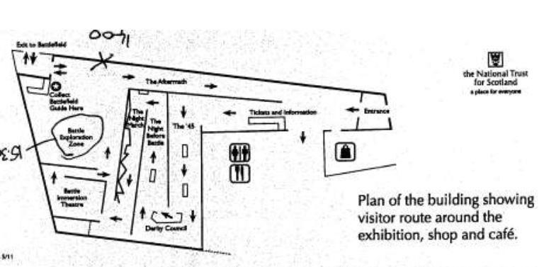
The visitor centre (which replaces a previous one) is designed to sit low within the landscape to minimise its visual impact from the battlefield itself. A flat roof allows visitors to gain a view from height, although this is not emphasised or particularly strongly interpreted.

The main visitor centre benefits from a large open lobby which can
accommodate large groups arriving/leaving simultaneously at busy times. The shop and restaurant are encountered first, and are often used by visiting coach groups regardless of whether they pay to visit the centre as well. There is limited outdoor seating area as well, and a set of folding walls can expand the restaurant into the adjacent function/lecture room. The restaurant emphasises local and high quality produce as a key part of its offer.
The main exhibition is comprehensive in its narrative of the 1745-46 campaigns: the build-up to the battle is narrated in a zig-zag route through to an immersion cinema room, beyond which lies an open room in which the actual battle itself is presented by various means.
The campaign route uses a number of interpretation techniques: traditional artefact display and narrative text and illustration panels; interactive spaces with focused speakers to allow different “characters” to speak to visitors; digital projection tables showing the movement of troops across Britain as the campaign unfolds; and finally a sound room where visitors can eavesdrop on a council of war.
The immersive video space presents a dramatic surround experience, and as a result needs to be viewed several times. Visitors remain standing as the battle unfolds around them.
A sense of the filming style can be gained from the teaser video:
https://www.youtube.com/watch?v=HR_ltIlAeYA
In the final battle interpretation space there is an area for understanding the archaeological investigations, displays of original weaponry, cases showing personal objects associated with the battle, and replica weapons and artillery outside of cases which can be viewed up close and touched. A large table shows a projected display of a birds-eye view of the battle formations during the engagement. This has been filmed by a visitor:
https://www.youtube.com/watch?v=x6R5lusax0c
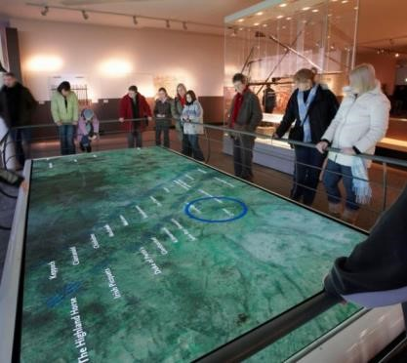
From here visitors can opt to collect a handset or otherwise, before heading onto the battlefield itself.
The battlefield trails cover both battle lines, with clear paths over the uneven moorland ground, occasional benches for rest stops, and flag poles and markers to identify unit placements. Victorian stones mark the location of massed graves, adding to the sombre feel.
Ongoing conservation work has returned the battlefield to moorland after a period of commercial forestry, and some of the enclosure dykes have been rebuilt. A small cottage has been refurbished and is expected to be used as an education space.
Interpretation Techniques:

Artefact displays | X
Text and picture panels | X
Interactive screens | X | Limited
Digital projection | X | Large table format (pairs of projectors used)
Film/video | X | Immersive 4-wall video, approx. 4mins
Focus spaces | X | Limited
Object handling (inc dress up) | X | Some static (replicas), plus some programmed.
Audio guide or handset | X | Satellite-linked handset with audio & screen for outdoors
Costumed guides/interpreters | X | Tours at extra cost
Live action performance

Limitations:

There are occasions when projectors are out of order due to maintenance or bulb failure, as they are required to operate all day (beyond normal usage). It has been estimated that basic maintenance of this type can consume most of the carparking revenues across a given year.

There are places where the architecture is designed to make a point, but this can be lost: for example, the arrangement of wooden panels in a wall being deliberately disordered to represent panic; or the unnatural positioning of wall panels to represent the confusion of the night march prior to the battle.

The campaign section of the exhibition tells the story from the two rival viewpoints on opposite walls which run in parallel. This makes the narrative disjointed, and it becomes too easy to miss information or artefacts if following the timeline.

The council of war area is clearly underused, as few people seem to sit and listen to it for more than a few moments. The voices all talking over one another and it is unclear who you are supposedly listening too. There are no accompanying visuals so the space is dark and uninviting, a feeling not aided by the agitated disembodied voices. This part of the interpretation is unsuccessful.

The cinematic display would benefit from lower light levels, so that the experience is more immersive. This can be seen in this short video taken by a visitor:
https://www.youtube.com/watch?v=ulDQZaUab6E

The costuming for volunteer interpreters/guides is of mixed quality.

The archaeological and cultural sensitivities of the site restrict some of the programme. There is little living history activity and no re-enactments, for example.

Events and Programming:

There is an annual commemoration in April each year on the battlefield, but this is not organised by the centre itself. They do however provide an associated lecture within the centre in conjunction with the commemoration.

Volunteer-led costumed tours and objects talks run regularly in the summer season.

There are occasional special lectures, and there is an annual promotional day for locals within the postcode area.

Details of the primary and secondary schools’ privision can be accessed here:
https://s3-eu-west-1.amazonaws.com/ws-nts/Production/assets/downloads/NTS-Culloden-SchoolsProgramme-2018-19.pdf?mtime=20180514091654

Battle of Bannockburn Experience www.nts.org.uk/visit/places/bannockburn

Type | Visitor Centre | With iconic statue/monument
Location | Bannockburn, Stirling
Location type | Suburban
Operated by | National body (charity) | National Trust for Scotland
Entrance price | £11.50/£8.50
Facilities | Restaurant/café  Shop  Toilets  Lecture/education room  Museum  Interactive Battle Game
Relationship to battlefield | On-site | Most of battlefield developed
Outdoor Event space | Yes
Estimated visitors per year | 55,347 (2017) | Up 7.9%
Tourist board rating | 4* visitor attraction
Average TripAdvisor rating | 4*

Site Summary:

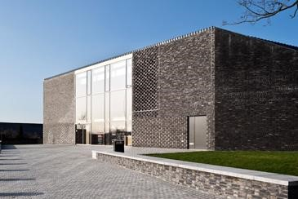
Like Culloden, this centre replaces a previous one also run on this site by the National Trust for Scotland. It opened in 2017 to mark the 700th anniversary of the battle and uses cutting-edge digital technology. The centre is site within a built-up environment in the suburbs of Stirling, and there is limited curb-side appeal to the architecture (although its textures are inspired by those of chain-mail). The small shop and restaurant surround a central courtyard, inspired it is said by medieval castle architecture. The feeling of the interior is a little cramped at busy times.
The main exhibition is focused on a single main gallery space, around which 3D displays spring to life to provide a sense of immersion. Interactive display spaces allow visitors to confront specific historical characters, also digitally created in 3D.
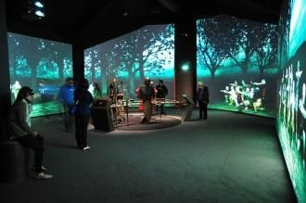
Visitors are given a timed slot for participating in an interactive wargame, a 3D projected landscape on which teams are able to lead one of the rival armies under the supervision of a “battle master”. After attempting to change the course of history, the battle master gives a run through of what actually occurred in 1314.
Outside the centre is a pleasant parkland area, crowed with a commemoration space containing an iconic bronze statue of Robert the Bruce.
The centre has an education/lecture room with a modest capacity, hung with heraldic banners.
A sense of the centre experience can be gleaned here: https://www.youtube.com/watch?v=anNspDWqO4M

Interpretation Techniques:
Artefact displays
Text and picture panels | X Limited
Interactive screens | X Interact with specific characters
Digital projection | X 3D projection dominates
Film/video | X Introductory puppetry animation
Focus spaces | X See character interactions
Object handling (inc dress up) | X Replica weapons and armour
Audio guide or handset
Costumed guides/interpreters
Live action performance | X (battle master)
Limitations:
Although the Pilkington Jackson statue of Robert the Bruce is iconic and has high impact, and the parkland views are pleasant, the developed nature of the battlefield does not facilitate the same locational connectivity with the history as is the case at Culloden for example.

The main exhibition does not contain much traditional museum artefact display, which leaves some visitors unsatisfied. Younger visitors are more likely to be impressed by the 3D technology of course, but the interactive wargame is not available for children under 7 years old. The latter is also a choke point in the visitor experience, and in the main summer season time slots must be booked in advance. Although the game can be enjoyable with friends, it could be an intimidating experience for solo visitors. Some of the interactive characters were not working smoothly during the site visit, which can lead to the amusing sight of visitors gesticulating wildly at sensors in the hope of being detected. Having to wear flimsy 3D glasses for much of your visit is also a little irritating.

The main critique of the Bannockburn approach is that it is totally reliant on the digital technology which effectively turns the whole battle into a computer game. This can be argued to place additional distance between the visitor and the reality of warfare, rather than bringing them closer which is perhaps a more fitting objective. As if to emphasise that it is not, however, the “battle masters” are dressed in extraordinary sci-fi style costumes. The quality of the experience is also very dependent on the individual battle master.

The unfortunate reality is that it is possible to come away from the experience without really understanding the Battle of Bannockburn at all, even if the individual visitor had enjoyed it.

Events and Programming:

There is an annual lecture programme, covering interests wider than the Bannockburn battle.

There is a varied events programme through the year, which in the past has included dog shows, Victorian Christmas, children’s storytelling sessions, “knight school” and small-scale living history displays of mixed authenticity standards.

Education sessions are provided, and the detail can be accessed here:
https://s3-eu-west-1.amazonaws.com/ws-nts/Production/assets/downloads/Bannockburn-TeacherInformation.pdf?mtime=20180507134817

National Wallace Monument www.nationalwallacemonument.com

Type | Visitor Centre
Location | Near Stirling
Location type | Urban rural | On a crag overlooking Stirling and the 1297 battlefield.
Operated by | Independent | Stirling District Tourism  (operates 4 sites locally)
Entrance price | £10.50/£6.50
Facilities | Shop  Toilets  Museum galleries  Tower with 360º views  Café
Relationship to battlefield | On a peripheral site related to the Battle of Stirling Bridge
Estimated visitors per year | 135,000 (2017) | Up 20%, highest in 10 years
Tourist board rating | 4* visitor attraction
Average TripAdvisor rating | 4.5*

Site Summary:
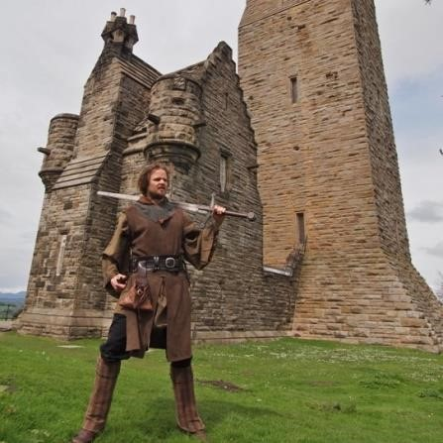
The monument is a 150 year old tower on top of Abbey Craig, the rocky crag overlooking Stirling from which Wallace and de Moray are said to have prepared for the Battle of Stirling Bridge. Dedicated to William Wallace, the tower has its café and shop facilities on the lower levels and then a single-room gallery on each floor as you ascend the spiral staircase to the summit. The first exhibition hall displays reproduction arms and weapons and tells the story of the Battle of Stirling Bridge. On the next floor up is the Hall of Heroes, featuring busts of famous Scots with light interpretation, surrounding the centrepiece of the exhibition which is a large claymore reputed to have belonged to Wallace. The floor above tells the story of the monument itself, and there is an block-model of the tower which children can build, before ascending to the top floor which provides spectacular panoramic views of Stirling and the surrounding landscape. From here it is easier to understand the Battle of Stirling Bridge than on the ground, so the distance from the area of fighting is no real detriment. In 2017 the pathway up to the monument was improved, with benches and interpretation plaques installed at intervals. It is estimated that during that year the attraction contributed a value of £4.5million to Stirling’s economy.

The centre is closed for several months in early 2019 for a major upgrade as part of the 150th anniversary of the structure.

Interpretation Techniques:

Artefact displays X Limited – the Wallace Sword being the main display
Text and picture panels X
Interactive screens
Digital projection
Film/video X TV size screen
Focus spaces
Object handling (inc dress up) | X | Replicas on display
Audio guide or handset
Costumed guides/interpreters | X | Scheduled 15-20min performances by costumed actors at weekends

Limitations:
Parking is about 15-20 minutes’ walk away from the tower, although a shuttle bus service is provided for those unable to manage the steep woodland walk (there are benches at intervals). The latter might also struggle with the spiral staircase which is the only access to the exhibition floors, although the retail and catering areas are more accessible. The spiral staircase becomes very narrow, and at busy times can uncomfortable.
The gallery spaces feel cramped, especially when busy, and the displays lack real detail or major points of interest. The opportunities are inevitably restrained by the structure itself, and perhaps some of the interpretational deficiencies may be addressed following the refurbishment.
Essentially the attraction succeeds on the basis of the impressive monument itself and the view its summit affords. The rest of the attraction may disappoint some who have paid the full price, especially as the views are weather dependent.

Events and Programming:
There is a programme of costumed interpretation across most weekends. These either see short appearances by William Wallace himself, or other actors performing “tales from the battlefield” sessions lasting around 20minutes. The outdoor Wallace performance is heavily scripted and pretty pedestrian, and the costume quality is weak. The impression is rather amateur, which sits poorly with the attraction’s price tag unfortunately.

Other recent initiatives have included the addition of a range of Heroines to the Hall of Heroes busts, and special late night tour openings. The venue can be hired for events, including small weddings.

Killiecrankie Visitor Centre https://www.nts.org.uk/visit/places/killiecrankie

Type | Battlefield & Visitor Centre
Location | Near Pitlochry, Perthshire
Location type | Rural | Close to Pitlochry, Blair Atholl and other tourist routes
Operated by | National body (charity) | National Trust for Scotland
Entrance price | Free
Facilities | Small café  Shop  Toilets  Small Museum  Nature walks & picnic spaces  Play area
Relationship to battlefield | On-site for peripheral aspects of the Battle of Killiecrankie
Estimated visitors per year | Unknown
Tourist board rating | 3* visitor attraction
Average TripAdvisor rating | 4.5*

Site Summary:
The NTS visitor centre in the Pass of Killiecrankie is not exclusively focused on the famous battle of 1689, but also covers geology and nature. Accordingly only a portion of the exhibition is given over to the battle, which the battlefield tourist may find disappointing. The displays are quite traditional, case and panel based, but although the level of detail is relatively low there is a good quality guide book available.
The main attraction of the centre is the woodland walks in the pass, which lead to locations related to the battle including the spot where the first shots are said to have been fired in its prelude, and the famous Soldier’s Leap, where a fugitive redcoat is said to have leapt the gorge above the river to make his escape. The distance is marked out in front of the visitor centre so that visitors can practice their long jump on the way back from having seen the spot.
The fact that the main fighting occurred some distance to the west does not deter from the sense of place occasioned by a visit, as the unique landscape is so closely associated with the events of the battle. There are activities for children and a play area, and ample scope for picnics.

Interpretation Techniques:

Artefact displays X
Text and picture panels X
Interactive screens
Digital projection
Film/video
Focus spaces
Object handling (inc dress up)
Audio guide or handset
Costumed guides/interpreters

Limitations:
It is difficult to criticise a free facility beyond the limitations already identified: that the exhibition lacks detail and only a small area is dedicated to the battle itself.

Events and Programming:

There are ranger’s tour available, and the occasional special event but not a regular programme of battle related activity. Re-enactments are held annually outside Killiecrankie village on the actual battlefield itself, but although the NTS usually have a stall the visitor centre is not involved in the organisation of the event.

The education sessions available include both nature, conservation, and the Battle of Killiecrankie: https://s3-eu-west-1.amazonaws.com/ws-
nts/Production/assets/downloads/EDUCATIONnts_tis_killiecrankie.pdf?mtime=20180226091516

ENGLISH BATTLEFIELD CENTRES

Bosworth Battlefield Heritage Centre
www.bosworthbattlefield.org.uk

Type | Battlefield & Visitor Centre
Location | Leicestershire, England
Location type | Rural | Close to a number of villages and a small town
Operated by | Local authority | Leicestershire County Council
Entrance price | £8.95/£5.75
Facilities | Free children’s Discovery Zone  Restaurant  Shop  Toilets  Museum  Walks & picnic spaces  Play area  Event area  Guided walks (extra cost)
Relationship to battlefield | On-site to periphery (core area has been relocated by archaeology to around 2miles away
Estimated visitors per year | Popular with school parties
Tourist board rating | Quality Assured; several recent awards | Accredited museum
Average TripAdvisor rating | 4.5*

Site Summary:
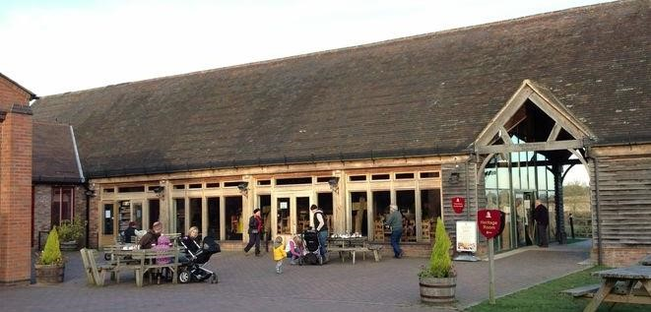
The visitor centre is anchored on a series of renovated farm buildings arranged around a courtyard, and the historic tithe barn serves as the restaurant, the beams of which give a decidedly medieval character to the facility. Dominating the visitor’s approach are two enormous pennants – those of Richard III and Henry Tudor – flying from the summit of the hill and instilling a sense of expectation and
place. There is a charging car park, as visitors may access the country park without visiting the battlefield centre.
The main exhibition covers a range of themes including the build-up to the battle, the detail of the engagement itself and the armour and weaponry used, and the aftermath and significance of the battle. There is also information about archaeological discoveries at the site, including the rediscovery of where the main fighting occurred (about 2miles away from the centre) and how the centre has had to adapt its interpretation. There are plenty of interactive elements within the exhibition, including focus areas where visitors can engage with a character whose story can be picked up again later. Weapons and armour replicas can be handled and there is a test of strength for the budding longbow-man. A central display table narrates the main battle, supporting with sound and light effects to give a somewhat immersive feel.
Some older parts of the exhibition feel a little dated, not least a slightly awkward mannequin of Henry VIII, who symbolises the importance of the coming Tudor dynasty. At the end of the exhibition visitors can cast their vote as to which claimant to the crown they would have supported.
Off the courtyard is an event space which formerly held a medieval stage-set where visitors could meet re-enactors from a society which appears to have been contracted to provide regular tailored services, although the set is no longer present. Part of this area has been subcontracted to a falconry display company, although this is not part of the main entry ticket and was not operating at the time of visit. The land on which the centre has been developed is used on long-term lease by the council from a private landowner, and most of the surrounding countryside through which the walkways and tours run is also privately owned but well signed and maintained. There are donations posts around the routes, presumably to encourage those who do not use the ticketed facilities. Fields immediately adjacent to the centre are opened up each August for the annual re-enactment and medieval fayre, which is a very grand affair.
There is a new Discovery Zone for children which is free to access and provides activities for the youngest visitors who would not yet be suited to the main exhibitions. Guided tours of the battlefield areas are offered for an additional charge.
There is a monument in the grounds featuring a crown held aloft by a bill-hook, which provides an excellent photography spot and contributes strongly to the sense of place.
A recent visitor provides a glimpse of the centre in this video, overlaying scenes from the annual reenactment: https://www.youtube.com/watch?v=1__h87k6zDo

Interpretation Techniques:

Artefact displays | X
Text and picture panels | X
Interactive screens | X
Digital projection | X
Film/video
Focus spaces | X
Object handling (inc dress up) | X
Audio guide or handset
Costumed guides/interpreters
Limitations:
Some of the adjacent areas off the main courtyard, previously used as living history spaces, appeared to have been subcontracted to a falconry company, although this did not seem to be open and it was unclear whether it was part of the main attraction.

Some lustre has gone from the overall site as a result of some of its famous landmarks – the spot where the king was believed to have fallen etc – having moved 2 miles distant. But the location remains significant to the narrative as it was the royal muster point ahead of the battle, and the walking routes (some of which still seem to need their interpretation updating slightly to take cognisance of the changes) still assist with understanding of the battlefield and its landscape.

Some parts of the main exhibition feel a bit dated, and this is especially so in contrast with some elements of the Richard III Visitor Centre in Leicester.

Events and Programming:
There is an active event programme, with special tours and lectures being its mainstay.
There are living history weekends, for which it seems there is a retained group contracted.
The annual medieval fayre, which climaxes with a major re-enactment of the battle, is a large-scale and professionally run event with a very busy programme and large audience turnout. It is supported by reenactors from across Britain and Europe, and the societies which perform are high quality. The battle event is supported by encampments, trade stalls, jousting and skill-at-arms displays.

Additional Note:
The centre is partnered with Leicester city’s Richard III Visitor Centre, built on the site of the king’s burial after the battle. There is a joint ticket arrangement for the two sites, which complement each other well. The Leicester exhibition is more recent, and features some large-scale wall projections giving a sense of the intensity of the battle at Bosworth. A sample can be seen here:
https://www.youtube.com/watch?v=rH20WJg57Ss
Both visitor centres also complement a visit to the king’s new burial place in Leicester Cathedral.

Battlefield 1403, Shrewsbury
https://www.battlefield1403.com

Type | Battlefield & Visitor Centre
Location | Near Shrewsbury, England
Location type | Rural | Countryside setting
Operated by | Commercial | English Heritage
Entrance price | Free
Facilities | Deli  Farm Shop  Toilets  Battle exhibition  Battlefield trail & church
Relationship to battlefield | On-site
Estimated visitors per year | --
Tourist board rating | --
Average TripAdvisor rating | 4.5*

Site Summary:
The site of the Battle of Shrewsbury – famous as the site where the future king Henry V cut his teeth and Harry Hotspur met his end – lies in a beautiful and peaceful countryside close to historic Shrewsbury. There was previously a battlefield trail, but the Battlefield1403 attraction is relatively recent. The landowners have developed a charming and well-presented farmyard attraction, with farmshop, deli and café, supported by child-friendly activity areas. They have used the battlefield heritage as a unique selling point. There is an exhibition on the battle – mainly information boards supported by a replica objects and some reproduction weapons and equipment – but its interpretation techniques are unambitious. The battlefield walk, and the fact that keys to the Battle Church can be obtained at the shop, remain the most rewarding aspects of a visit but the other facilities bring these to a wider audience and make a visit to the battlefield more of an experience.

Interpretation Techniques:

Artefact displays X
Text and picture panels X
Interactive screens
Digital projection
Film/video
Focus spaces
Object handling (inc dress up) X
Audio guide or handset
Costumed guides/interpreters

Limitations:
The exhibition is an added attraction to the main effort of the facility, which means it is unlikely to satisfy the committed military historian, but is of clear interest to the general visitor.

Events and Programming:
Most of the activities are associated with the non-battlefield side of the operation, ranging from bouncy-castle fund days to cider tasting sessions. However there are also battlefield tours and living history days as well.

1066 Battle of Hastings, Abbey & Battlefield
https://www.english-heritage.org.uk/visit/places/1066-battle-of-hastings-abbey-and-battlefield

Type | Battlefield & Visitor Centre
Location | Battle village, England
Location type | Suburban Rural | Close to small town on one side
Operated by | National body (charity) | English Heritage
Entrance price | £11.80/£7.10
Facilities | Café/Restaurant  Shop  Toilets  Battle visitor centre Abbey ruins and exhibition centre  Terrace and rooftop viewing  Audio guides (inc children’s’)
Relationship to battlefield | On-site for peripheral aspects of the Battle of Killiecrankie
Estimated visitors per year | 123,220 (2017) | Down 10.6%
Tourist board rating | --
Average TripAdvisor rating | 4.5*

Site Summary:
This is a multi-layered attraction, featuring impressive monastic ruins as well as walks onto England’s most famous battlefield. The abbey and the mighty gatehouse building which houses the exhibition about its history, sit atop the ridge which was held by the Saxon army in 1066. Spreading beyond is the slope up which the Norman invaders were obliged to attack, and there are walking paths around the site to allow those perspectives to be understood. An audio guide is available for the trail, and there is a special version for children.
In addition there is a separate visitor centre dedicated to the story of the battle, housed in a modern building. There is an introductory video, and an atmospherically lit exhibition which includes a number of interactive projections, and replica weaponry fixed to the walls which visitors can touch and feel. A sense of the space is offered by this visitor video: https://www.youtube.com/watch?v=2VeeCtNuVNE
Ironically, the battle narrative is perhaps less effectively interpreted than it is at Bayeux in France, and it is the walking of the site which leaves the impression rather than the exhibition itself. A strong sense of place is provided by the marker identifying where it is said that King Harold was slain.

Interpretation Techniques:

Artefact displays | X
Text and picture panels | X
Interactive screens | X
Digital projection | X
Film/video | X
Focus spaces
Object handling (inc dress up) | X
Audio guide or handset | X
Costumed guides/interpreters
Limitations:
Parts of the interpretation centre, particularly the text panels, feel dated.
Parking is limited and is charged separately to the visitor attraction.
Some of the paths become muddy in poor weather, although the abbey terrace allows views of the battlefield in poor weather without needing a comprehensive walk.
Due to its profile, the site can get very busy at times within the visitor centres.

Events and Programming:

The activity programming covers both the battlefield and monastic sides of the site’s history, ranging from children’s “battle” days to members only archaeology talks and tours. There are also special seasonal events, and in October a major re-enactment and living history weekend.

The re-enactments are amongst the most well-known in England, as is fitting for the site’s profile. It attracts large numbers of participants and strong audiences. There is a particular appeal to witnessing the battle played out upon the very slopes where it played out in 1066.

Both self-led and staff-led sessions are available for school parties. There is a video and further information available here: https://www.english-heritage.org.uk/visit/places/1066-battle-of-hastings-abbey-andbattlefield/schools/

Henry VII & Richard III Experience, York Walls (Battle of Towton)
https://richardiiiexperience.com/

Type | Visitor centre(s)
Location | York, England
Location type | Urban | Housed in two gatehouse towers on the medieval city walls
Operated by | Commercial | The Jorvik Group
Entrance price | £5/£3, or as part of a pass
Facilities | Small Shop  Medieval gatehouse galleries  Wall walks
Relationship to battlefield | Distant but associated
Estimated visitors per year  Tourist board rating | --
Average TripAdvisor rating | 3.5*

Site Summary:
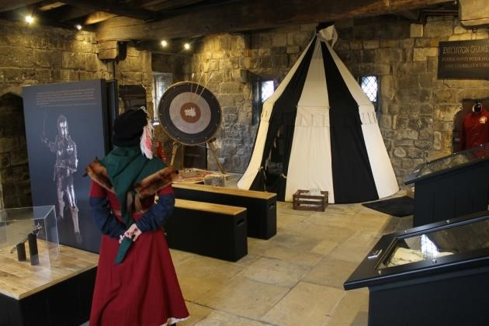
These twin museums are located in two of the magnificent medieval gatehouses of York’s city walls. They are therefore connected by the wall walks, despite being on different sides of the city. The walls are an added attraction to military enthusiasts. The Richard III experience is relevant here as it focuses attention on the Battle of Towton, England’s bloodiest battlefield, which was fought during the War of the Roses near Tadcaster. The Lancastrian army left for the battle from York, and the city capitulated to Edward IV after his victory.
The museum itself feels like a hidden treat, as there are many other attractions in York with higher profiles. The galleries are modest sized – constrained of course by the structure – and in that they are somewhat comparable to the National Wallace Monument. The interpretation is not complex or ambitious, and uses replica weaponry and miniature models to tell the chosen stories. There is a documentary film display providing a deeper level of information about Towton battlefield and its significance. The challenge however is that the video is long, and although some visitors were clearly inclined to sit and watch it in full, those who came in part-way through were not likely to wait for it to restart.
A striking feature is the children’s activity spaces, a pseudo-medieval pavilion inside the room, which creates a focus space containing interactive activities. This is a simple but clever idea, and combined with the authentic medieval architectural setting it engenders a sense of excitement and independence for young visitors.
A single ticket provides access to both museums, and is valid for repeat visits over the year.
A good sense of the exhibition is provided by this visitor:
https://www.youtube.com/watch?v=qsag5jXn9_Q

Interpretation Techniques:

Artefact displays X
Text and picture panels X
Interactive screens X
Digital projection
Film/video X
Focus spaces X
Object handling (inc dress up) X
Audio guide or handset
Costumed guides/interpreters

Limitations:

The stone stairways into the museums make the sites inaccessible for those with disabilities, and can be claustrophobic. The gallery spaces are not large, but they are atmospheric, and so if the attraction were busy it would be uncomfortable.
The main themes – Richard III and Henry VII – seem tenuously connected to some of the displays, which might be better marketed as more generally War of the Roses. There are no toilet facilities.

Events and Programming:
There is little space to accommodate a busy events programme, but there is an attractive schools programme offered which features a costumed facilitator and medieval activities as well as gallery tours. Children’s activity sheets can be printed in advance for self-led visits, as can the answer sheets. There are also outreach programmes, loan boxes for schools, and virtual (Skype) sessions available for classroom-based learning. https://richardiiiexperience.com/learning/

Additional Note:
The Jorvik Group operates other historical attractions within York, including the famous Jorvik Viking Centre and the charming medieval house, Barley Hall. All can be visited on a joint ticket, which is economically priced. The Barley Hall site features particularly good interactive scenery, using high quality reproduction furnishings and objects to bring the hall to life, creating a rewarding selfexploration experience.

Other relevant sites of interest

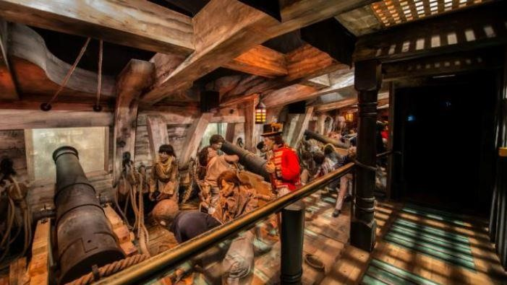
The Trafalgar Experience, Portsmouth: part of the National Museum of the Royal Navy, this small museum is designed to complement a visit to the historic warship HMS Victory. The centre is billed as a multi-media experience, and uses stage settings and animatronics to bring help bring the experience of the Battle of Trafalgar to life. From the briefing room, where Nelson’s battle plan is introduced, to the booming cannon effects of the gun deck, then through into the cabin to hear about Nelson’s death, the narrative of the battle is presented. Although the mannequins look a little old fashioned, the settings are effective and are likely to leave an impact on younger visitors. The Trafalgar Experience is connected to a more conventional style museum, using artefact display to present the wider naval heritage.

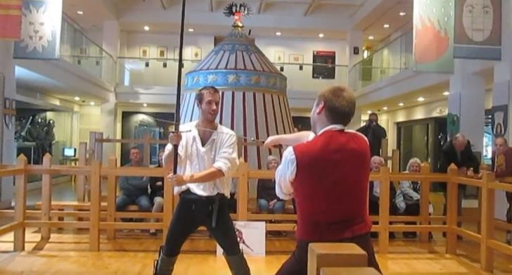
Leeds Armouries, Leeds: part of the national armouries museums, this is the northern counterpart to the famous Tower of London collection. The Leeds Armouries museum is housed in a large modern building in the renovated wharf area of central Leeds, and the collection is wide ranging. In the main historical arms and armour displays, certain famous battles are highlighted as exemplars of their time. Some are presented with large-scale dioramas of dressed mannequins, which have powerful impact and show how different types of soldier interacted (eg, a 16th century pikeman holding off an armoured horseman). The Battle of Agincourt and a section of the Battle of Waterloo are represented by high quality traditional terrain models with miniature figures. The Battle of Marston Moor is told with a dramatic re-enactment film, shown on a screen in an enclosed darkened space within the 17th century display area (although on the last visit this was out of order). Each method of interpretation is supported by the accompanying artefact displays and text panels, and there are interactive screens and tactile activities at various stages.

Most notably however, there are also a
number of small dressed performance areas, in which costumed interpreters present demonstrations of combat and weapons use, scheduled throughout the day during the main season. There is also a stable block and outdoor display arena adjacent to the main building, facilitating cavalry displays and jousts etc.

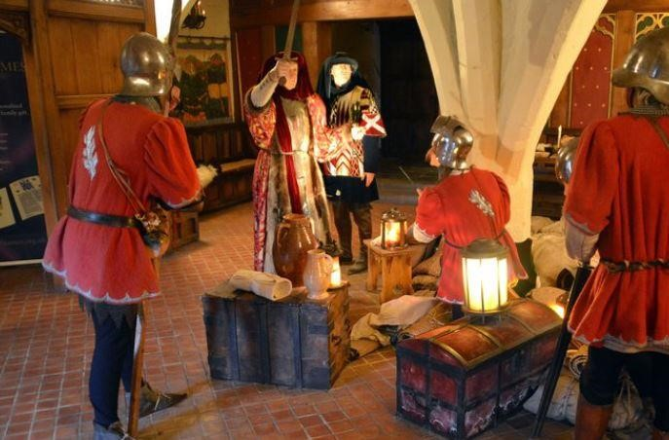
Warwick Castle, Warwickshire: this large medieval castle site is run as a popular attraction by Merlin Entertainments Group Ltd. The castle and grounds are themselves impressive, and the interior of the castle area is subdivided into separate attractions to explore. Amongst these are the Kingmaker experience, which tell the story of the Earl of Warwick’s preparations for the Battle of Barnet during the War of the Roses. The first section of the experience is the “Dream of Battle” audio-visual display, in a small theatre space with an ethereal film – the squire’s dream of coming disaster – is played, using dark imagery which may unsettle some junior visitors and excite others. After this sense of foreboding is established, visitors visit the main Kingmaker rooms as they enter part of the castle building. They pass through various portions of Warwick’s household as he prepares for war: well-dressed mannequins fill the sets, but the lack of barriers and the use of smell and sound effects makes it feel as if the visitor is walking
amongst the protagonists. Warwick was killed at Barnet, and so there is a poignancy to the preparations which is enhanced by the preliminary dream. At Warwick Castle the emphasis is more on entertainment than learning, but there are aspects of this style of display which are highly effective at creating visual memories.

National Civil War Centre, Newark: this museum is dedicated to the English Civil War and the repeated sieges of Newark which took place during that conflict. The centre has only been open for a few years and is run by the local authority as part of the town museum. The centre shares reception and café facilities with a theatre, and the development incorporates a former Tudor grammar school building. There is a fine Tudor hall which provides an atmospheric indoor event space, and several outbuildings which can be hired as meeting rooms etc.
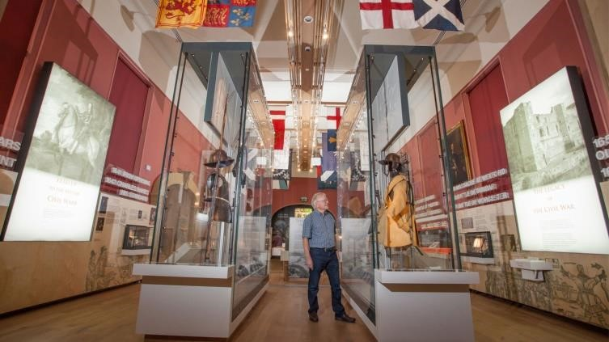
The main civil war exhibition is housed in one large gallery, featuring display cases of interesting artefacts and weaponry whilst replica battle flags hang above providing colour and a sense of immersion. There are a number of interactive display screens, ranging from short videos about pike/musket drills to a light-hearted Roundheads vs Cavaliers quiz. One of the interactive projections was not working during the site visit, reinforcing an issue
raised at Culloden, and leaving a fairly large display space empty as a result. There is also a children’s dressing up area, with good quality replica clothes and armour, in a discrete space. The use of “floating” header texts and large visual panels makes the overall impression pleasing, contrasting nicely with the use of 17th century portraits hanging on the walls which give a feeling of old and new in harmony. Some of the exhibition coverage lack detail, but this is unsurprising when condensing 13 years of conflict into one gallery.
At the end of the gallery is a cinema space, featuring three looped short films focussing on a particular person tied up in the events of the siege of Newark. There are two narrower screens beside the main display, which gave a sense of immersion.
Supporting the main gallery is a temporary exhibition room with relevant themed displays on the upper story. There is an augmented-reality town trail and mobile app which hubs from the centre, which is visually impressive even though the short videos do not add much content to the text.

IRISH BATTLEFIELD CENTRES

Ballinamuck 1798 Battlefield Visitor Centre , Longford: the visitor centre is housed in a refurbished mid-nineteenth century constabulary barracks and mainly features text and graphic panels explaining the events of the Franco-Irish campaign in 1798 which was defeated in the ground beyond the centre. Outside the centre there is a memorial statue and a cannon mounted in commemoration of one of the Irish heroes of the engagement. There are walking trails onto the battlefield and to nearby graves. The visitor centre was opened in 1999 after the barracks was refitted as a memorial hall, but it does not have a high marketing profile and appears to be open by arrangement.

Battle of Aughrim Interpretive Centre, Galway: this small visitor centre sits on the important battlefield at Aughrim, an important Jacobite defeat during the Williamite War. Self-led walking trails around the battlefield are enhanced by a visit to the centre, the main feature of which is a terrain model identifying the unit positions. There is also a video display shown on suspended screens, and there are set-dressing props which give a sense of atmosphere. It would benefit from refurbishment.

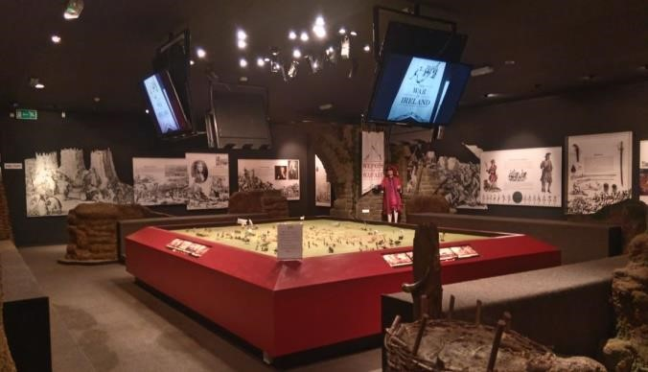
The centre appears to be operated by a single member of staff and run by the local authority, with a relatively modest 5euro entry price. Visitors can purchase hot drinks, and there is an adjacent play area for children. Guided tours onto the site can be booked.

Visitor feedback at centre commends the enthusiastic and welcoming staff, which appears to compensate for any deficiencies in the
interpretation experience. Aughrim is a rural setting with a low marketing profile; visitor numbers appear to be relatively low and the centre is only open for a few months of the year.

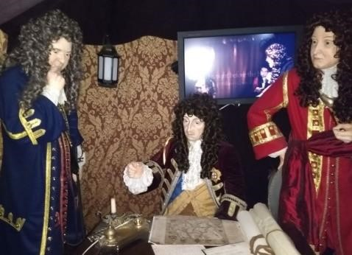
Battle of the Boyne 1690, near Drogheda: probably Ireland’s most famous battlefield, the Boyne is also one of the most politically sensitive. The visitor centre is housed at Oldbridge Estate, an 18th century mansion house in the centre of the battlefield area. Cannons are mounted at the entrance, and ticket price is 5euros. There is a gift shop and a café. The exhibition itself is dated in appearance, with text and graphic panels bearing most of the burden. There are also video displays, and mannequin dioramas of the rival kings’ councils of war. The mannequins are oldfashioned and lifeless, and the incongruous TV screens behind them add to the dated feel of the interpretation. Nevertheless, the attractive grounds (the 18th century landscaping has impacted the battlefield of course) provide additional reasons to visit and also the scope for outdoor events such as living history and re-enactment cavalry displays. The centre appears to be run by the Department of Public Works.

