Sustainably funding the Battle of Prestonpans Living History Visitors Centre
This brief paper explores the financial dynamics of running a battlefield visitors centre in Scotland, discusses the financial outcomes required to make the Battle of Prestonpans Visitors Centre a success and lists supporting evidence demonstrating why this trading performance is deliverable. Having discussed financial assumptions made and the expected contribution to overheads that will be generated, supporting evidence considered includes an analysis of the business models of similar / local visitor attractions and a review of Prestonpans visitor forecasts previously produced by external consultants. The review argues that the forecasts created by RGA Consulting in 2010 are reasonable / conservative for a world class battlefield visitor site in Prestonpans today.
Financial highlights
A five year Battle of Prestonpans Living History Centre trading budget has been prepared.
The analysis undertaken suggest that a successful visitors centre needs to deliver the following …
- 80,000 visitors per annum
- An average visitor spend of £12 (Ticket £6, Catering £3 and Retail £3)
- Gross margin / cost of sales percentage of 50% on catering and retail activities
Achieving these targets will allow the centre will generate the £800,000 per annum that is required to service budgeted overheads.
Business model and assumptions
The analysis undertaken by RGA Consulting in 2010 argued that with multiple income sources in place (ticket sales, membership fees, catering and hospitality, retail, guided events, fundraising and donations) the proposed visitors centre was likely to deliver the trading performance required to fund on-going activity and site and centre maintenance. External funding for the initial capital investment would however be required, as the trading performance of the visitor centre, in common with the other organisations considered here, was not sufficient to service capital employed.
The financial projections developed for the visitors centre income in 2019 have a similar focus on ticket sales, the operation of a restaurant and tearoom, retail sales, battlefield tours and charitable donations. These are detailed below along with cost of sales and overhead figures.

The Battle of Prestonpans Living History Centre – assumptions, projected visitor numbers and contribution to overheads generated by operations
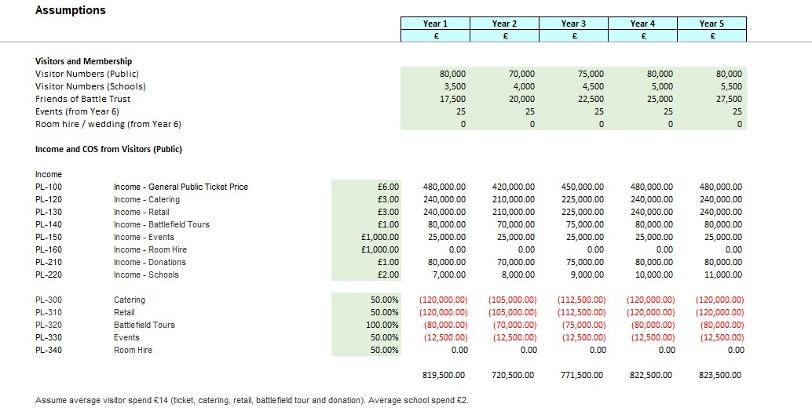

The Battle of Prestonpans Living History Centre – five year profit and loss
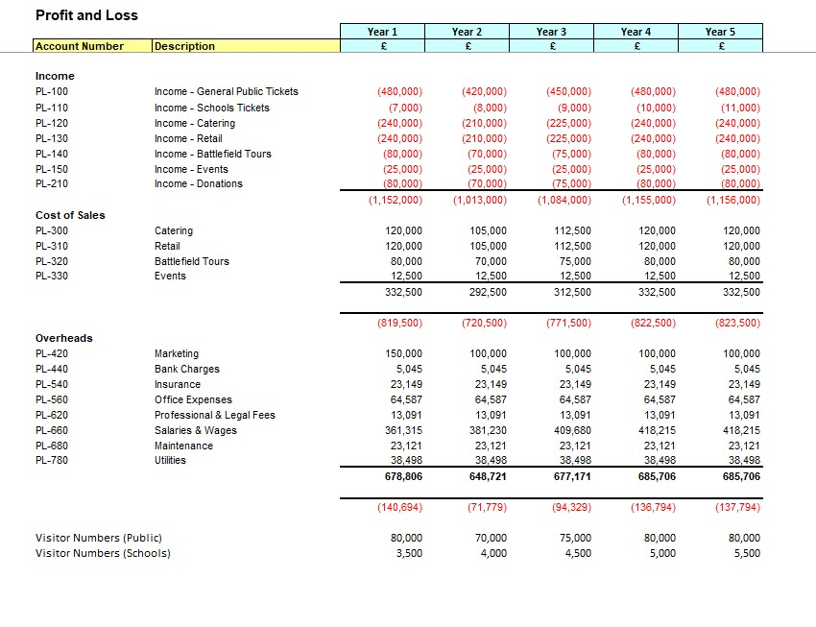

Supporting evidence
To evaluate the deliverability of our visitor centre offering we have had conversations with the National Trust of Scotland who manage other battlefield sites, reviewed the financial results of similar visitor attractions and considered past funding documents produced by the Trust and elsewhere. Conversations have focused on demonstrating our ability to develop and deliver a business model for the visitors centre that will generate a trading surplus to sustainably fund centre maintenance, educational and charitable work and other activities of the Trust. Research undertaken has analysed areas such as the most appropriate mix of visitor spend (tickets, food, merchandise, donations, other income etc.) and the nature of operating costs (e.g. appropriate cost of sales percentage rates, seasonality of costs and an analysis of payroll costs).
Multiple sources of income
The Scottish Seabird Centre has been operating since 2000. Themes highlighted by the Chairman in the 2017 accounts include a reliance on donors, visitors and members for income, the need for a strong mission with active campaigning and research, education, engagement and exhibitions, a focus on marketing and the importance of trading operations (café, gift shop and boat trips). A review of The Scottish Seabird Centre accounts (2017) demonstrates that they are effectively operating a themed restaurant, café and shop with 58% of total centre income coming from catering, hospitality, retail and boat trips. These are the primary elements in their offering, demonstrating that our operational success depends on consistently generating sufficient visitor numbers and achieving a significant ticket and non-ticket spend from each visit. The Naseby Battlefield budgets analysed are similar, with most of the expected income coming from catering, hospitality and retail. On-going donations (16% of income) and membership (8% of income) are an important part of the Scottish Seabird Centre funding model with membership also acting as a driver of repeat visits. Ticket sales are a relatively small part of overall income for the Seabird Centre (9% of income) which again reinforces the need to focus on multiple, robust non-ticket sources of income.
Visitor numbers
The Battle of Prestonpans Living History Centre feasibility study created by RGA Consulting (2010) used potential market size and an expected penetration rate to predict visitor numbers of 98,139, 87,353 and 89,422 in the first three years of operation. The document sense checked these numbers, noting that in 2009, the Scottish Seabird Centre achieved 291,474 visitors, Culloden 112,178 visitors and Bannockburn 50,571 visitors.
In the years since the preparation of the study, Culloden has seen rising visitor numbers, with the number of visitors rising from 117,814 in 2015 to 213,343 last year (ALVA visitor figures). Visit Scotland argue that this rise has been driven in part by the ‘Outlander’ effect (Visit Scotland, 2019) which would also be relevant to The Battle of Prestonpans Living History Centre. Visitor Centre tickets for Culloden are priced at £11 (£9.50 for concessions) which is significantly higher than the budgeted ticket price of £6 for Prestonpans. The Culloden battlefield site generates income well in excess of the budgeted numbers that would allow the Living History Centre to achieve trading breakeven.

Conclusion
The analysis undertaken suggests that the budgeted visitor numbers, average visitor spend, and gross margin figures included in the Battle of Prestonpans Living History Centre five year trading projection are deliverable provided that the Trust creates a Living History Centre that offers a world class visitor experience, focuses on catering and retail operations and offers high quality educational and creative programming for local residents to drive repeat visits.
Documents
Association of Leading Visitor Attractions, http://www.alva.org.uk/details.cfm?p=423 – Culloden had 213,343 visitors in 2018 (2012 - 96,271, 2015 – 117,814, 2016 – 139,691 and 2017 - 180,875)
Battle Trust (2019). The Battle of Prestonpans Living History Centre – Five Year Trading Projection
Naseby Phase One: Living History Centre Feasibility Study
Naseby Visitor Centre Business Plan (2007/08 to 2012/13)
Scottish Seabird Centre (2017). Scottish Seabird Centre Annual Review
RGA Consulting (2010). The Battle of Prestonpans Living History Centre - Reassessment of visitor number and financial projections, prepared by Richard Gerald Associates
Visit Scotland (2019). The Outlander Effect and Tourism, March 2019, Visit Scotland

