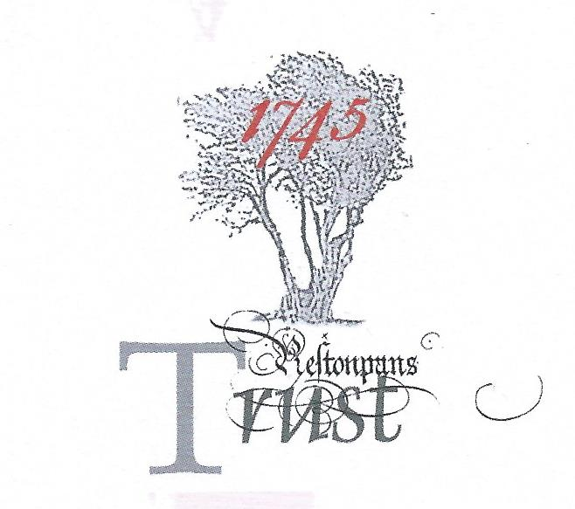

CULTURAL ACTIVITIES OFFICER:
PATH TO VICTORY – 275th ANNIVERSARY OF BATTLE PROJECT v2

The individual appointed will work with the Project Leader to co-ordinate and ensure effective delivery and evaluation of the programme of cultural activities the Trust has resolved shall be presented to honour the 275th Anniversary of the Battle of Prestonpans during 2020. The programme is required to maximise local community engagement at all appropriate levels as well as nationally involved audiences. During 2021 the legacy of the activities will be enshrined creating sustainable resources. Thoroughgoing evaluation will include the digital capture of the portfolio of activities as an eBook created through direct participation by the community.

The Project Leader reports directly to the Chairman of the Battle of Prestonpans [1745
Heritage Trust [BPHT] and, with the Chairman, to the Path to Victory Taskforce of Trustees and
other sponsors of the Project.

The Cultural Activities Officer, working with the Project Leader, will receive dedicated BPHT
office and financial support services. They will importantly also have access to the volunteer
support on which the BPHT thrives including artists, musicians, embroiderers, historians, social
media groups and re-enactors.

DUTIES AND KEY RESPONSIBILITIES

- The Project Team must engage with and work in close relationship with all appropriate local community as well as appropriate professional interests including the Clans that Came Out with The Prince at Prestonpans and the burgeoning ‘Friends of The Prince’.
- The Project Team must work in close relationship with and support of the extant NLHF Great Places initiative in the PSG Area.
- The Project Team must ensure the delivery and evaluation of the programme, mindful that the Project is required to demonstrate and ensure the Trust’s ability to deliver and instiutionalise such cultural events for the future in addition to its already well established activities.
- The Project Team must take all feasible steps to engage with those across the community who purchase Lottery Tickets so that they can readily see how Lottery Heritage Grants are being spent and gain greater appreciation and understanding of this unique aspect of their community’s heritage.
- The Project Team will ensure all feasible support for the training and development of volunteer battlefield guides to ensure greater provision for community schools and groups as well as tourists.
- The Project Team will also be responsible for a 10th Anniversary Tour of The Prestonpans Tapestry and Celebration of the 300th Birthday of Prince Charles Edward.

Engaging with local communities

- The Project is totally committed to engaging with the local community and supporting them in every feasible aspect to maintain and/ or enhance their contributions.
- The Project does not anticipate nor will it propose any single pattern of engagement with local communities although BPHT is committed to encouraging the broadest possible access by and for all.
- The Project Team will encourage local community groups to recruit and train volunteers and to work with schools to encourage attention to the cultural heritage involved and to understand why and how the battle was fought and why its message has been remembered and nurtured for generations.

SKILLS & EXPERIENCE SOUGHT

The role of Cultural Activities Officer requires the ability to relate with diverse local community groups ranging from local government officers to volunteer enthusiasts. Previous experience will be expected that demonstrates this competence ideally in a cognate field.

The Officer will work with the Project Leader to help deliver and formally report against the 2 year timescale, within budget and within the ethos and policies of the BPHT; and help to ensure that all concerned are kept routinely updated on progress and any challenges that require early attention.

The Project specifically involves the further development of the Trust’s use of the Gaelic in its activities to honour the language spoken by the great majority of Highlanders at Prestonpans in 1745. The Project Leader and/ or the Cultural Activities Officer will be required to take focused responsibility for this component.

The Cultural Activities Officer will be drawn from a differing but cognate primary professionalism to the Project Leader.

The Project involves interactive and proactive support of diverse communities, exhibitions and tapestry displays, and this means all members of the Project Team must be willing to travel on field visits; and be able to drive.

BPHT actively supports and encourages action-learning, requiring continuing personal and professional development for sessional staff and volunteers. As such it will expect members of the Project Team to keep their Project Diary not only as a basis for formal reporting and support to community groups including the eBook but also as a basis for their own personal self-evaluative development including qualifications and, as opportunity presents, for input to seminars and professional publication.

Annex:
THE PROGRAMME OF CULTURAL ACTIVITIES

A 2 year project expanding community engagement to mark 275th anniversary of the battle, 300th birthday of Charles Edward, and 10th anniversary of The Prestonpans Tapestry.

• Nationwide project for 10-17 year olds to create poetry, prose or visual art, increasing relatability of heritage and encouraging young audiences to contribute to its legacy - resulting in exhibitions and publication.
• Development of Friends of The Prince support network, recruiting and training new volunteers and guides, with a rejuvenated online presence which is visitor-focused and makes both battlefield and activities more accessible.
• Renovated travelling exhibition of The Prestonpans Tapestry, reaching at least 4 relevant communities across Scotland.
• “Prestonpans 275” Exhibition, exploring changing landscape and cultural interpretation of the heritage; bringing a unique collection together through new partnerships with loaning collections; supported by workshops and related events.
• Songs of War: community theatrical/musical/poetic performances highlighting works relating to the heritage in both English, Scots and Gaelic, creating alternative entry points for interest in the history.
• 275th Anniversary – September 2020: events reaching diverse audiences: concert, costumed battlefield walks for both local schools and general public, historian’s conference in partnership with Helion publishing, and new exhibition panels on the clans and regiments.
• Legacy plan to harness momentum throughout 2021 and beyond, creating sustainable networks and resources for the Trust.

NLHF APPROVED PURPOSES IDENTIFIED

NLHF has provided 49% Match Funding towards the programme and has identified what it sees as its Approved Purposes on which Evaluative Reporting will be required i.e.

- To involve a wider range of people with the heritage of the Battle of Prestonpans through a range of activities such as an arts and literature project aimed at 10-17 year olds, a 275th anniversary weekend, including walking tours for schools, and two exhibitions.
- To better identify and explain the heritage of the Battle of Prestonpans by delivering activities using art, music, literature, re-enactment and exhibitions allowing people to learn about heritage.
- To train at least 30 volunteers to become battlefield guides, from the 'Friends of' network and from other local voluntary organisations. Allowing them to develop skills.
- To update The Battle of Prestonpans (1745) Heritage Trust’s digital presence, with support from students at Edinburgh College.
- To develop a ‘Friends of’ support network and a volunteer database, with a focus on improving organisational capacity.
- To create a Legacy Plan with a focus on activities that can delivered beyond the 275th anniversary celebrations.

