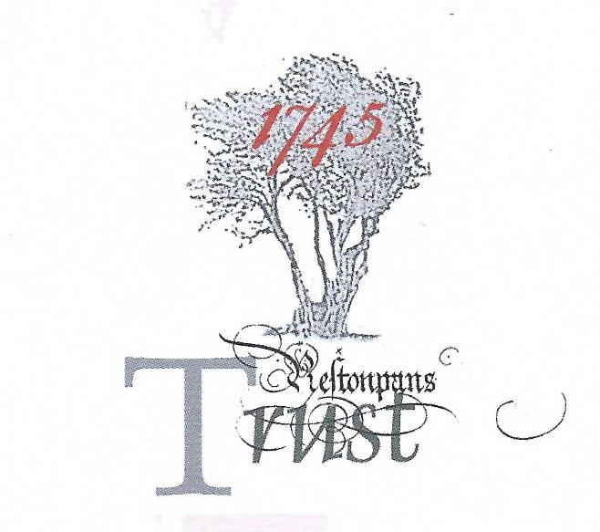

MINUTES OF HLF RESILIENCE PROJECT TASKFORCE
held on March 20th/21st 2019 @ The Prestoungrange Gothenburg, Prestonpans, EH32 9BE
*Part time contributions [e] electronic contributions

Present: Gordon Prestoungrange [in the chair]
Sharon Beck
*Hannah Bradley – Soundbite PR
*Martha Bryce – Soundbite PR
Stephen Connolly – DC Consulting
Herbert Coutts
Sharon Dabell [e]
*Christopher Hadley - Savills
Arran Johnston
*Kirstie Pirie – Source Marketing
*Iain Slater - Hargreaves
Michael Taylor [e]
Avril Wills
Mathew Wills [e]

Received: Discussion Papers: The Prince’s Friends; Battle Trust Funding Thoughts; Show Home Strategy 2020/ 2022; A Listing of Jacobite Assets; correspondence with Diarmid Hearn NTS

Noted: That the Condition Report on the Scottish Diaspora Tapestry undertaken by Tuula Pardoe on March 13th 2019 at New Lanark Mills had raised no concerns and would be tabled shortly.

Reviewed & Discussed: The content of all new papers tabled and those carried forward from our February 22nd 2019 Meeting. Concluded for Element [iii] of the Project:

That Drs Arran Johnston and Stephen Connolly should proceed to create the Draft Manifesto by end March 2019 in two parts: [a] Vision of Living History Prestonpans and [b] a Transition Phase.

[a] Vision of Centre for Living History Prestonpans shall embrace:
[i] Battle of Prestonpans Interpretation/ Immersion and The Clans that Fought - in the context of the Jacobite Cause 1686/ 1807; [ii] total continuous display of the 103 metre Prestonpans Tapestry; [iii] extensive Temporary Exhibition and Education facilities to accommodate and support the diverse strands scoped including cohort displays of the Scottish Diaspora Tapestry, the Community Arts of Prestonpans and The Jacobite Trail; [iv] integral bookshop & themed café; [iv] Scope the events and activities programme for Years 1 & 2; [v] relationship with battlefield and walks/ tours; [vi] interactive social media relationship with ‘Friends of The Prince’.
Concept designs for the Centre at two locations will be provided.
[b] Our Transition Phase shall accomplish via the advent of fulltime professionals:
[i] Formalised working relationships with extant volunteers, sessional staff and Clans that Came Out with The Prince; [ii] Enhancement of existing programmes for educationalists; [iii] Developmental partnerships with travel trade advisers; [iv] Integration and refocusing of disparate extant social media, project and archival web sites to build and share with emergent Friends of The Prince as an audience/ customer base and as a source for volunteer contributions; [v] establishment and hubbing of The Jacobite Trail; [vi] reviewing and supplementing the extant merchandise ranges; [vii] reviewing and as necessary updating the APPs; [viii] Exhibiting, resting and as necessary restoring The Prestonpans and the Scottish Diaspora tapestries; [ix] Identifying how to sustain the Gaelic.

During the 3 year transition to The Opening, the 275th Anniversary of the 1745 Battle will be commemorated in 2020 with [i] an exhibition at the John Gray Centre Haddington; [ii] a final five stop tour of Scotland by the Prestonpans Tapestry; [iii] celebrations of the cultural impact - music/ poetry/ literature/ theatre etc. since 1745; [iv] battlefield tours and walks; [v] 2021 will see a fullscale battle re-enactment in September; continuation of battlefield tours and walks; fundraising events e.g Ball at Holyrood House. Participants will be enjoined to become a Friend of The Prince.

The Prestoungrange Gothenburg will provide pieds a terre and HQ for the fulltime professionals and will further develop its role as a micro-museum facility.

[c] Raising Capital and underwriting initial Trading:
It is the Trust’s intention during the Transition Phase to raise the necessary capital to [i] create and populate the Living History Centre per se and [ii] to underwrite the initial 2 years trading to reach breakeven. Financial scenarios and budgets to this end will necessarily be prepared at the start of the Transition Phase.

[d] Funding the Transition Phase:
The Trust has £100,000 donated funds in hand to deploy as match funding for Resilience and Organisational Development Grants which will be sought from National Lottery Heritage Fund, HES, Viridor, ELC and others as feasible. The community based Prestoungrange Gothenburg will be gifted as a going concern [Bistro/ Microbrewery] to the Trust affording the opportunity for in-kind staff accommodations, micro museum, events, exhibitions and books/ merchandise sales.
The fulltime professional staffing required will be developed around Sessional Staffers Dr Arran Johnston and Sharon Beck. A total of 4 FTEs [including Capital fundraising] are envisaged with office and administrative support provided through The Prince’s Friends and Trustees.
A ballpark estimate of budget requirements for The Transition [over and above in-kind] is £175,000pa x 3years = £525,000.
Application date for National Lottery Heritage Funding is May 28th and for HES September 28th 2019.

Next Step:
CONSULTATION TOWARDS OUR NATIONALLY AGREED MANIFESTO

The Draft Manifesto will be out for comment through PR/ arranged meetings throughout April 2019 during which Letters of Support will be sought to accompany the subsequent applications for Transition Funding. The Nationally Agreed Manifesto will form the basis for applications for Transition Funding.

Applications for Transition Funding will be based on the possible location[s] for the Living History Centre i.e. Charlestoun or ELC location, and the creation of an Equestrian Statue of The Prince as the site.

