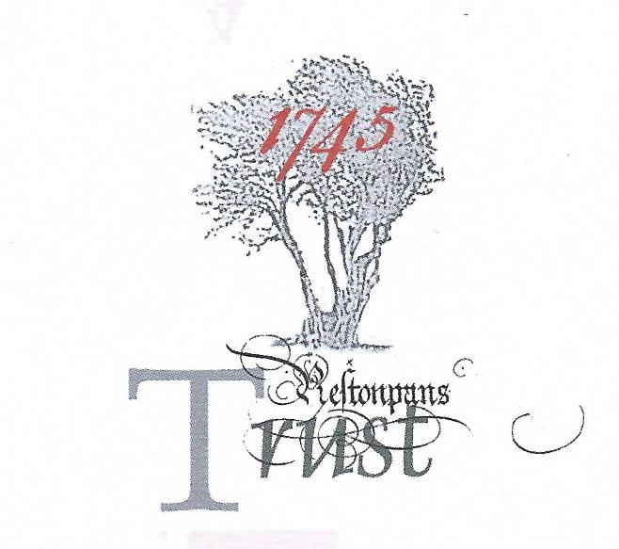

MINUTES OF RESILIENCE PROJECT TASKFORCE
held on February 22nd 2019 @ The Prestoungrange Gothenburg, Prestonpans, EH32 9BE

Present: Gordon Prestoungrange [in the chair]
Sharon Beck
Stephen Connolly [e]
Herbert Coutts
Arran Johnston
Mathew Wills [e]

Received: Revised Interim Reports under Elements [i] and [ii] of the Resilience Project; Progress Report tabled with HLF; Policy Papers [1] Tapestry Conservation etc.; [2] Visitor Segmentation at LHC; [3] HLF Feedback re BathHouse Application and Resilience; [4] Clans that Came Out with The Prince & Hanoverian Regiments; EGM’s Elucidation of Charter to include public interest clause and Living History Centre [LHC]; Feedback from ELC Officers in Haddington TownHouse re location of LHC and their partnership support.

Noted: That the Condition Report on the Scottish Diaspora Tapestry will be undertaken by Tuula Pardoe on March 13th 2019 whilst on display at New Lanark Mills.

Dr Michael Taylor has been commissioned by the Trust to advance the concept of the Jacobite Trail and the contextualisation of the Jacobites at Prestonpans including an International Colloquium for report before March 20th.

That Mathew Wills FCA, Trustee/ Treasurer, is undertaking Financial Analyses of Comparable Heritage enterprises to draw conclusions re capital funding and trading patterns for report before March 20th.

Reviewed & Discussed: The content of all papers tabled. Concluded:

There was no evidence from the comparative study and financial analyses to suggest a modest provision could achieve long term sustainability. There was however clear evidence e.g. Culloden, Waterloo, Bayeux and Newark that adequately scoped world class facilities can be self-sustaining once pro bono capital investment has been achieved. There was also clear evidence of the visitor appeal of the Trust’s tapestries and of international interest in the Jacobite Cause e.g. NMS Exhibition and Outlander.

/ continued

Agreed for the Draft Manifesto:

[a] That Gareth Bryn-Jones, the Trust’s Architect, be asked to create Concept Visuals of the LHC in line with the Scoping already tabled by March 20th to achieve: [i] total continuous display of the 103 metre Prestonpans Tapestry; [ii] Battle of Prestonpans Interpretation/ Immersion and The Clans that Fought - in the context of the Jacobite Cause 1686/ 1807; [iii] extensive Temporary Exhibition and Education facilities to accommodate and support the diverse strands scoped including cohort displays of the Scottish Diaspora Tapestry, the Community Arts of Prestonpans and The Jacobite Trail; [iv] integral bookshop & themed cafe.

[b] That the Trust should Step Up to fulltime professional staffing at the earliest opportunity in 2019, which staffing should be mandated, working formally with extant volunteers and sessional staff, educationalists and travel trade advisers, to make the Trust wholly Ready to Launch The Living History Centre and continue as since 2006 to prototype/ pilot divers elements of its putative programme. The Trust’s £100,000 of Restricted Funds for the Permanent Home for the Tapestries should be used judiciously/ as match funding to accomplish this Step Up.

[c] That the professional staffing should involve 2 fulltime and 2 part time members + office support with the following responsibilities: [i] to update the Economic Feasibility Studies by RGA for the LHC; [ii] raise the necessary capital/ make lease arrangements for the LHC; [iii] create the diurnal programme of activities and operations for the LHC for its first two years including sensitivity analyses of forecast trading budgets; [iv] establish Friends of the LHC via social media most particularly focussed on residents within 50 miles of Prestonpans but also including all who joined the Online Petition, Friends of the Tapestries and Alan Breck Regiment; [v] establish formal contacts and agreements with the Tourist Trade in Scotland to bring successive cohorts of visitors to the LHC; [vi] establish formal contacts, resources and agreements with schools within 50 miles, both primary and secondary, to address their curriculum and social needs; [vii] reinforce contacts with the Committee of High Sponsors and all Clans that Came Out with The Prince/ British Army Regiments/ Edinburgh Castle; [viii] seek howsoever to create the nation’s first equestrian statue of The Prince.

[d] That the professional staffing would be located via match funding at The Prestoungrange Gothenburg until the LHC was opened.

[e] That the LHC’s synergy with outdoor access to the Battlefield Walk/ Bing/ Bankton Dovecote/ Monuments/ Memorial Tables/ 18th century agriculture must be optimised including Interpretation Boards and the GPS app.

[f] That the use of the Gaelic language as already pioneered should be sustained as appropriate.

[g] That the Trust should proceed wheresoever appropriate in partnership with the Scottish Battlefields Trust and East Lothian Council [Economic Development and Museums] and in the closest co-operation with PSG’s Heritage Team and Prestonpans and Cockenzie and Port Seton Community Councils.

/ continued
Next Step:
CREATING THE DRAFT MANIFESTO/ CONSULTATION/ NATIONAL AGREED MANIFESTO

That the Trust was now felt to be ready to create its Draft Manifesto for the Next Decade. It Ambition will be: to Open the LHC by 2022. The professional staff appointed from 2019 and based at the Prestoungrange Gothenburg will address the responsibilities set down above prior to its opening. Working with the Volunteers already in place, they will sustain the Trust’s divers extant initiatives e.g. re-enactments/ commemorations, school and tourist visits, tapestry displays.

[a] Drs Stephen Connolly and Arran Johnston have been commissioned by The Trust to accomplish HLF Resilience Study Element [iii] - i.e. creating the Draft Manifesto; Consultation thereon to arrive at the Agreed Manifesto; Application to HLF and other Grant Givers for support to fund Stepping Up to professional staffing by May 28th 2019.

[c] Martha Bryce has been commissioned to address PR/ publicity for the Manifesto Draft/ Agreement.

TIMESCALE TO HLF GRANT APPLICATION
The requisite timescale is as follows:

March 21st: Taskforce Proposes & Trustees Adopt the Draft Manifesto
Draft Manifesto ‘Printed’ as an efile
April 1st : Public Consultation/ Publicity Commences/ Requisite Enquiry Lodged at HLF
May 3rd : Public Consultation Ends & Outcomes incorporated
May 17th: Formal Evaluation of Resilience Study lodged with HLF
May 23rd: Agreed Manifesto Adopted by Trustees
May 28th: Application submitted to HLF to support Stepping Up

N.B. There is a grave cash flow challenge if missing this schedule. May 28th HLF Application will be evaluated by HLF Scottish Committee for 12 weeks before decision by end August 2019. If it needs revision for HLF it will occasion at least 6 months more delay i.e. end February 2020 before any decision can be gained from HLF.

