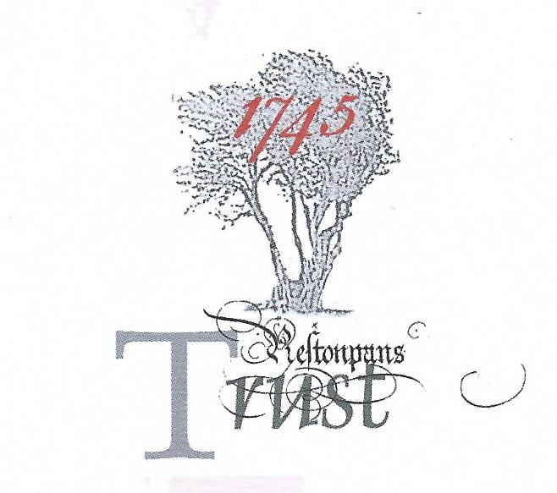

MINUTES OF RESILIENCE PROJECT TASKFORCE
held on January 10th 2019 @ The Prestoungrange Gothenburg, Prestonpans, EH32 9BE

Present: Gordon Prestoungrange [in the chair]
Sharon Beck
Stephen Connolly [p/t]
Herbert Coutts
Arran Johnston
Mike Taylor [p/t]

Received: The Interim Reports under Elements [i] and [ii] of the Resilience Project; and the initial Report on the Prestonpans Tapestry being within Element [i].

Noted: That a further Condition Report, on the Scottish Diaspora Tapestry, would be undertaken in March whilst that tapestry is on display at New Lanark Mills.

Discussed: The Reports received per se and identified ways in which they can be further enhanced; and agreed that such work [other than for the tapestry at New Lanark] should be completed asap and no later than end January 2019.

Agreed: That immediate initiatives should be taken to further the Trust’s Jacobite Project to create [a] a Jacobite Assets Register and [b] an international Jacobite Trail; and Mike Taylor was mandated to carry this forward including convening a Jacobite Colloquium in the near future with potential partners across such a Trail.

That the Interim Reports as enhanced should be tabled in confidence to ELC and to
HLF so that those stakeholders can themselves appreciate the emerging outcomes.

Confirmed: That discussions on February 22nd with ELC had been arranged to carry forward its offer in 2017/ 2018 to facilitate the evaluation of possible locations for the Living History Centre prior to which meeting the enhanced Interim Reports will have been shared.

On February 6th a field visit by Trustees to Charlestoun/ Blindwells has also been arranged with Iain Slater which will be followed by discussions of Hargreaves emerging Town Centre plans by the Prince’s Loch and the possible location of a statue of The Prince under % for the arts.

Debated and Provisionally Agreed: [1] That the CORE PURPOSE of the Living History Centre shall focus on the Battle of Prestonpans advancing all the Objects set out for the Trust. The literary and artistic heritage it has occasioned will be celebrated.

[2] That the Battle shall be presented as perhaps the most optimistic moment in Jacobite History when Victory for the Ambitious young Prince Charles Edward afforded Hope that the Stuarts could be restored to the their thrones. This Victory will be presented in the context of the entirety of Jacobite History from 1686 to 1807.

[3] That The Prestonpans Tapestry shall be permanently exhibited as the Trust’s unique interpretation of the Prince’s campaign leading to his Victory in Prestonpans. The artwork’s creation as the ‘originating’ Scottish community tapestry shall be exemplified both in the exhibition and in the encouragement and support of such initiatives in the future.

[4] That the Scottish Diaspora Tapestry shall be exhibited as segments on a frequent but occasional/ temporary basis at the Living History Centre; and occasionally compleat outwith the Centre as has already become the pattern.

[5] The Living History Centre shall provide the HQ of the Battle Trust and carry responsibility for the maintenance and management of the Trust’s assets including the interpretation of the battlefield and the two tapestries. It will be responsible for the continuing engagement of Sessional Staffs and Volunteers that have built the work of the Trust since 2006.

[6] That the Living History Centre shall specifically encourage and support the congruent activities of the Alan Brecks Regiment of Prestonpans Volunteers, East Lothian Battles Re-enactments, the Scottish Battlefields Trust and the Prestoungrange Arts Festival including the Murals Trail.

[7] That the Living History Centre will act as the hub of the planned International Jacobite Trail to be established in partnership with other Jacobite centres.

[8] That whilst the Living History Centre will seek capital grants and donations for its establishment its leadership and management team will be mandated to be self-sustaining in their operations. Revenue streams will include Admissions, Bookstore and Catering Services.

[9] The audiences for the Living History Centre will include schools addressing the Jacobite curriculum, residents within 50 miles making repeat visits to a varied programme of activities, tourists from across Scotland and internationally emanating from Edinburgh. It will also welcome Jacobite historians and continue to build its library and research services.

NEXT MEETING OF THE TASKFORCE: February 21st/ 22nd 2019

Confirmed: That the next meeting of the Taskforce will be on February 21st/ 22nd to debate and arrive at the dimensions of the Draft Manifesto to be published for Consultation. This, Element [iii] of the Resilience Project, will work howsoever with external Mentors Stephen Connolly, Mike Taylor and Grace Martin. Martha Bryce will assist with the PR aspects of the process which is intended to arrive at:

[1] An Agreed National Manifesto – under a yet to be determined title/ slogan;

[2] An Application to HLF for ‘Resilience – Stepping Up’ for which the Trust stands ready to invest the Restricted Accumulated Fund as Match Funds up to £100,000 that will enable the Trust to achieve its Agreed National Manifesto.

